Revolution of Jupiter's Moons
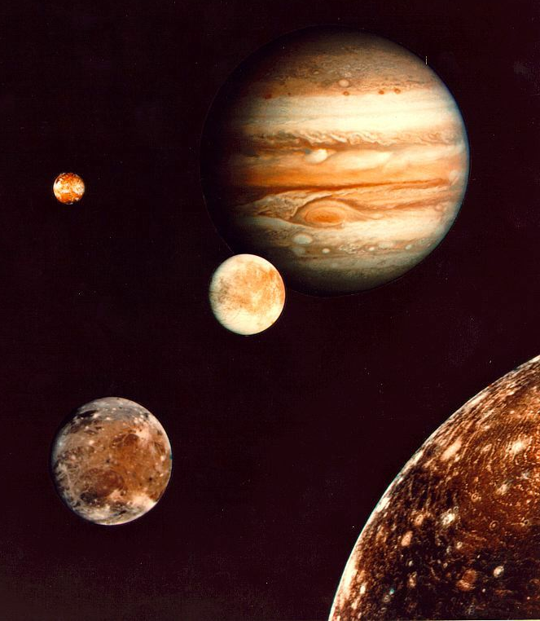
Introduction

In 1543 Copernicus hypothesized that the planets revolve in circular orbits around the Sun. Not much later, Tycho Brahe carefully observed the location of the planets over a period of 20 years using a sextant and compass. These observations were used by his student, Johannes Kepler, to deduce three empirical mathematical laws governing the orbit of one body around another.

His first law is that the planets orbit the sun as ellipses, rather than circles. This solved the “horribly complex” issue with the Ptolemeic model of the solar system, with its epicycles, although it wasn't until more accurate data was available that it could be tested more thoroughly.

His second law was that a planet travels its orbit with equal areas in equal times. In other words, when a planet is closest to the sun, it moves fastest, and when it's farthest it moves slowest. For planets, which move nearly on circles, this isn't a big difference. For comets, it can be!

Kepler's third law notes that you can measure the mass of the sun by measuring the period and semi-major axis of a planet orbiting the sun.

In 1609 the telescope was invented. When Galileo turned his telescope to the skies the next year, he could see Jupiter's four largest moons. His observations of their orbit was part of his argument that the Earth orbited the Sun, rather than the other way around: since he could see things orbiting Jupiter, he argued, it only made sense that it was a possibility for the Earth to orbit the Sun. Unfortunately for Galileo, the Inquisition took issue with his findings; he was tried and forced to recant and spent the rest of his life under house arrest.

Today we'll follow in the footsteps of Galileo in making observations of the four brightest moons of Jupiter. Since they behave like a miniature solar system, we can then use Kepler's 3rd Law to calculate Jupiter's mass. Fortunately for us, the Pope apologized to Galileo about the whole Inquisition thing (400 years after Galileo's death), so we won't have to worry about that.
Part 1 – Kepler's Third Law
We will begin by developing an understanding of Kepler's Third Law. This section explores the relationships between orbital period, orbital velocity, orbital radius, and gravitational mass.

Let us begin by exploring the relationship between orbital period and orbital velocity.

- Together with your group members, open your answer packet and answer Part 1, Questions 1, 2, and 3.

- Compare answers with your partner group (your instructor should have assigned one) and come to a consensus.

- When your instructor asks you to, report your results to the class.

Next, we will use Kepler's Third Law, $a^{3}{\text{=P}}^{2}$, to make some predictions about the relationship between orbital velocity, orbital period, and orbital radius.

- In your group, answer Part 1, Questions 4 and 5 in your answer packet.

- Report your answers to the class.

- Open the orbit simulation on the computer (your instructor will tell you how). Enter the starting values from the table below. Using the ruler tool, verify that the orbit is circular.

 | Mass | X-Pos. | Y-Pos | X-Vel. | Y-Ve.
Body 1 | 1000 | 0 | 0 | 0 | 0
Body 2 | 1 | 142 | 0 | 0 | 263

- Double the orbital radius (X-Position) and adjust the orbital velocity (Y-Velocity) so that the orbit is again circular.

- Answer Part 1, Questions 6 in the answer packet. Discuss the results with the class.
Isaac Newton generalized Kepler's Third Law by including the gravitational mass:

$$a^{3}{\text{=P}}^{2}\frac{G\left(\text{M+m}\right)}{4π^{2}}$$

Now, we will explore the relationship between orbital velocity, orbital period and mass.

- Reset the simulator to the starting values given in the previous table.

- Increase the mass of the orbiting body (body 2) until there is a noticeable wobble in the “star” in the center.

- In your group, answer Part 1, Questions 7, 8, and 9.

- Work with your partner group to come to a consensus on your answers.

- Share your answers with the class and test your prediction with the simulator.

- Double the Body 1 mass in the simulator. Change the orbital velocity until the orbit is once again circular.

- Answer Part 1, Question 10. Discuss the answer with the class.

Part 2:

In this section, we will see how to apply Kepler's look at the Jovian system.

- Below is a typical snapshot of Jupiter and its moons taken from a telescope on Earth. The moons and Jupiter appear in a straight line. In fact, in all such images, Jupiter and its moons appear in a straight line. Use the picture to answer Part 2, Questions 1 and 2 in your answer packet.
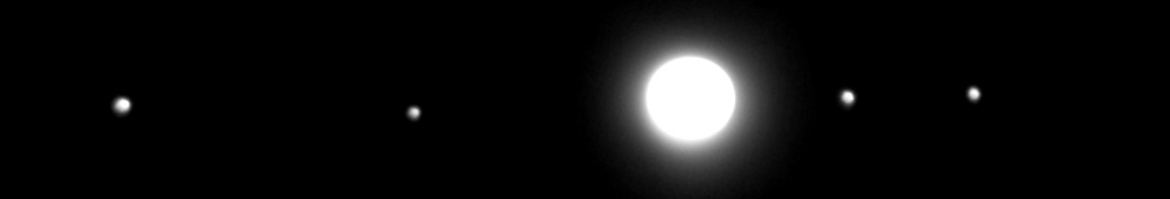
- Compare your answer with your partner group and come to a consensus on the answer.

- Below are three snapshots of the of the Jovian system as viewed from above Jupiter's north pole. Answer Part 2, Question 3. Share your results with the class.

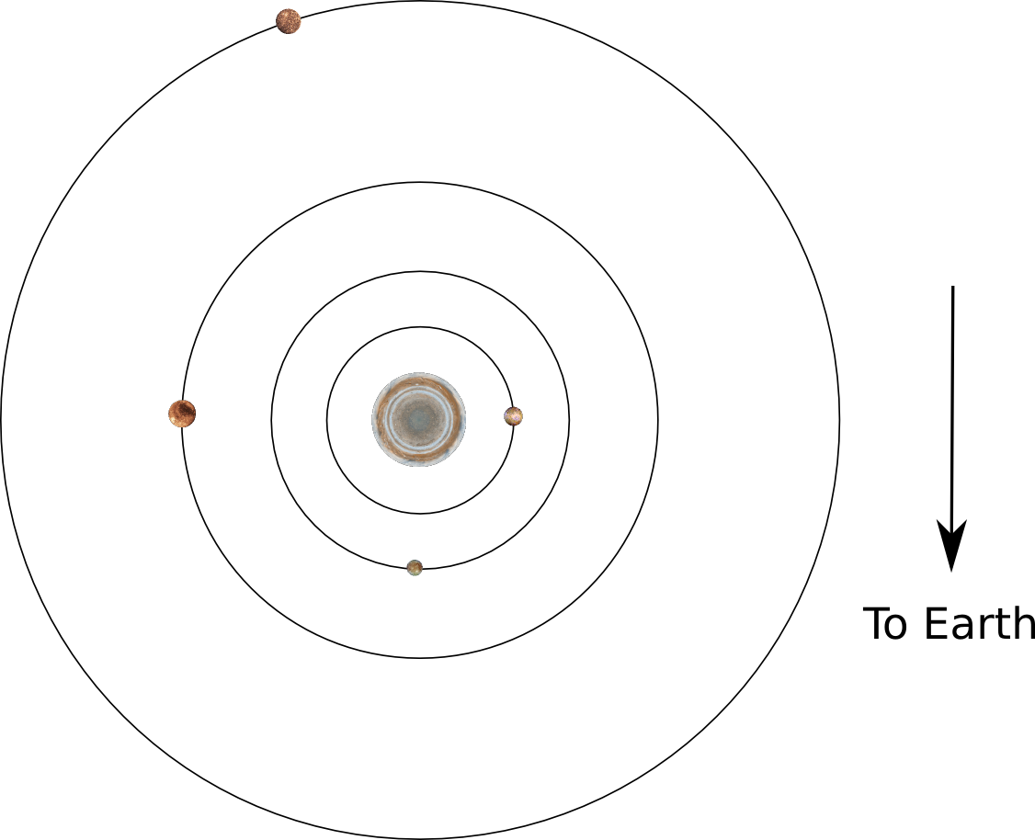
Step 1
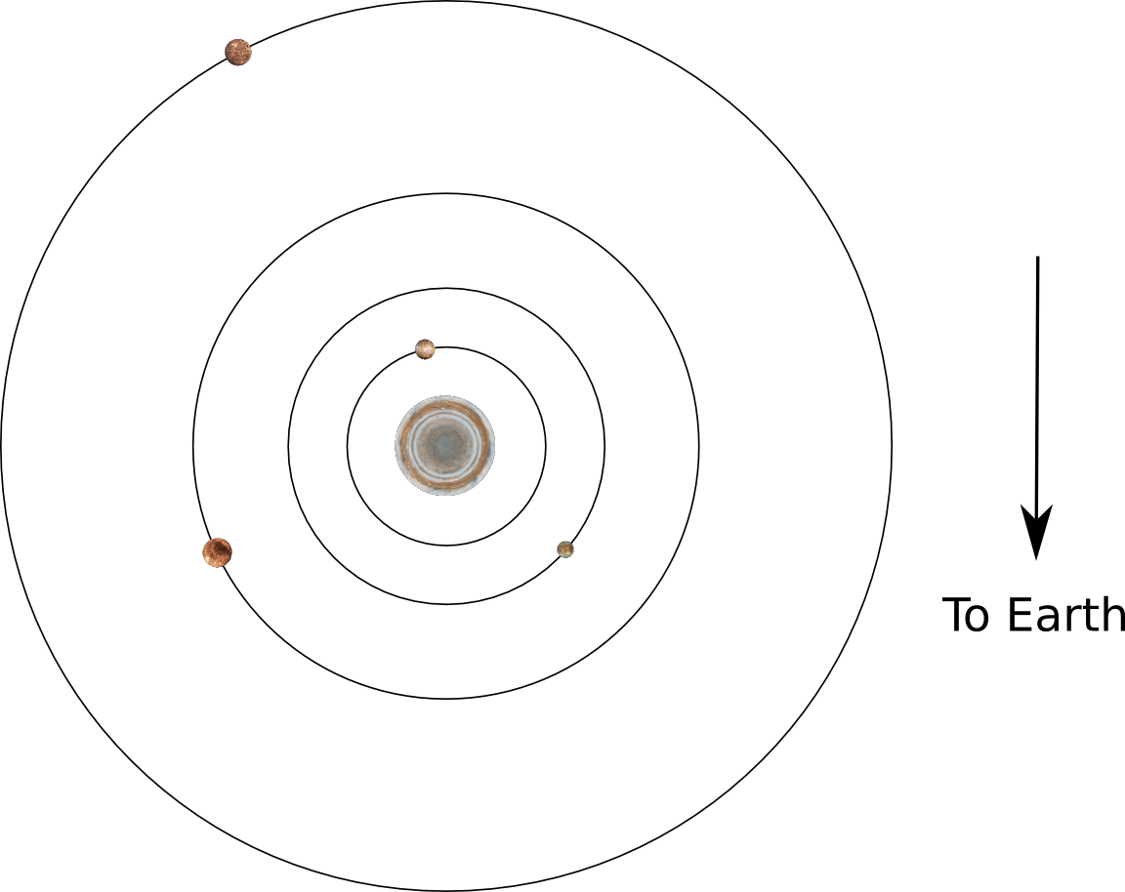
Step 2
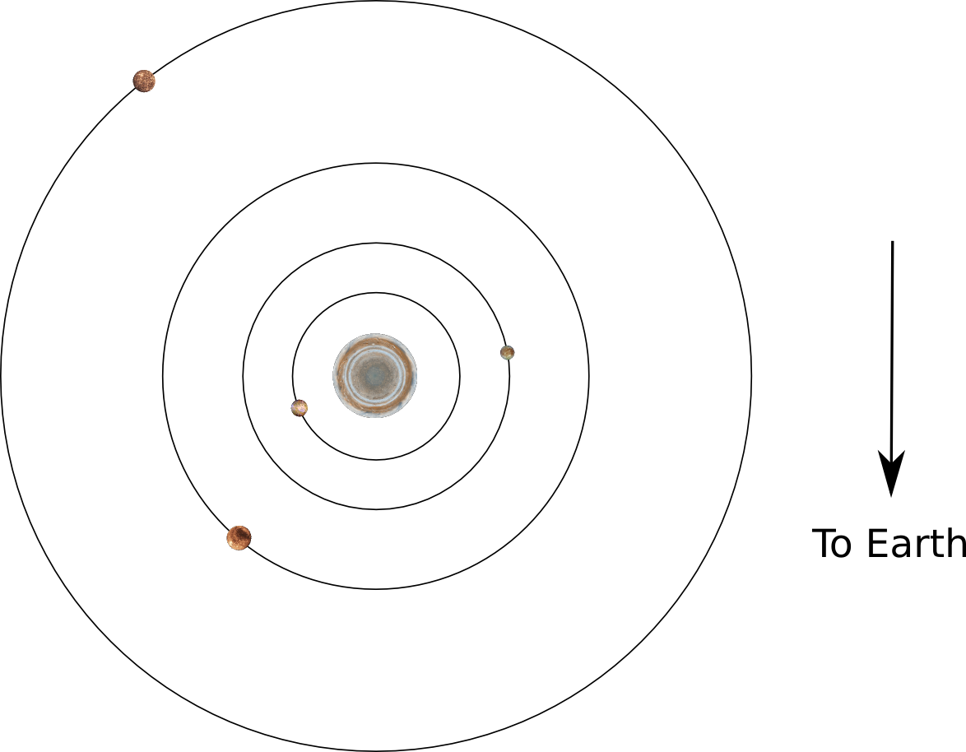
Step 3

- The three pole on snapshots above were taken 12 hours apart. Use this information to answer Part 2, Questions 4, 5, and 6. Discuss your answers with the class.

Part 3:
In this section, we will determine how to “weigh” Jupiter using images of the Jovian system and develop an observing plan.

- In your groups, answer Part 3, Questions 1 and 2. Share your results with the class.

- Answer Question 3 as part of a class discussion.

- Telescope time isn't free. If it were, you could just take a whole bunch of images of Jupiter and get a very good measurement of the orbit of it's moons.

As a class, you have been awarded 20 images of Jupiter. Your task is to choose how to distribute those images most effectively to measure the orbit of Jupiter's moons and calculate the mass of Jupiter.

- The table in Part 3, Question 4 of your answer packet lists the relevant observing parameters. Within your groups, determine a set of of observing parameters that will most effectively use your 20 images. Enter them in the table in Question 4.

- Discuss your parameters with the class. Your class will come to a consensus and your instructor will log in and submit your observing request to the observatory.

