Revolution of Jupiter's Moons

Turn in one copy of this lab with each group member's printed name and signature. By signing, you certify that you have actively participated in the exercise and have put forth effort in equal share to your fellow group members.

Printed Name Signature

______________________ _____________________

______________________ _____________________

______________________ _____________________

______________________ _____________________

Part 1

1. Develop a definition of orbital period.

2. Develop a definition of orbital velocity.

3. The planet Earth has an orbital period of 365.25 days. Assuming that the orbit is perfectly circular and that Earth is 92.956 million miles from the Sun, calculate the orbital velocity of the Earth in miles per hour.

Explore what happens to the orbital period and orbital velocity of a planet when the orbital radius is increased as described in your packet. Keep Kepler’s 3rd Law () in mind for the following questions:

4. In Kepler’s 3rd Law above, what is a? If the orbit is a circle, what is a?

5. Using the equation above, if the orbital radius increases, does the orbital period increase, decrease, or stay the same?

6. Did the orbital velocity increase, decrease, or stay the same for the orbit to stay circular?

7. At what mass did you see wobble in the central mass? Do you expect the Earth to cause significant “wobble” in the Sun? (The sun’s mass is 332,946 times the mass of Earth.)

8. Looking at the general version of Kepler’s 3rd Law, if the central mass increases, must the orbital period increase, decrease, or stay the same in order to maintain a circular orbit at the same distance?

9. If the central mass increases, must the orbital velocity increase, decrease, or stay the same in order to maintain a circular orbit? Find out by increasing the mass in the simulation.

Part 2

1. Why do Jupiter's moons appear in a straight line in all of the images?

2. What can you actually measure in a single snapshot of the Jovian system?

3. For each of the three pole-on images in Part 2 of your question packet, sketch how the system would appear from Earth in the boxes below.

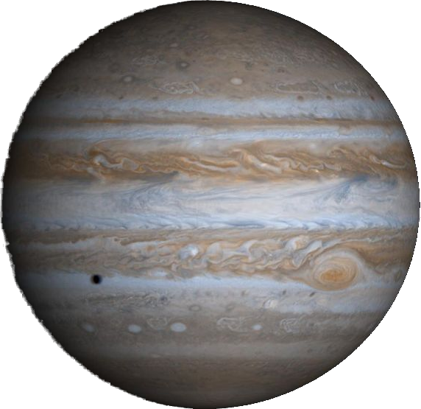

Step 1

Step 2

Step 3

4. Estimate the orbital period of each of the four Galilean moons.
Explain your process!

Moon | Orbital Period
I
II
III
IV

5. The orbits of Jupiter's moons are almost completely circular. Appealing to Kepler's Second Law, what does this imply about their orbital velocity?

6. We are viewing the system edge on. At what point in the orbit does the moon appear to move the fastest? The slowest? Why?

Part 3
1. Looking at the generalized version of Kepler's Third Law from Part 1, assume that the mass of any moon is small compared to the mass of Jupiter and that we know the gravitational constant G. What do we need to know to solve this equation for the mass of Jupiter?

2. Can we measure these values from a single image of Jupiter? If yes, how? If no, why not and what is the solution?

3. Given your answers to Part 2, Questions 2 and 6 and Part 3, Question 2, describe the data that you expect to gather from the telescope and sketch a plot of what you expect to see.

4. Record your observing parameters in the table below.

Number of Images per Night
Time Between Images
Number of Nights to observe

