**Revolution of Jupiter's Moons – Lab 2**

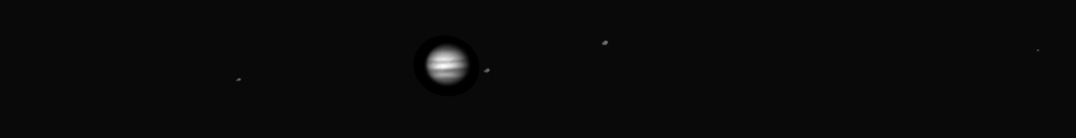*Jupiter and its moons as seen from the UST Observatory.*

**Introduction**

In Lab 1 of this two lab series, we discovered that Kepler's Laws of planetary motion could be used to calculate the mass of a planet. We then learned how we could weigh Jupiter by measuring the period and orbital radius of its moons in a time series of images. In this lab, we are going to use the images from the telescope to first measure the period and semi-major axis of the Jupiter's moons and then use those values to calculate the mass of Jupiter.

**Part 1: Measuring the positions of the Moons**

Depending on your original observing plan, you will have as many as 20 images of Jupiter. In each image, you will measure the distance between Jupiter and each of its four moons and record that distance in a spreadsheet.

* Open the program “Revolution of Jupiter’s Moons” on the desktop.
* Go to **File 🡪 Log In**. In the space for Student #1, enter **Class1**, then click OK. **You do not need to fill in any other information.**  Click “Yes” when it asks if you have finished logging in.
* Go to **File 🡪 Run**. This brings up a window for setting the Date and Time. We want to use our observing plan list, so in this new window click on **Hotlist 🡪 Access Hotlist**. This is the list of observations. Double click on the first one. This will fill in the Date & Time information in the Date/Time window. Click “**OK**” to load this data.

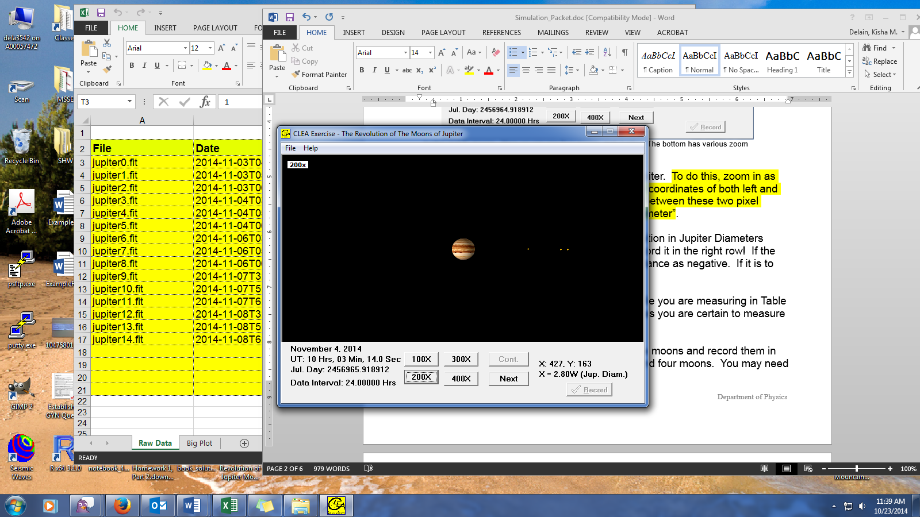

Jupiter and its moons. Here we can see three moons, and Jupiter. The bottom has various zoom levels, with 400x being the most zoomed in. Clicking and holding gives you the crosshairs, and pixel data in the lower right.

* You will need to measure the diameter of Jupiter. To do this, zoom in as far as you can. Click and hold to get x and y coordinates of both left and right sides of Jupiter. **Record the difference between these two pixel values in the spreadsheet and in Question 1**.
* Next, click on a moon and record its position in Jupiter Diameters in your spreadsheet (see figure on the next page). If the moon is to the East (left) of Jupiter, record the distance as negative. If it is to the West (right), record the number as positive.
* Now measure the positions of the other three moons and record them in the spreadsheet as well. The moon order does not matter so long as you are certain to measure all of the moons. (Hint: Try your hardest to find four moons. You may need to zoom in or out!)
* Repeat the preceding procedure for each of the dates assigned to your group. Once your data is entered, ask your instructor to review it.

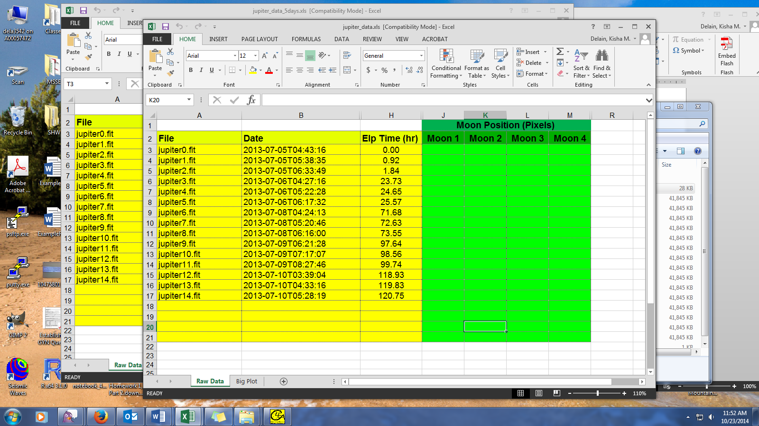



**Part 2: Determining the orbital parameters**

Make sure that you are entering data in the correct row! Note that the time is in Universal Time, which is six hours more than our time here (so 10Hrs will be listed as 04 in your table).

Now that we have the positions, we will use them to measure the period and the semi-major axis of each of the moons. We do this by calculating the expected positions of a moon given an arbitrary semi-major axis, period and phase and comparing the result to the observed positions.

* Select the 'Big Plot' sheet in the tabs at the bottom. You will see the observed positions of all the moons plotted. The x-axis is *time* based on the date and time the observation was made*.* The y-axis is *distance from Jupiter* ***in Jupiter Diameters***. Print the plot so you have a copy to work on.
* A sine curve looks like this:

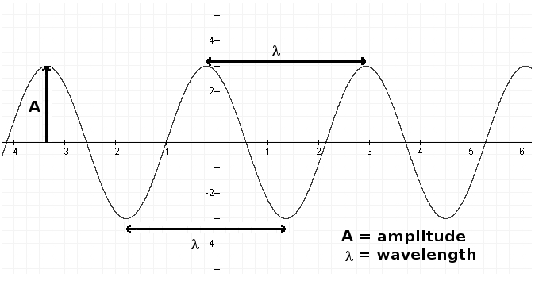

**Answer questions 2 and 3** in your answer packet by comparing the above graph to your data. It may be helpful to look at your printout of the Big Plot.

* We do not have the moons separated. Try to draw a sine curve estimating each moon. Think about how you can tell which moon is which from one time to the next. Once you have done so for all four moons, **answer question 4** in the answer packet.
* An actual image has distances in pixels. We need the distance from Jupiter in astronomical units. The program performs part of this calculation for you, but we need to understand it. If a moon were 77 pixels from Jupiter, **show how you would convert this to astronomical units in question 5**. We measured Jupiter’s diameter in pixels at the start of class. Its actual diameter is 142,000 km, and 1 AU = 1.5 x 108 km.

In the next several steps, you will enter your measurements into the tables in the answer packet.

* Estimate **a** in *Jupiter Diameters* and **P** in *hours* for each moon from your graph. Note: In order of distance from Jupiter, the moons are: Io (closest), Europa, Ganymede, and Callisto. Write this data in Table 1.
* Convert **a** to AU and **P** to years and write these in Table 2.

We're now ready to measure the mass of Jupiter! To do this we are going to use Kepler's 3rd Law:

**M = a3 / P2**

**M** is the mass of the central object (in this case, Jupiter)

**a** is the semi-major axis (which is the *radius*, if the orbit is a circle)

**P** is the period (the time it takes to go around once)

M is the mass of Jupiter, but you can also do this for the Sun if you observe the planets going around to measure **a** and **P**.

* Calculate the mass of Jupiter once for each moon and write in Table 3.
* Calculate the average and write that in Table 3
* Answer the remaining questions in the answer packet.