Under Pressure
Introduction
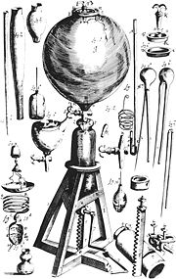Illustration of an air pump used by Robert Boyle for gas pressure experiments in the 1600s.
We live in a particularly crowded region of space with a lot of solid material around us. In reality, the vast majority of matter in the universe is in a gaseous state. So, in order to understand how the universe works, we have to understand how gases behave. In this lab, we will explore the relationship between the temperature of a gas and the pressure that it exerts. We will also calculate the lowest possible temperature and understand why nothing can be colder.
All matter is composed of atoms and molecules. In a solid, they are locked together and are unable to move freely about. In a gas, however, they are not bound to one another and zip around bashing into things. When you blow on your hand, the pressure you feel is the impact of billions of air molecules slamming into your skin.
Temperature is a measure of the kinetic energy of the individual particles that compose a gas. Increasing the temperature increases the average velocity of the atoms and molecules. Faster particles means harder impacts and increasing pressure. Conversely, lowering the temperature slows the velocity of the particles reducing the pressure.
Although we can't bring most astronomical objects into the classroom, we can discover how their component parts behave. The simple relationships explored on the table top in this lab govern many astronomical objects. Stars and gas giant planets hold themselves up because their internal gas pressure counterbalances the gravitational force that would otherwise cause them to collapse. This same balance between gravity and gas pressure determines whether a giant molecular cloud will remain in equilibrium or collapse to form a new planetary system or a new galaxy.
Procedure
For this exercise we will need:
- A laptop running LoggerPro
- A Vernier interface box and pressure sensor
- An Erlenmeyer flask with rubber cork, stopcock, and tubing
- A large beaker
- A hot plate
- A thermometer
- Graph paper
- Clamps etc. to suspend the Erlenmeyer flask

Equipment Setup
- Connect the Vernier equipment to the laptop as shown in the photograph and start LoggerPro. Verify that LoggerPro is reading the pressure.
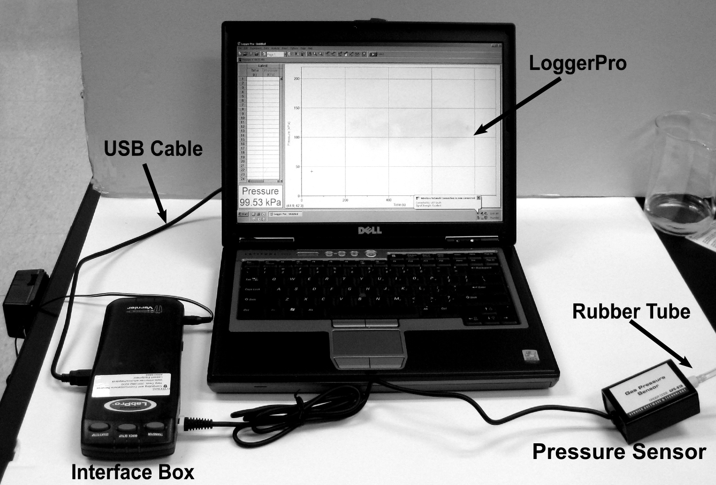
- Firmly place the rubber cork into the mouth of the Erlenmeyer flask.
Make sure that the stopcock is open.

- With the hot plate OFF, set the EMPTY beaker on top of the hot plate.
DO NOT put water in the beaker until step 7.
DO NOT turn the hot plate on until step 10.

- Suspend the Erlenmeyer flask as deeply as possible inside the empty beaker by adjusting the table clamp. The Erlenmeyer flask should not make contact with the beaker anywhere.

- Connect one end of the rubber tube to the connector on the cork without the stopcock. Connect the other end of the tube to the pressure sensor.

- Close the stopcock.

- Carefully fill the beaker to the top with water.

- Put the thermometer in the water.

- When you are done, your apparatus should look like the photograph on the next page.

- Turn the hotplate on to its lowest setting and let the apparatus sit for 5 minutes.

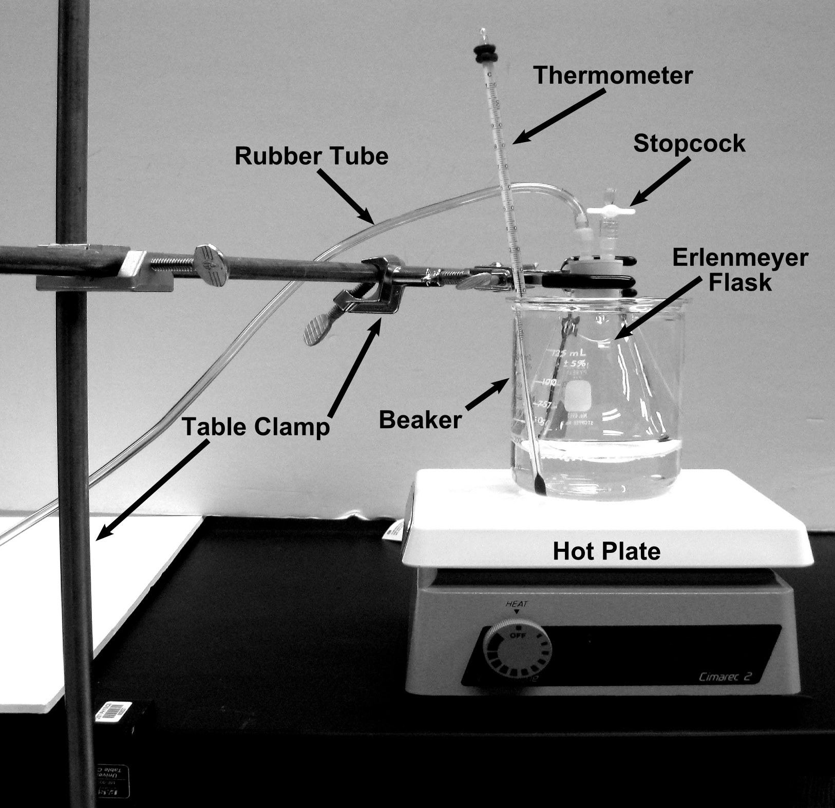
When the equipment setup is done, your apparatus should look like this.
Data Collection

- It is EXTREMELY important that the water temperature does not rise more than about 3 degrees per minute. For the experiment to work, the water and the gas inside the Erlenmeyer flask must be at the same temperature. If the water temperature rises too fast, the gas won't be able keep up, and your data will be bad.

- Record the current time, water temperature, and gas pressure in the data table. Be sure to include units.

- Turn the hotplate up one notch if the water temperature is rising less than 1 degree per minute.

- Allow the temperature rise 4 to 5 degrees. You don't have to wait for the temperature to stop rising.

- Go back to step 2 and continue collecting data until you have at LEAST 15 measurements.
Analysis
Note: You will be graded on both the neatness and completeness of your plot and associated calculations. Show all of your work. Do your initial calculations on scratch paper and transfer them to the graph when you are satisfied that they are correct.

- Plot your data on a piece of graph paper. Make the Y-axis Temperature and the X-axis Pressure. Be sure to label your axis and include UNITS.

- Draw a best fit line through your data.

- The equation of a line is $y=mx+b.$
In our case we have $T=mP+T_{Z}$
where T is temperature, P is pressure, m is the slope of the line, and T_{Z} is absolute zero (the Y-intercept).

Calculate the slope of your best fit line. Clearly mark the points used in the slope calculation on your best fit line. Neatly copy the calculation and the resulting slope onto your plot.

- Calculate the temperature of absolute zero using one of the two points from your slope calculation, the slope that you found in Step 3, and the second equation from step 3. Neatly show your work and the resulting temperature on your graph paper.

