Introduction
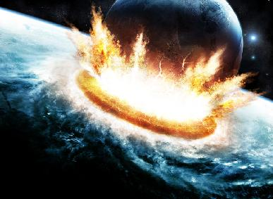
Our goal is to discover the relationship between the energy of a meteoroid smashing into the Earth and the size of the crater it makes. We will use ball bearings as mock meteorites to find the relationship and use that relationship data to make some predictions about impacts from more massive objects.
In the ancient world, meteorites were believed to contain supernatural powers. In the 1790s, E. F. F. Chlandi, a German lawyer and physicist, collected evidence suggesting that meteorites originated in space, but the scientific community rejected his hypothesis. Thomas Jefferson remarked, upon hearing a report from two Yale professors regarding the extraterrestrial origin of a meteorite, "It is easier to believe that Yankee professors would lie, than that stones would fall from heaven".
In 1803, a shower of meteorite fragments hit L'Aigle, France. The notoriously skeptical French Academy of Sciences dispatched renowned physicist Biot, whose investigation concluded that Chlandi's hypothesis had been correct. The idea that 'stones from heaven' existed and originated in space slowly spread through the scientific community.
Today, astronomers call these "stones from heaven" meteoroids when they are traveling through space, meteors while they are passing through Earth's atmosphere, and meteorites when they are on the ground. Most meteors are the size of a marble or smaller and last only a few seconds. An object of this size is usually completely vaporized in the atmosphere. Larger pieces are only partially vaporized and survive as meteorites.

Galileo used the word crater (Greek for cup) to describe the circular pits he observed on the moon. We now know that these craters were caused by impacts. They are the result of the conversion of kinetic energy to thermal and mechanical energy at the moment of impact. This process vaporizes a portion of the rock in the Earth's surface. The resulting explosion propels debris out to form the crater shape.
Every few thousand years the Earth is hit by a meteoroid tens of meters or more in size. An impact from a large meteor produces an enormous blast on impact, propelling debris into the atmosphere. One of the most famous meteor impacts is in northern Arizona about 40 miles east of Flagstaff. The crater is about 1.4 kilometers in diameter and 200 meters deep. Scientists estimate that the meteor was 50 meters in diameter and hit the earth about 50,000 years ago.
There is also evidence that at the end of the Cretaceous period (about 65 million years ago) an asteroid or comet hit the earth and caused the extinction of the dinosaurs. This hypothesis is based on traces iridium (an element often found in meteroiods) and shocked quartz (created in cataclysmic impacts) in a layer of clay from 65 million years ago. The "smoking gun" is a fossilized crater centered on the town of Chixulub, a small town in Yucatan, Mexico. The size of the crater (150 kilometers in diameter) suggests that the meteorite was approximately 10 kilometers in diameter.
A 10 kilometer meteoroid of this size would produce an explosion equivalent to several billion nuclear weapons. The impact not only created the crater, but blasted substantial amounts of dust and molten rock into the atmosphere. The molten rock would have started fires and the hot fragments would have created poisonous gases that, when combined with water in the atmosphere, would result in acid rain. The nitric acid rain and the dust in the atmosphere would have dropped the temperature of the Earth substantially, causing mass extinctions.

Part 1 – Gathering Data and Plotting
When we lift the ball bearing above the sand and release it, several energy transfers take place:
- Chemical potential energy (from food) into kinetic energy of our muscles.
- Kinetic energy from our muscles into gravitational potential energy of the ball.
- Gravitational potential energy of the ball into kinetic energy of the ball.
- Kinetic energy of the ball into ?
The gravitational potential energy of an object is expressed as
$$PE=mgh$$
where m is the mass in grams, g is the acceleration due to gravity in centimeters per second squared, and h is the height above the ground in centimeters.
The kinetic energy of an object in motion is expressed as.
$$KE=\frac{1}{2}{mv}^{2}$$
where m is the mass in grams and v is the velocity in centimeters per second.

Supplies
We are going to gather crater size data by dropping ball bearings into a sandbox. You will need:
- A box of sand
- A two meter stick
- A centimeter ruler
- Three ball bearings of different masses.
Procedure
- Weigh your three ball bearings on the scale. Record the results in Table 1.
- You will drop each of the three balls from three different heights. You are free to choose the three heights, but make sure that at least one is less than one meter and at least one is greater than one meter and that all are LESS THAN TWO METERS. Record the heights in Tables 2, 3, and 4.
- Perform the trials by dropping the ball bearings. Measure each crater using your centimeter ruler and record its size in the appropriate spot in Table 2, 3, or 4.
- Calculate the potential energy of each trial. Record your answer in scientific notation and limit yourself to 3 significant figures.
- The relationship between energy and crater size is non-linear, so we will plot our data on log-log paper. If you are unfamiliar with log-log paper, your lab instructor will assist you. Plot each trial on Graph 1.

Part 2- Analysis
Two quantities are correlated if the value of one can be estimated from the value of the other. For example, the height and weight of people are correlated; tall people tend to weigh more than short people. It is extremely rare to find a person 6'6" tall who weights only 50 Ibs. Likewise, it would be unlikely to find a person 4' 6" who weighs 400 Ibs.
One way to show a correlation is by looking at a graph of with one quantity on the x axis and one on the y axis. If a pattern emerges, then a correlation exists and knowledge of one value can be used to predict the other.
Procedure
- Draw a best fit line through your data points. Extend the line past the top and bottom of the graph.
- Using your best fit line, find the crater diameters when the energy is 1x10⁵ ergs and 1x10⁸ ergs. Record the results at the bottom of Graph 1.
- Plot the two points that you recorded at the bottom of Graph 1 onto Graph 2. The gray box on Graph 2 is the area that Graph 1 would occupy. Draw a line on Graph 2 connecting these two points and extend it to the top of the graph.
- Answer the questions after the graphs.

Ball Bearing | Mass
#1
#2
#3
Table 1- Ball bearing masses

Trial Number | Height  (cm) | Crater Diameter  (cm) | Energy  (ergs)
1
2
3
Table 2- Trials for Ball Bearing #1

Trial Number | Height  (cm) | Crater Diameter  (cm) | Energy  (ergs)
1
2
3
Table 3- Trials for Ball Bearing #2

Trial Number | Height  (cm) | Crater Diameter  (cm) | Energy  (ergs)
1
2
3
Table 4- Trials for Ball Bearing #3
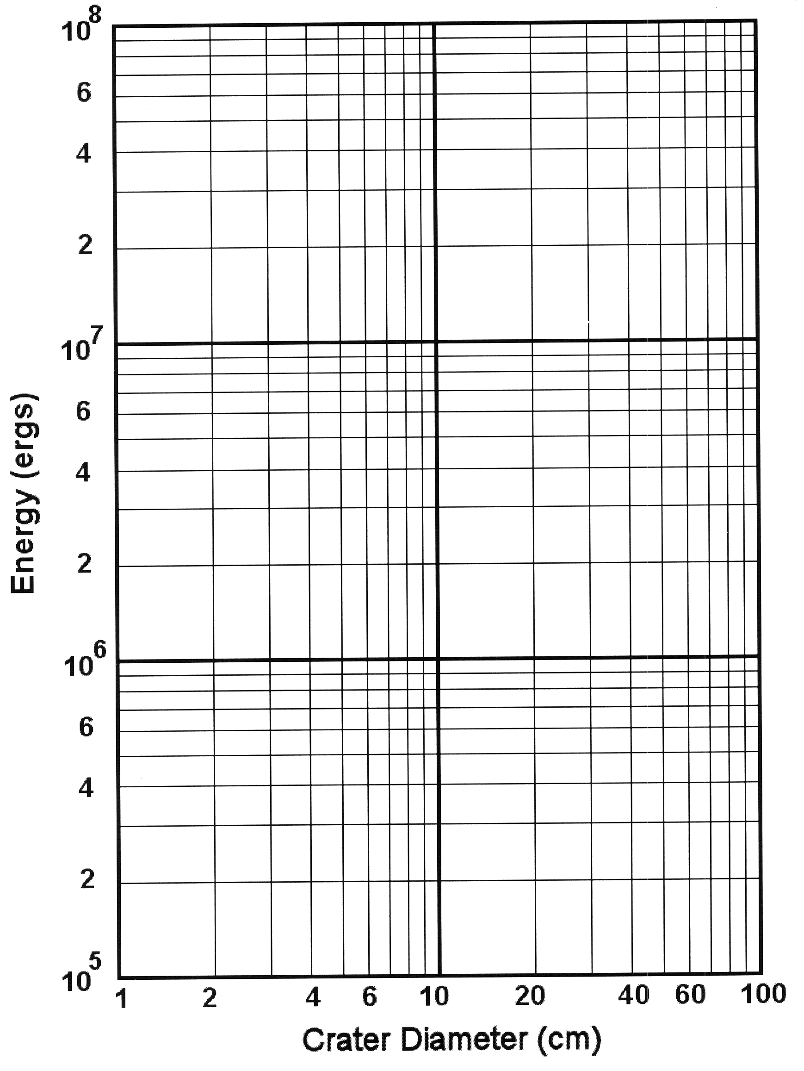
Graph 1

Crater diameter when Energy = 1x10⁵ ergs: ______________

Crater diameter when Energy = 1x10⁸ ergs: ______________
Graph 2
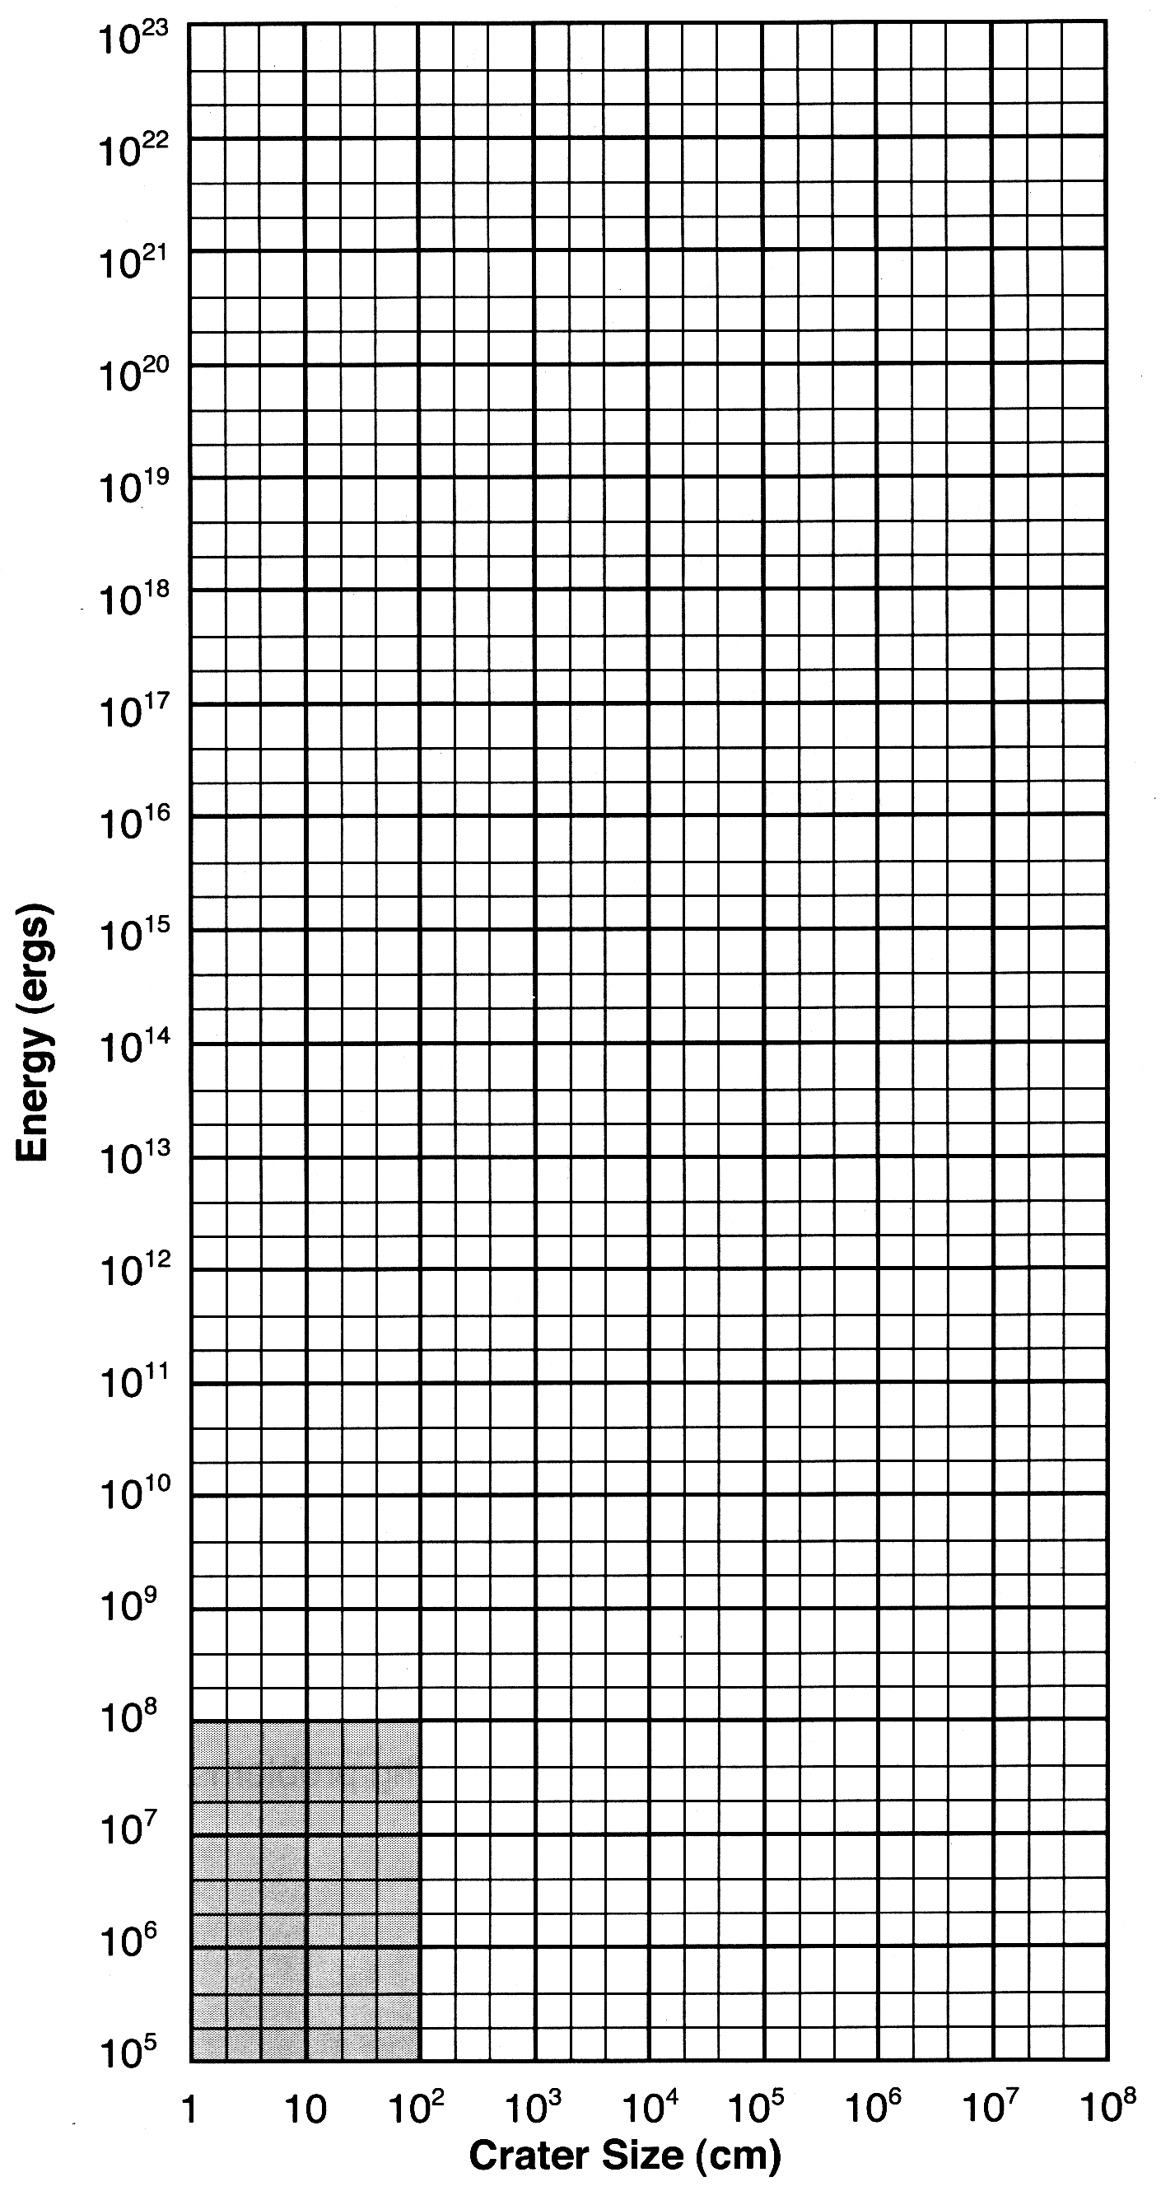
Questions

- Does the correlation that you observed on Graph 1 make physical sense? Explain.

- Are there any points that do not follow the correlation? If so, can you think of a reason why?

- Calculate the energy of ball bearing #3 dropped from two meters. Use your best fit line on Graph 1 to predict the crater size.
SHOW YOUR WORK!

- Drop ball bearing #3 from two meters. Did your prediction in question 3 work? How far off was it? What are the possible sources of error? Don't just say "Human Error." Think about the precision of your measurements.

In the next few questions, we'll try to estimate the size meteor that created Meteor Crater in Arizona.

- Meteor Crater is approximately 1.4 km across. Using your line on Graph 2, estimate the energy needed to create such a crater. Record your answer here.

- Geologists estimate that about 1x10²³ ergs of energy were required to create the impact. Do you get the same answer?

Your answer is probably low. Why does this experiment underestimate the crater size? Think about where the kinetic energy of the impact is going in the sandbox versus in a large impact with the Earth.

- Let's assume that the meteoroid was going at normal orbital speeds. Calculate the orbital speed of the Earth going around the Sun in miles per hour. Convert your answer into cm/s.
SHOW YOUR WORK!

- Using your calculated orbital speed and the equation for kinetic energy, estimate the mass of the impactor.
SHOW YOUR WORK!

Turn in one copy of this lab with each group member's printed name and signature. By signing, you certify that you have actively participated in the exercise and have put forth effort in equal share to your fellow group members.

Printed Name Signature

______________________ _____________________

______________________ _____________________

______________________ _____________________

______________________ _____________________

