The Orbit of Mars
Introduction

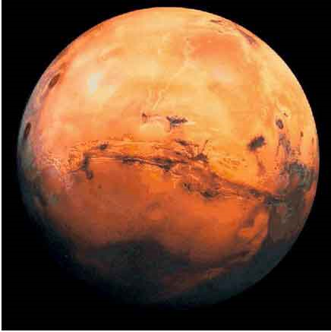
The relatively large eccentricity of Mars' orbit makes its elliptical shape relatively easy to study. Johannes Kepler said that, to discover the secret of the cosmos, we must use the motion of Mars; "otherwise, it would remain eternally hidden."

Mars and the Earth come close to each other (called opposition) about every two years. Because Mars' path around the Sun is elliptical, some oppositions are nearer than others. The closest oppositions occur about 15 years apart. At a particularly close one in 1877, Asaph Hall discovered the satellites of Mars and Giovanni Schiaparelli first observed the canali on its surface. At another favorable opposition in 1894, Percival Lowell made a big splash with his theory of intelligent life on Mars.

Although the Martian orbit has an appreciable eccentricity, it is a mistake to think of its shape as an obvious ellipse. It looks much more like a circle that is oddly off-centered from the Sun. In this exercise we will investigate the elliptical nature of Mars' orbit by employing some data from Tycho Brahe and following the method invented by Kepler in the early 1600's,

Kepler had been in Prague only a few weeks when he began to developed a particularly ingenious geometrical method to establish Mars' orbital path. He knew that the period of Mars' orbit is 687 days while the period of Earth's orbit is only 365 days. Hence, if Mars were observed at a particular point in its orbit, it would be back at the same spot in 687 days, but the Earth would not have completed its second revolution. Mars could therefore be sighted from a slightly different vantage point. Using triangulation, the precise position of Mars with respect to the Earth and Sun can be determined.

Procedure
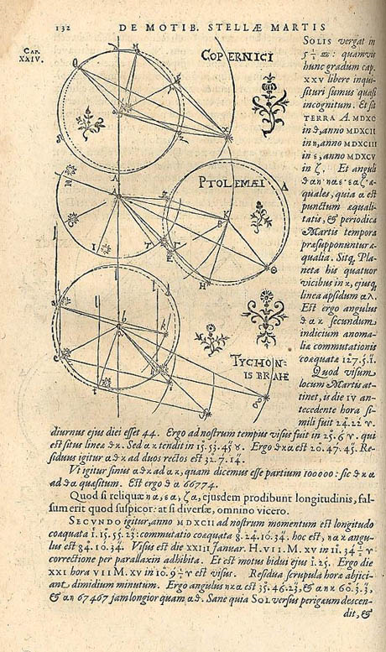A page from Kepler's book Astronomiae Nova (A New Astronomy) illustrating his method for determining the orbit of Mars.

For this exercise we will need:
- a protractor
- a centimeter ruler
- a compass
- a piece of graph paper.

- Find the center of your graph paper. This is the location of the Sun.

- Using your compass, draw a circle with a radius of five centimeters. This circle represents the Earth's orbit.

- Draw a horizontal line (parallel to the bottom edge of the paper) from the Sun to the right-hand edge of the graph paper. This represents the direction of the Sun as seen from the Earth at the time of the vernal equinox.

- Center the protractor on the Sun and align it so that the vernal equinox line is at 0°. Now mark off the heliocentric longitude of the Earth on each date in the table and label the date.
**Be sure that the angles are increasing counterclockwise**

- Next, for each observation, center the protractor on the Earth and align 0° in the direction of and parallel to the vernal equinox and mark off the geocentric longitude of Mars. Draw a straight line from Earth in the observed direction of Mars.
**Be sure that the angles are increasing counterclockwise**

- For each pair of observations, the position of Mars lies at the intersection of the lines drawn in Step 5.

- Kepler chose perihelion and aphelion as the first two sets of observations. A line connecting them (and intersecting the Sun) represents the semi-major axis of the orbital ellipse. Draw the best possible line connecting these three points and find its midpoint.

- Using your compass, approximate the orbit of Mars by drawing a circle centered at the midpoint of the semi-major axis. Using simple ratios, find the length of the semi-major axis of Mars' orbit in AU (Astronomical Units). Record this number in the lower left corner of your diagram.

- The eccentricity, e, of the orbit is:
$$e=\frac{\text{Sun to Midpoint Distance}}{\text{Semi-Major Axis Length}}$$
Calculate the e (make sure to convert the Sun to Midpoint distance to AU) and record it in the lower left corner of your diagram.

Date | Heliocentric Longitude of Earth | Geocentric Longitude of Mars
Feb. 17, 1585 | 159° 23' | 135° 12'
Jan 5, 1587 | 115° 21' | 182° 08'
Sep 19, 1591 | 5° 47' | 284°18'
Aug. 6, 1583 | 323° 26' | 346° 56'
Dec 7, 1593 | 85° 53' | 3° 04'
Oct 25, 1595 | 41° 42' | 49° 42'
Mar 28, 1587 | 196° 50' | 168° 12'
Feb 12, 1589 | 153° 42' | 218° 48'
Mar 10, 1585 | 179° 41' | 131° 48'
Jan 26, 1587 | 136° 06' | 184° 42'

Questions

- Why does the closest opposition of Mars always occur in August?

- What is the minimum distance between Mars and the Earth in AU?

- What is the heliocentric longitude of Mars at perihelion? At aphelion?

Turn in one copy of this lab with each group member's printed name and signature. By signing, you certify that you have actively participated in the exercise and have put forth effort in equal share to your fellow group members.

Printed Name Signature

______________________ _____________________

______________________ _____________________

______________________ _____________________

______________________ _____________________

