Mapping the Solar System From Earth

Background: Some newspapers and science magazines, such as Sky and Telescope, provide sky charts that describe what sky objects are visible at different times. These typically include prominent stars, bright planets, and the Moon. There are two principle maps provided to readers: (1) a geocentric horizon view and (2) a heliocentric orrery view. The geocentric perspective is the view from Earth looking up into the southern sky. The heliocentric perspective is the view of the Solar System looking down from above. From above the north pole, the plants orbit and spin counter-clockwise (except Venus, which appears to spin backwards).

Part I: Rising and Setting Times
Figure I-a: Observer Positions on Earth
[Observer is at Equator]

As seen from above the north pole, Earth appears to rotate counterclockwise. Figure I-a shows a top view of Earth and an observer at noon. Note that our Sun appears overhead at noon when standing at the equator.

- In Figure I-a, sketch and label the positions of the observer at midnight, 6 pm (sunset) and 6 am (sunrise).

- Consider Figure I-b, which shows Earth, Moon, Mars, and Venus. At what time would each of these sky objects be overhead? Remember that Earth spins counter-clockwise when viewed from above. [Hint: Make use of Figure 1a]
Figure I-b: Orrery

Time Overhead:

Venus: ____________________

Moon: ____________________

Mars: _____________________

- If Earth spins in 24 hours, that means that each sky object is visible for about 12 hours. What time will the sky objects shown in Figure I-b rise and set? Complete the table below? Each member of your team should fill in the data for one sky object.

Sky Object | Rise Time | Time Overhead | Set Time
Sun
Venus
Moon
Mars

- Using complete sentences, explain why our Sun is not visible at midnight. Add a sketch of Earth, Sun, and observer in the space provided to support your explanation.

Narrative | Sketch
Part II: Converting Geocentric to Heliocentric

- Figure II-a shows the horizon view of the first quarter Moon and Saturn visible at sunset. On the orrery shown in Figure II-b, sketch and label the position of Jupiter, Moon and Saturn. Use an arrow to indicate the direction to our Sun. Start by indicating the position of the observer at sunset. After completing the diagram, complete the table on the next page.

Figure II-a: Horizon View at Sunset (6 pm)

Sky Object | Rise Time | Set Time
Sun
Jupiter
Moon
Saturn

- If Neptune is visible overhead in the southern sky at sunrise (6 am) sketch the relative positions of Sun, Earth, Neptune, and observer in an orrery in the space below.

Part III: Converting Heliocentric to Geocentric

- Figure III-a shows the position of Mercury, Venus, Earth, Mars, and Moon. On the horizon diagram, Figure III-b, sketch and label the positions of Mercury, Venus, Mars, a comet, and Moon at midnight.

- Venus is often called the morning star or the evening star. Why is it never seen at midnight?

Part IV: Mapping Mars’ orbit

Now that we know how we see things in the sky, we can try to use those ideas to figure out how they move. Johannes Kepler (1571-1630) had the goal of developing an accurate mathematical description of the motions of the planets, a goal that he did eventually achieve. However, first he needed to determine exactly what those motions were and, unlike most astronomers before him, Kepler chose to look only at that data to answer this question without relying on any underlying philosophical models. We will look now at how Kepler used Tycho’s data to determine the true orbit of Mars.

Procedure: Kepler’s approach was very clever. He knew that the Earth goes around the Sun every 365.25 days and was able to work out the correct numbers for the other planets as well. For instance, Mars goes once around the Sun every 687 days, which is about one and seven eighths Earth years. The table at the bottom of the final page gives matched data for eight different locations of Mars around its orbit. Mars is in the same location for both observations (taken 687 days apart) but Earth is in different locations. Your task is to use this data to plot Mars’ path around the Sun by finding these eight locations on the scale diagram. Mars position 3 has been done for you using the following procedure.

Suppose that we observe Mars on January 1 at which time the Earth is at position C in the figure on the final page. Mars is observed at an angle of 10° using the coordinate system on the figure.
If you draw a straight line beginning at position C at 10°, Mars must lie somewhere along that line. Mars is next observed 687 days later, in mid-November, when Mars has returned to the same location but Earth is now at position B. From Earth, Mars now appears to lie at an angle of 53°. If you draw a straight line beginning at position B at 53°, Mars must lie somewhere along that line. The intersection of your two lines pinpoints Mars location on both dates and gives you one point in its orbit.

Use the remaining data to locate seven additional points along Mars’ orbit making sure that each member of the group finds at least one point (this should take a total of 10-15 minutes). When you have all the points, sketch in the approximate path of Mars during this time interval—you will only have about half an orbit.

- From your map, estimate the radius of Mars’ orbit in Astronomical Units. (Hint: Measure the approximate radius of Mars’ orbit and divide that by the approximate radius of Earth’s orbit).

- Which one of the eight points in Mars’ orbit was most prone to error? Why?

- In the orbit you have drawn, there is no epicycle evident. Why not?

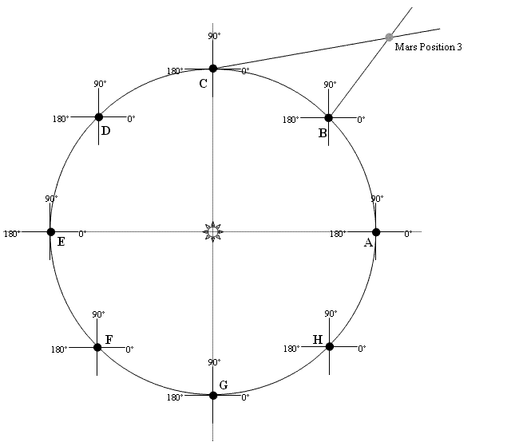

Mars Position | Earth’s Position | Bearing to Mars | Earth’s Position One Martian Year Later | Bearing to Mars
1 | A | 0 | H | 38
2 | B | -4 (or +356) | A | 55
3 | C | 10 | B | 53
4 | D | 34 | C | 46
5 | E | 62 | D | 58
6 | F | 93 | E | 82
7 | G | 124 | F | 109
8 | H | 155 | G | 139

