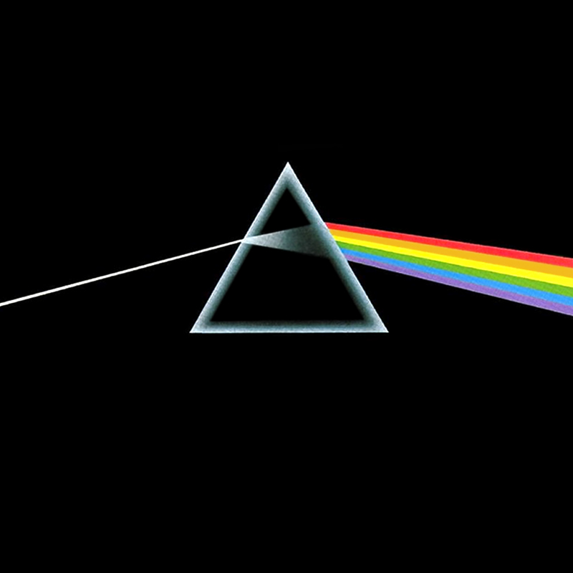
Background
Astronomers are in a very peculiar situation for scientists. They generally can't plan their own experiments. Instead, they must simply observe the experiments that nature provides for them. It is therefore critical to get as much information as possible from each drop of light that enters their telescopes. Today we’ll look at several of the ways that astronomers extract information from the light that they receive.
Light is odd. Sometimes it behaves like a wave, sometimes it behaves like a particle, and it always travels at the same speed regardless of the speed of the object that emitted it. Because of its wave-like nature, we assign wavelike terms to it. The color of light is determined by the wavelength of the wave. The wavelength of a wave is the distance between one crest and another. If we count the number wave crests that pass us in one second, we will have measured the frequency of the wave. Wavelength and frequency are related by the velocity of the wave.
Light also behaves like a particle. It comes in discrete little packets known as photons. Each photon has a distinct color (or frequency, or wavelength). Astronomers often use wavelength to refer to the color of a photon. The spectrograph that you'll use in lab measures the wavelength of the incoming light. It seems a little strange to assign a wave-like word like wavelength to something that behaves like a particle, but it's equally strange to assign particle like behavior to something that behaves like a wave. But, light is a just a little bit strange.
The particle like nature of light is extremely useful for describing emission lines from a gas. The atoms in the gas only absorb and emit photons of very particular colors (or wavelengths). Each element has a unique set of preferred colors. By examining the emission lines, we can decipher the composition of the gas from far away. How handy!
Part I – Lab Spectra
We’ll begin by looking at several light sources in the lab with a spectrograph. Because we believe the laws of physics are universal, we assume that objects in space obey the same laws as objects in our laboratory. By comparing spectra of the lab sources with spectra of actual stars, astronomers can determine the star’s chemical composition, temperature, and velocity.

- Get used to using the spectroscope by looking at an incandescent light and the fluorescent lights.

- Calibrate your spectrograph by looking at a hydrogen lamp. Look at the hydrogen tube and record the wavelengths of the emission lines that you see.

Find the same lines on the chart in the lab and record the actual wavelengths of those lines.

Use the information from steps 1 and 2 to calibrate your spectroscope adjust the scale in your spectrograph so that the hydrogen lines show up at the proper wavelenghts.

- Observe a hot dense object, like a tungsten filament of an incandescent light, with your spectroscope. An incandescent light emits like a blackbody and it should show you the entire visible spectrum.

Record on your worksheet the wavelength range for each of the following colors: Red, Orange, Yellow, Green, Blue, Indigo, Violet.

- Frequency is a measure of how many wave peaks per second are received by an observer. The wavelength of visible light is very short (and light moves very quickly) so many wave crests enter your eye each second. The wavelength and frequency are related by:

Wave speed = wavelength times frequency or c = λν

where c is the speed of the waves, f is the frequency in cycles per second (also called Hertz, Hz) and λ is the Greek letter lambda that stands for the wavelength. Using this equation and the knowledge c is 3x10⁸ meters/second, Calculate the frequency of each color of light.

Now we will look at some emission line spectra. Emission lines arise from diffuse gases that are somehow excited. They are often produced by clouds of gas near a particularly hot star. The Orion Nebula is a place where many hot young stars exist and the surround gas produces many emission lines.

- Look at the spectra of Mercury, Neon, and the Mystery Gas and carefully record the wavelengths of their emission lines.

- Using the chart on page 7, determine the color of each line.

- Using the spectrum chart in the lab, identify the mystery gas.

Part II - Interpreting Spectra
Next we’ll look at some simplified stellar spectra. These spectra can be used to measure the surface temperature of the star. A real stellar spectrum is a blackbody spectrum with absorption lines superimposed. In this section, we are only concerned with the blackbody part of the spectrum.
Wien’s Law relates the wavelength (color) at the peak of the blackbody to the surface temperature of the emitter:
λ_{max} x T_{surface} = 2.9x10⁶ K•nm
Here, λ_{max} is the wavelength (color) of the peak intensity and T_{surface} is the temperature of the stellar surface. The number 2.9x10⁶ is a constant.
Astronomers use a historical classification system to identify stars known as the Spectral Class. Among other things, this system associates the surface temperature of a star with a letter in the sequence 0 B A F G K M. O stars have very high surface temperatures while M stars have very low surface temperatures. The table below gives the spectral class associated with a range of surface temperatures.

Spectral Class | Surface Temperatue
O | > 28,000 degrees
B | 10,000 - 28,0000
A | 7,400 - 10,000
F | 6,000 - 7,400
G | 4,900 - 6,000
K | 3,500 - 4,900
M | < 3,500

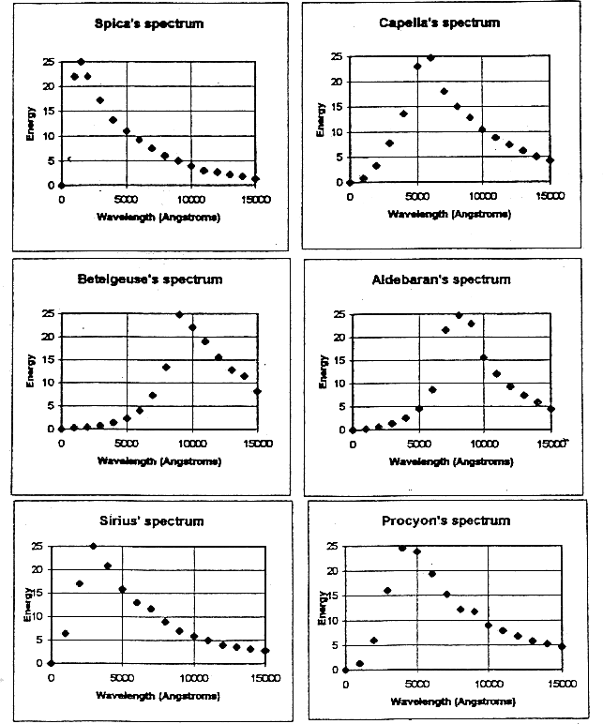

1. Using Wien's Law, calculate the surface temperature of each of the six stars. Record your answers in the table on your data sheets.

2. Identify the spectral class for each of the six stars.

3. Find λ_{max} and the associated color for the Sun and Vega.

