Physics 104- Astronomy
Measuring the Sky

Part 1- Measuring angles

Objects in the night sky appear to be imprinted on a two dimensional sphere called the celestial sphere that surrounds the Earth. Astronomers use angles to measure the relative positions of objects on the celestial sphere. We are going to learn to use a ruler held at arms length to measure angles.
Using a meter stick, measure the distance between your eyeball and the end of your thumb, as in the picture above. Have each group member read the yardstick for you and record the results in the table below. Calculate the average and record it in the table below.

Group Member | GM1 | GM2 | GM3 | GM4 | Avg

Holding a clear ruler at arms length, the markings on the ruler tell us the "distance" between two distant points. According to the rules of trigonometry, the study of triangles, if the angular size is small we can write

where

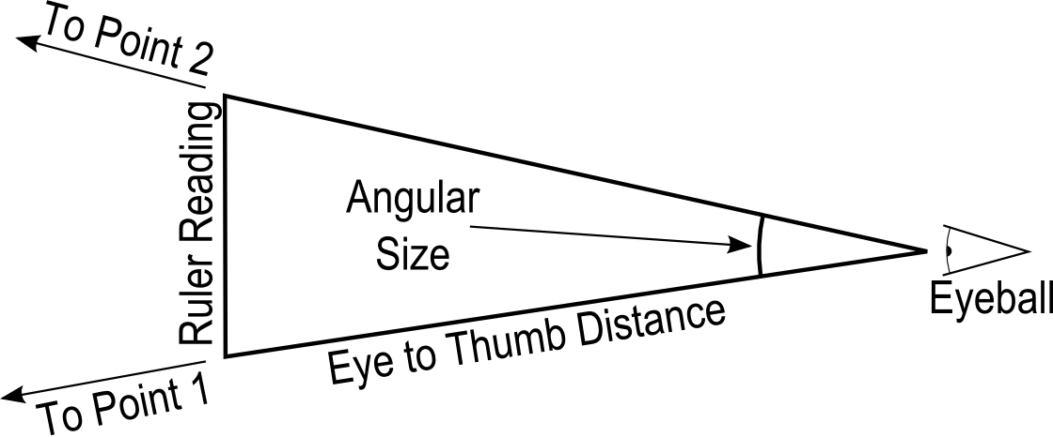
Using your Average Eye to Thumb distance from page one, calculate your personal Conversion Factor and record it on the next page.

Now calculate the angular size of our hand, fist, thumb, and pinkie. First, use your ruler to measure the distance between your outstretched pinkie and thumb, the width of your closed fist, and the widths of your thumb and pinkie. Use your personal conversion factor to calculate their angular sizes. Record all of this information on the table on the next page.

Personal Conversion Factor: ____________ (Degrees/cm)

 | Size  (cm) | Angular Size  (Degrees)
Outstretched Hand
Closed Fist
Thumb
Pinkie

Take a two meter stick out into the hallway and measure its angular size at four different distances using each of the measurement tools that we've just devised.

Distance | Hand |  | Fist |  | Thumb |  | Pinkie |  | Ruler
Distance | # | Angle | # | Angle | # | Angle | # | Angle | cm | Angle
1/4
2/4
3/4
4/4

Answer the following questions.
1. What happens to the angular size of the two meter stick as it is moved further away?

2. Which measuring instrument achieves the most accurate results? Why?

3. What would the angular size of the meter stick be if it were 100 km away? How many centimeters is that on your ruler? Could you accurately measure that angle? Why or why not?

4. Imagine that two photons leave a star 4 light years away. If the photons hit opposite sides of our planet, what was their angular separation as they left the star?

5. What does question 4 suggest about the lines of sight from the surface of the Earth to the stars?

Part 2- The Sun and the Zodiac

Over the course of a year, the Sun's apparent position among the background stars changes. In this section, we'll explore why this is true.

On the back wall of the room, the positions of two "constellations" are marked on the wall. In the front of the room are three tape marks representing where the Earth is in its orbit on three different dates, one for February 1st, one for March 1st,and one for February 15th. The "Sun" is on the table in the center of the room. Have each group member stand on each of the three tape marks and use your ruler to measure the angular distance between the Sun and the two constellations.

February 1st
 | GM1 | GM2 | GM3 | GM4 | Avg
Capricorn
Aquarius
February 15th
Capricorn
Aquarius
March 1st
Capricorn
Aquarius

Answer the following questions
1. How fast (in degrees per hour) does the sky appear move due to the Earth's rotation?

2. If the Sun is at Meridian on February 15th, how long (in minutes) will it be before Aquarius crosses the meridian?

3. How fast (in degrees per day) does the Sun's position appear to change with respect to the background stars?

4. Why does the Sun's position against the background stars appear to change?

Part 3- The Sun's Coordinates

The sky, from our perspective, is two dimensional. To locate an object on a two dimensional surface, we need two numbers or coordinates. On this piece of paper, our coordinates might be the horizontal and vertical distance from the lower left corner. On the celestial sphere, however, we use angles.

Because we're stuck to the Earth's surface, it feels natural to measure positions with respect to our local horizon. An object's height above the horizon is its altitude. The horizon is at 0⁰ degrees and zenith is at 90⁰. Direction (North, South, East, West) is called azimuth. North is 0⁰, East is 90⁰, South is 180⁰, and West is 270⁰.
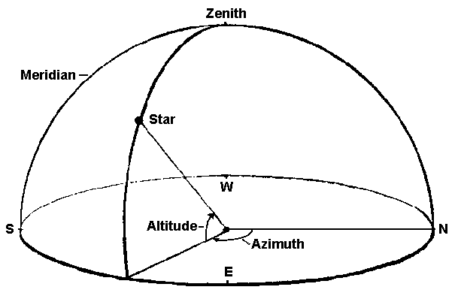

The altitude and azimuth of a given celestial object is not fixed. The altitude of Polaris is 90⁰ at the North Pole but 0⁰ at the equator. In St. Paul, the Sun is low in the East in the morning, high in the South at noon, and low in the West in the evening.

We need a coordinate system that is fixed to the sky. Astronomers use a system whose axis are parallel to the lines of longitude and latitude on the Earth. The lines of latitude are called lines of declination. The lines of longitude are called right ascention. The Celestial Equator is 0⁰ declination and the North Celestial Pole is 90⁰ declination. Right ascension is 0⁰ at the position of vernal equinox and increases Eastward.
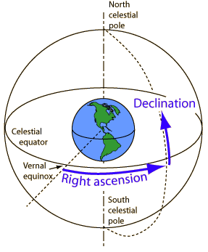
Because the Earth's axis is tilted 23⁰ with respect to the ecliptic, the Sun's declination changes throughout the year. This means that the Sun's altitude at meridian as well as its azimuth at sunset change throughout the year. Assume that you're in St. Paul (44⁰ North Latitude) and use the picture below as a guide to complete the following table:

Date | Declination | Altitude at Meridian | Sunset Position
Vernal (spring) equinox (March 21st) |  |  | Due West
Mid-May  (approximately) | 12⁰
Summer Solstice  (June 21st) | 23⁰
Autumnal equinox (September 22nd) |  | 44⁰
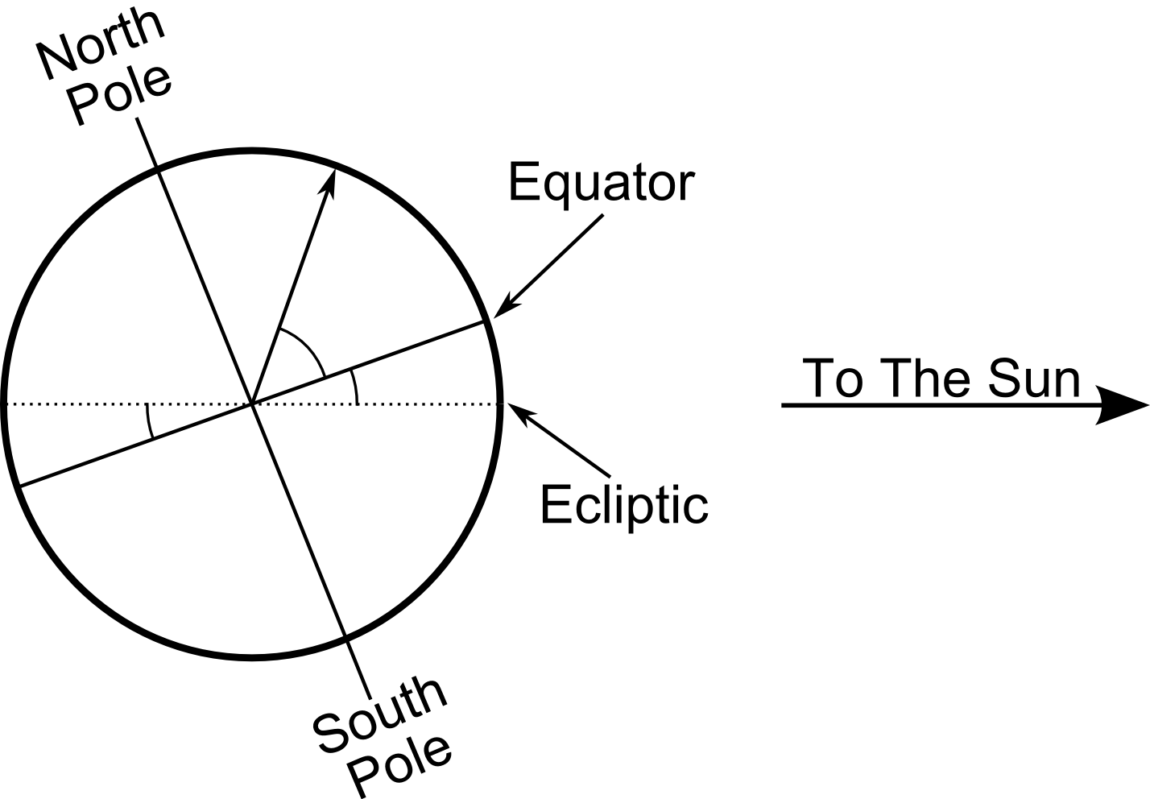  Mid-November (approximately) |  | 32⁰
Winter Solstice  (December 21st) |  |  | South of West

Turn in one copy of this lab with each group member's printed name and signature. By signing, you certify that you have actively participated in the exercise and have put forth effort in equal share to your fellow group members.

Printed Name Signature

______________________ _____________________

______________________ _____________________

______________________ _____________________

______________________ _____________________

