Physics 104- Astronomy
Measuring the Sky

Part 1- Measuring angles

Because the distance to celestial objects is so large, from our perspective they appear to be imprinted on a two dimensional surface in the night sky. This two dimensional surface appears as a great dome over our heads. If we could remove the Earth, we would appear to be surrounded by a great sphere, known as the celestial sphere. To describe the position of objects on the celestial sphere, Astronomers use angular measurements. In this lab, we are going to learn how to measure the angular separation of various objects and develop an understanding of the relationship between angular separation and distance.

Step 1- Calibrate
One way to measure angles is to use a clear ruler held at arms length. But, rulers are marked in centimeters and angles have units of degrees so we need a way to convert centimeters from the ruler to an angle in degrees.

1. Have each of the other members of your group use a meter stick to measure the distance between your eyeball and the end of your thumb, as in the picture below. Record the result in the table below and then calculate the average.
Names  (Across and down) |  |  |  |  | Avg
Table 1 – Put all group member names in the first row AND in the first column. On your row, have each of your group members measure your eye to thumb distance. You can't measure your own, so that cell is blacked out

To convert the reading on a ruler held at arms length to degrees, we us the rules of trigonometry, the study of triangles. If the angle being measured is small we can write:
$$\text{Angular Size (in degrees)}≈\text{Ruler Reading}×\text{Personal Conversion Factor}$$
where
$$\text{Personal Conversion Factor}=\frac{180}{π×\text{Eye to Thumb}}$$

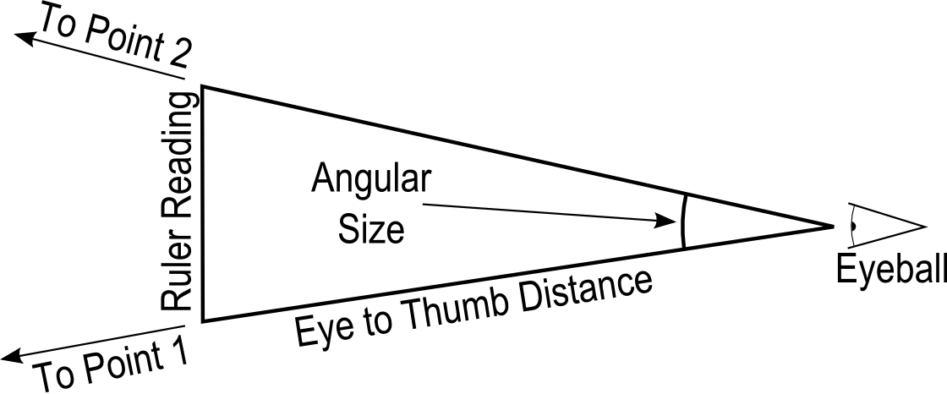

2. Use your Average Eye to Thumb distance from Table 1 and the formula on the previous page to calculate your Personal Conversion Factor. Record your personal conversion factor below.

Personal Conversion Factor: ____________ (Degrees/cm)

Step 2 – Measure

Now we will use our ruler held at arms length to measure the Angular Size of a meter stick positioned at several distances.

1. Have one group member hold a meter stick at each of the three distances indicated in Table 2.

2. Hold your ruler at arms length and measure the apparent length of the meter stick in centimeters for each distance. Record the results in Table 2.

3. Use your Personal Conversion Factor to convert each ruler reading (in centimeters) to angular size (in degrees).

Distance | Ruler Reading (cm) | Angular size (Degrees)
10m
15m
20m
Table 2

Step 3 - Answer the following questions:
1. What happens to the angular size of the meter stick as it is moved further away?

2. What would the angular size of the meter stick be if it were 100 km away? How many centimeters is that on your ruler? Could you accurately measure that angle? Why or why not?

3. Imagine that two photons leave a star that is 4 light years away. If the photons hit opposite sides of our planet, what is the angular separation of the photons? (R_{Earth} = 12,700 km, 1 Lyr = 9.4x10¹² km)

4. What does question 4 suggest about the lines of sight from the surface of the Earth to the stars?

Part 2- The Sun and the Zodiac

Over the course of a year, the Sun's apparent position among the background stars changes. In this section, we'll explore why this is true.

On the back wall of the room, the positions of two "constellations" are marked on the wall. In the front of the room are three tape marks representing where the Earth is in its orbit on three different dates, one for February 1st, one for March 1st,and one for February 15th. The "Sun" is on the table in the center of the room.

1. Have each group member stand on each of the three tape marks and use your ruler to measure the angular distance between the Sun and the two constellations. Record the measurement in centimeters in Table 3.

Angular separation in CENTIMETERS
February 1st
Names:
Capricorn
Aquarius
February 15th
Capricorn
Aquarius
March 1st
Capricorn
Aquarius
Table 3 – Separation in centimeters
2. Use your Personal Conversion Factor to convert the values in Table 4 into degrees. Record the results in Table 5.

Angular separation in DEGREES
February 1st
 | GM1  (deg) | GM2  (deg) | GM3  (deg) | GM4  (deg) | Avg  (deg)
Capricorn
Aquarius
February 15th
Capricorn
Aquarius
March 1st
Capricorn
Aquarius
Table 4 – Separation in degrees

Answer the following questions
1. How fast (in degrees per hour) does the sky appear move due to the Earth's rotation?

2. If the Sun is at Meridian (exactly halfway across the sky) on February 15th, how long (in minutes) will it be before Aquarius crosses the meridian?

3. Why does the Sun's position against the background stars appear to change?

4. How fast (in degrees per day) does the Sun's position appear to change with respect to the background stars?

Turn in one copy of this lab with each group member's printed name and signature. By signing, you certify that you have actively participated in the exercise and have put forth effort in equal share to your fellow group members.

Printed Name Signature

______________________ _____________________

______________________ _____________________

______________________ _____________________

______________________ _____________________

