Revolution of Jupiter's Moons

Turn in one copy of this lab with each group member's printed name and signature. By signing, you certify that you have actively participated in the exercise and have put forth effort in equal share to your fellow group members.

Printed Name Signature

______________________ _____________________

______________________ _____________________

______________________ _____________________

______________________ _____________________

Part 1
What is the relationship between orbital period and orbital velocity?

1. Develop a definition of orbital period.

2. Develop a definition of orbital velocity.

3. The planet Earth has an orbital period of 365.25 days. Assuming that the orbit is perfectly circular and that Earth is 92.956 million miles from the Sun, calculate the orbital velocity of the Earth in miles per hour.

Given Kepler's Third Law, $a^{3}{\text{=P}}^{2}$, and assuming circular orbits, what happens to the orbital velocity and orbital period of a planet when the orbital radius is increased?

4. If the orbital radius increases, does the orbital period increase, decrease, or stay the same?

5. If the orbital radius increases, does the orbital velocity increase, decrease, or stay the same?

6. Given the stated starting values, predict the orbital velocity that will maintain a circular orbit if the initial orbital radius is doubled.
In the table, X-Pos represents the orbital radius and Y-Vel represents the orbital velocity.

Given the generalized version of Kepler's Third Law,

$a^{3}{\text{=P}}^{2}\frac{G\left(\text{M+m}\right)}{4π^{2}}$,

what happens to the orbital velocity and orbital period of a circular orbit if the central mass is increased?

7. At what mass did you see wobble in the central mass? Do you expect the Earth to cause significant “wobble” in the Sun?

8. Looking at the equation above, if the central mass increases, does the orbital period increase, decrease, or stay the same in order to maintain a circular orbit at the same distance?

9. If the central mass increases, does the orbital velocity increase, decrease, or stay the same in order to maintain a circular orbit?

10. Given the simulator starting values from Part 2, predict the orbital velocity that will maintain a circular orbit if the initial central mass is doubled.

Part 2

1. Why do Jupiter's moons appear in a straight line in all of the images?

2. List everything that you could possibly measure in an image of Jupiter and its moons.

3. Sketch the view from Earth of each of the three Jovian system snapshots in Part 2.b

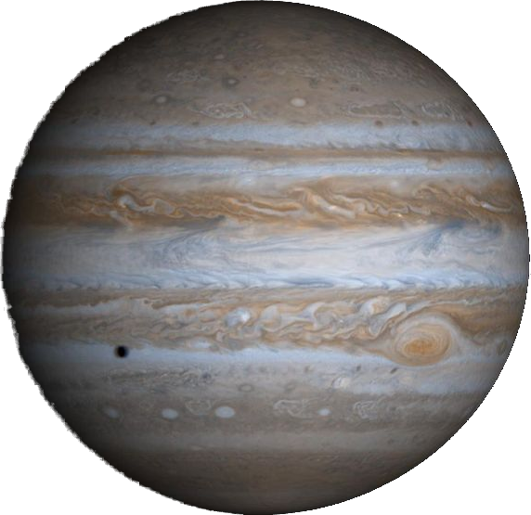

Step 1

Step 2

Step 3

4. Estimate the orbital period of each of the four Galilean moons.
Explain your process!

Moon | Orbital Period
I
II
III
IV

5. The orbits of Jupiter's moons are almost completely circular. Appealing to Kepler's Second Law, what does this imply about their orbital velocity?

6. We are viewing the system edge on. At what point in the orbit does the moon appear to move the fastest? The slowest? Why?

Part 3
1. Looking at the generalized version of Kepler's Third Law from Part 1, assume that the mass of any moon is small compared to the mass of Jupiter and that we know the gravitational constant G. What do we need to know to solve this equation for the mass of Jupiter?

2. Can we measure these values from a single image of Jupiter? If yes, how? If no, why not and what is the solution?

3. Given your answers to Part 2 Question 2 and Part 3 Question 2, describe the data that you expect to gather and sketch a plot of what you expect to see.

4. Record your observing parameters in the table below. Go to the website and enter them in the Submit/Retrieve Observations.

Number of Images per Night
Time Between Images
Number of Nights to observe

