Revolution of Jupiter's Moons – Lab 2

Jupiter and its moons as seen from the UST Observatory.

Introduction

In Lab 1 of this two lab series, we discovered that Kepler's Laws of planetary motion could be used to calculate the mass of a planet. We then learned how we could weigh Jupiter by measuring the period and orbital radius of its moons in a time series of images. In this lab, we are going to use the images from the telescope to first measure the period and semi-major axis of the Jupiter's moons and then use those values to calculate the mass of Jupiter.

Part 1: Measuring the positions of the Moons

Depending on your original observing plan, you will have as many as 20 images of Jupiter. In each image, you will measure the distance between Jupiter and each of its four moons and record that distance in a spreadsheet. That's as many as 80 individual measurements! Your instructor may divide you into teams to make the data extraction go faster.

- Your instructor will provide you with a URL where the data can be retrieved. Go to that URL, download the zip file, and extract it into a folder on your desktop.

- Inside the folder, open the file named 'jupiter-data.xls'. This is where you will record the data.

- Go into the folder labeled 'ds9' and double click 'ds9.exe'. This is the program you will use to display the images and make measurements.

- Select File->Open and open the first file in the list. You should see an image of Jupiter, although the moons may not be visible, as in the figure below.

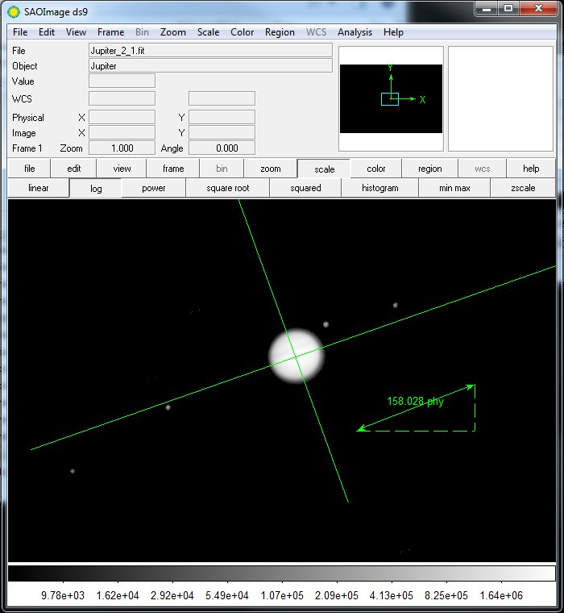
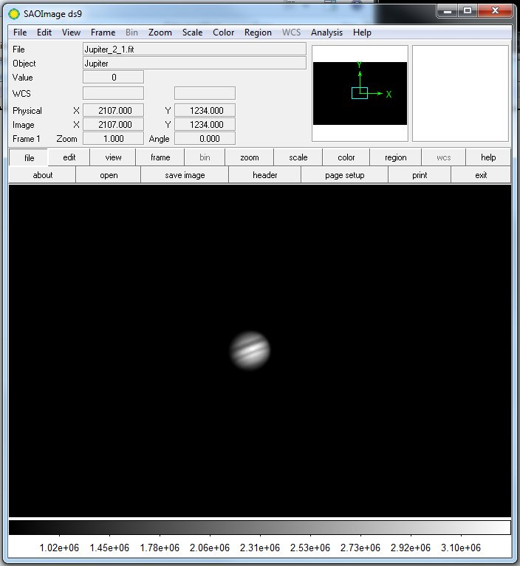
Two images of Jupiter. The image on the left is unscaled. Details on Jupiter are clear, but the moons aren't visible. The image on the right is scaled so that details on Jupiter are washed out but the moons are visible. The image on the right also shows the measurement tools.

- Choose Region->Load Regions on the menu bar and load the file called 'measure.reg'. The measurement tools will appear, as in the figure above.

- When the image loads, you'll likely see Jupiter, but not the moons. Use the ruler tool to measure the diameter of Jupiter. Record this number in the appropriate spot on the spreadsheet and in Question 1 in the packet.

- Press the Scale button and choose a log scale and the moons should appear, although Jupiter will be washed out.
IMPORTANT: Don't change the scaling before you've measured the diameter of Jupiter!

- Put one end of the ruler arrow on the leftmost moon in the image. Place the other end of the arrow against the line that is perpendicular to the orbital plane of the moons. Try to make your ruler line parallel to the line representing the orbital plane as in the figure below.

- Record your data in the proper location on your spreadsheet. The row is given by the file name. The order of the moons is given by the 'Moon Order' column. In the example below, the leftmost moon is moon III, so is entered as the first moon in the list.

- If the moon is to the left of Jupiter, record the distance as positive. If it is to the right, record the number as negative.

- Now measure the positions of the other three moons and record them in the proper cell on the spreadsheet.

- Repeat the preceding procedure for each of the images assigned to your group. If the data has been divided among the class, enter all the data from other groups into the spreadsheet before continuing.
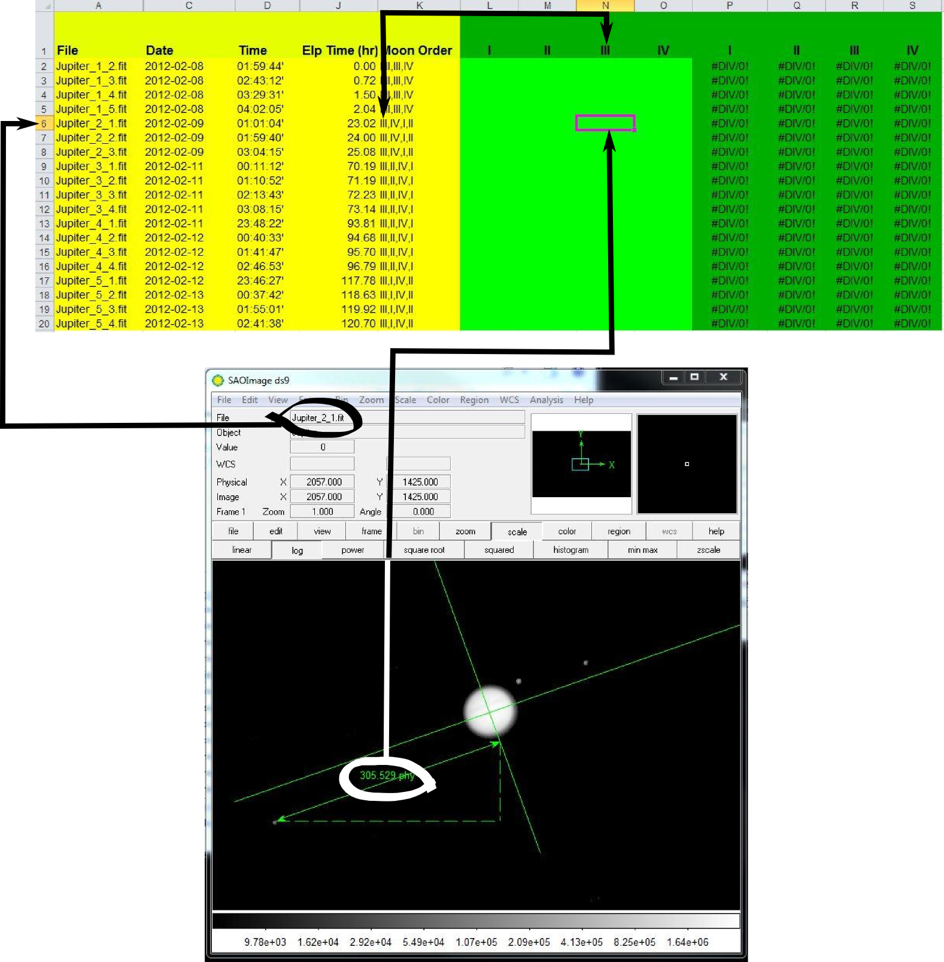

Part 2: Determining the orbital parameters

Now that we have the positions, we will use them to measure the period and the semi-major axis of each of the moons. We do this calculating the expected positions of a moon given an arbitrary semi-major axis, period and phase and comparing the result to the observed positions. We adjust the inputs until the expected and observed values match as closely as possible.

- Select the 'Moon I' sheet. You will see the observed positions plotted as blue diamonds and the expected positions plotted as a red curve. The x-axis is time, and the y-axis is distance from Jupiter in pixels.

- You have three parameters to play with: semi-major axis (a), orbital period (P), and phase (Phi). The red curve is based on these three parameters. Fiddle with each of these in turn to see what it does to the curve, then answer questions 2-4 in the packet.

- Adjust the parameters until the red curve coincides as closely as possible to the blue diamonds. As you get closer, the 'RMS Error' gets smaller. Try to make RMS error as small as possible.

- When you are satisfied with your fit, repeat the procedure with the remaining three moons.

Part 3: Calculating the mass of Jupiter

We're now ready to measure the mass of Jupiter! To do this we are going to use Kepler's 3rd Law:
M = a3 / P2

M is the mass of the central object (in this case, Jupiter)
a is the semi-major axis (which is the radius, if the orbit is a circle)
P is the period (the time it takes to go around once)

M is the mass of Jupiter, but you can also do this for the Sun if you observe the planets going around to measure a and P.

However, your semi-major axis is currently measured in the less-than-useful “Pixels” (for distance) and “Hours” (for time). To calculate the mass of Jupiter, it's more useful to use the special units of “A.U.” and “years”.

- First, convert your numbers for a to Jupiter Diameters using the number of pixels you measured for Jupiter’s diameter. Write this in Table 2.

- Next convert a to astronomical units by dividing by 1050 (this may seem arbitrary, but it is the number of Jupiters that can fit in one A.U.)

- Convert your hours to years.

- Write your new numbers in Table 2

Now, we can calculate the mass of Jupiter! Let's see how well the different moons match up.

- Calculate the mass of Jupiter four times, once for each moon. Use Kepler's 3rd Law, M = a3 / P2 and write your answers in Table 3

- Calculate the average and write that in Table 3

- Answer the remaining questions in the answer packet.

