Revolution of Jupiter's Moons – Lab 2

Jupiter and its moons as seen from the UST Observatory.

Introduction

In Lab 1 of this two lab series, we discovered that Kepler's Laws of planetary motion could be used to calculate the mass of a planet. We then learned how we could weigh Jupiter by measuring the period and orbital radius of its moons in a time series of images. In this lab, we are going to use the images from the telescope to first measure the period and semi-major axis of the Jupiter's moons and then use those values to calculate the mass of Jupiter.

Part 1: Measuring the positions of the Moons

Depending on your original observing plan, you will have as many as 20 images of Jupiter. In each image, you will measure the distance between Jupiter and each of its four moons and record that distance in a spreadsheet. That's as many as 80 individual measurements! Your instructor may divide you into teams to make the data extraction go faster.

- Go to http://ida.phys.stthomas.edu/MoonsOfJupiter. Click on “Submit / Retrieve Observations” in the menu at the left. Log in using the information given to you by your instructor, then click on “Retrieve” to get your data.

- Open the zip file you just downloaded, then click “extract all” at the top of the folder. Save it into a new folder on your desktop.

- Go into the folder labeled 'ds9' and double click 'ds9.exe'. This is the program you will use to display the images and make measurements.

- Open the first file assigned to you using File->Open. You should see an image of Jupiter, although the moons may not be visible, as in the figure below. (Important: Do not change anything to try to see the moons!!)
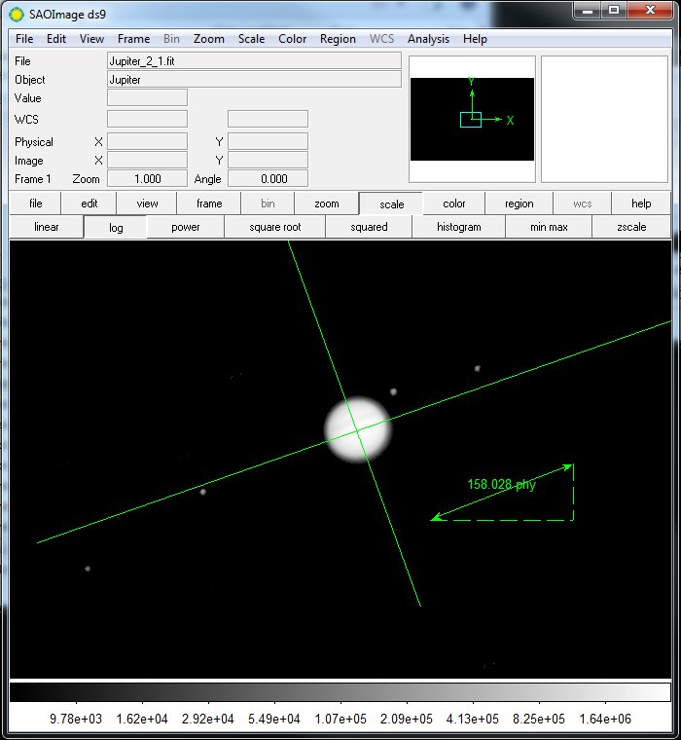
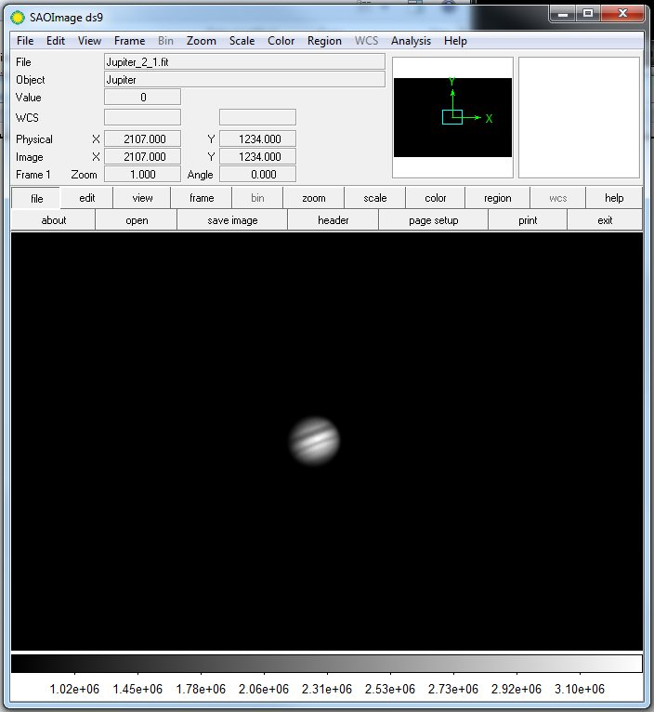
Two images of Jupiter. The image on the left is unscaled. Details on Jupiter are clear, but the moons aren't visible. The image on the right is scaled so that details on Jupiter are washed out but the moons are visible. The image on the right also shows the measurement tools.

- Choose Region->Load Regions on the menu bar and load the file called 'Measure.reg'. The measurement tools will appear, as in the figure above.

- Use the ruler tool to measure the diameter of Jupiter. Write your number on the board. Record the class average in Question 1 in the packet.

- Press the Scale button and choose a log scale and the moons should appear, although Jupiter will be washed out.
IMPORTANT: Don't change the scaling before you've measured the diameter of Jupiter!

- Put one end of the ruler arrow on the leftmost moon in the image. Place the other end of the arrow against the line that is perpendicular to the orbital plane of the moons. Try to make your ruler line parallel to the line representing the orbital plane as in the figure below.

- If the moon is to the left of Jupiter, record the distance as negative. If it is to the right, record the number as positive.

- Record your data in the row for the specific file you are measuring in Table 1. The moon order does not matter so long as you are certain to measure all of the moons.

- Now measure the positions of the other three moons and record them in Table 1 as well. (Hint: Try your hardest to find four moons. You may need to zoom out!)

- Repeat the preceding procedure for each of the images assigned to your group. Once your data has been recorded, enter all your data into the class spreadsheet (see figure on the next page) before continuing.
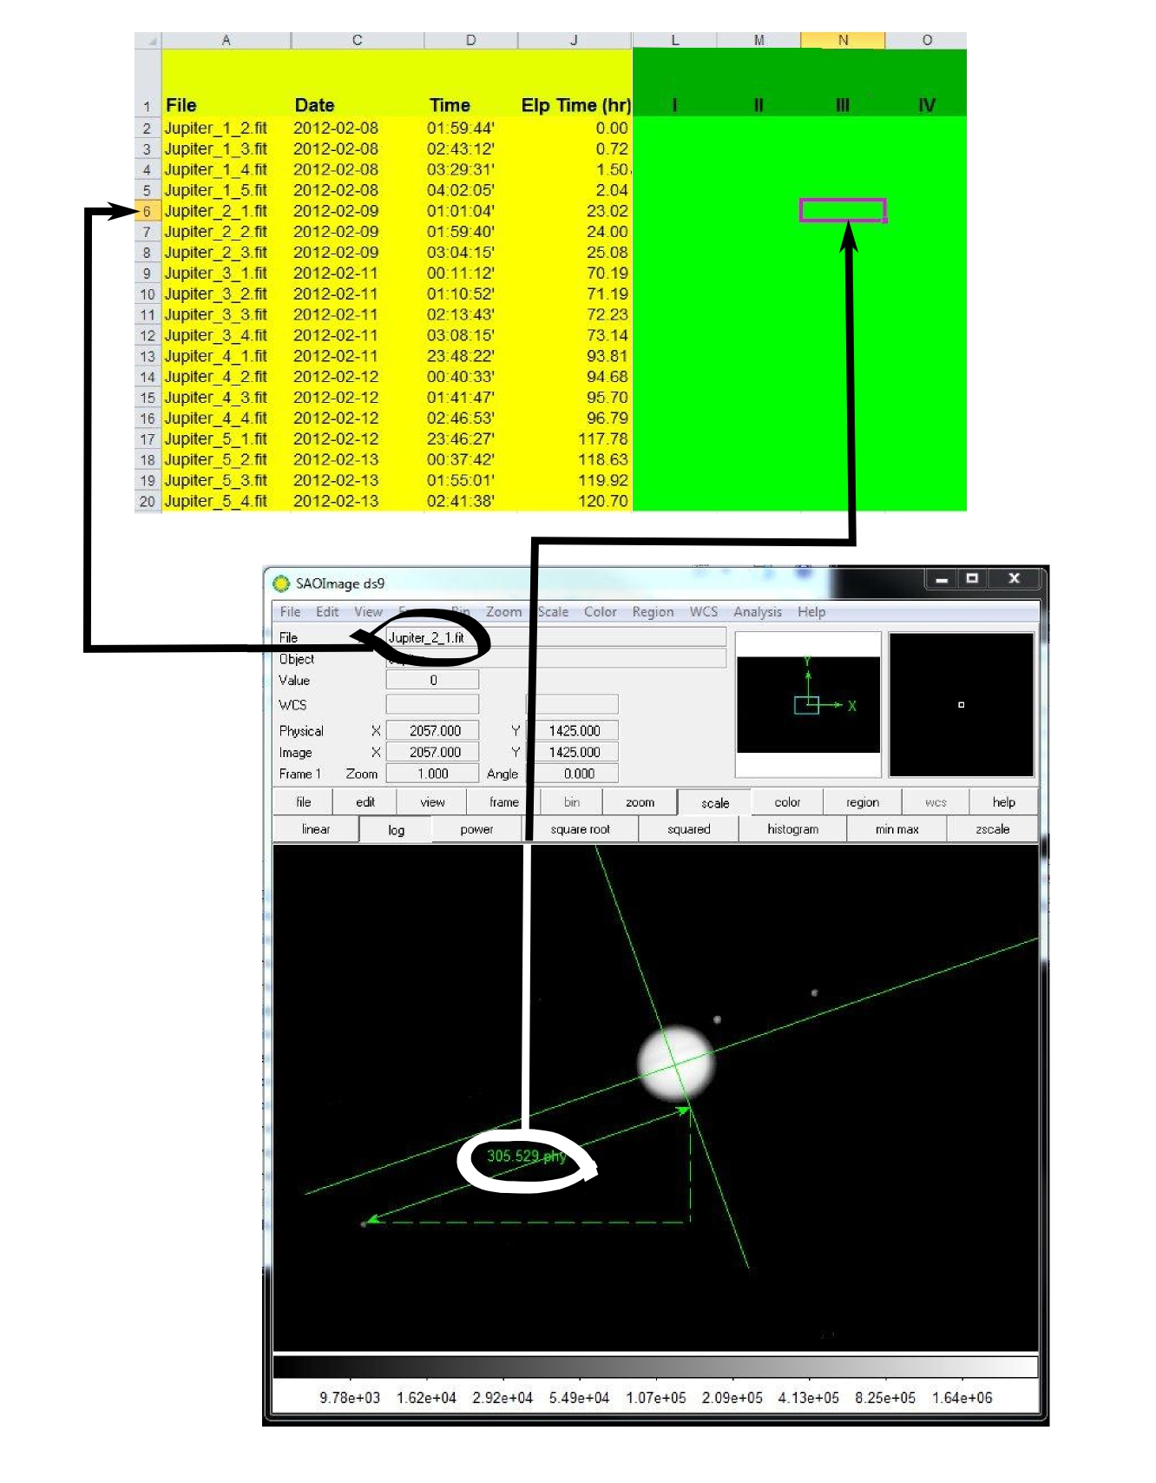
Part 2: Determining the orbital parameters

Now that we have the positions, we will use them to measure the period and the semi-major axis of each of the moons. We do this calculating the expected positions of a moon given an arbitrary semi-major axis, period and phase and comparing the result to the observed positions.

- Select the 'Big Plot' sheet in the tabs at the bottom. You will see the observed positions of all the moons plotted. The x-axis is time based on the date and time the observation was made. The y-axis is distance from Jupiter in pixels. Print the plot so you have a copy to work on.

- A sine curve looks like this:

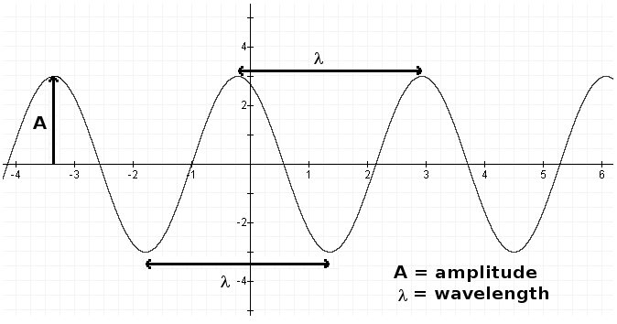
Answer questions 1 and 2 in your answer packet by comparing the above graph to your data. It may be helpful to look at your printout of the Big Plot.

- We do not have the moons separated. Try to draw a sine curve estimating each moon. Think about how you can tell which moon is which from one time to the next. Once you have done so for all four moons, answer question 4 in the answer packet.

In the next several steps, you will enter your measurements into the tables in the answer packet.

- Estimate a and P for each moon in pixels. Note: In order of distance from Jupiter, the moons are: Io (closest), Europa, Ganymede, and Callisto

- Convert pixels to Jupiter diameters using your measurement of Jupiter's diameter from the picture.

- Convert Jupiter Diameters to Astronomical Units. Jupiter's actual diameter is 142,000 km, and 1 AU = 1.5 x 10⁸ km. Show an example of your conversion in question 5 in your answer packet.

- Convert your period to years.

We're now ready to measure the mass of Jupiter! To do this we are going to use Kepler's 3rd Law:
M = a3 / P2

M is the mass of the central object (in this case, Jupiter)
a is the semi-major axis (which is the radius, if the orbit is a circle)
P is the period (the time it takes to go around once)

M is the mass of Jupiter, but you can also do this for the Sun if you observe the planets going around to measure a and P.

- Calculate the mass of Jupiter four times, once for each moon. Use Kepler's 3rd Law, M = a3 / P2 and write your answers in Table 3

- Calculate the average and write that in Table 3

- Answer the remaining questions in the answer packet.

