A box with mass m, initially at rest, is pushed a distance d along a surface with a force F making and angle θ with the horizontal. The coefficient of friction between the box and the surface is μ_{k}.

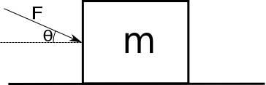

a) Draw a free body diagram of the box.
b) Calculate the work done by each force.
For each vector pair below, sketch the pair and calculate.

a.
b.
c.

For each vector pair in the previous question, use your calculated dot product to find the angle θ between and .

3. Which pairs of vectors are orthogonal? What is the dot product of the orthogonal pairs?

For each pair of vectors below, is the sign of positive, negative or zero?

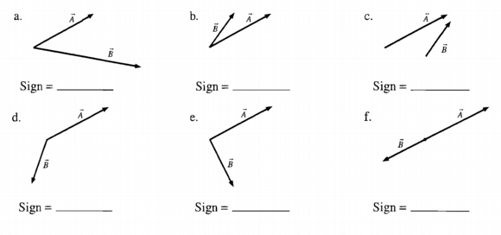

Each of the diagrams below shows a vector. Draw and label a vectorthat will causeto have the indicated sign.

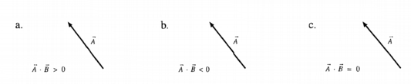

For each situation described below:

a) Draw a free body diagram.
b) Make a table next to each free body diagram showing each force and whether the work is positive, negative, or zero

1. An elevator being pulled upward by a cable.

2. The same elevator on the trip down.

3. A mover pushing a box across a rough floor.

4. A ball thrown straight up. Consider the ball from the point just after it leaves your hand until the highest point in its trajectory.

5. A mass on a string swings one revolution in a circle on a horizontal, frictionless table at a constant speed.

A skier of mass m skis a distance L down a frictionless hill that has a constant angle of inclination θ. The top of the hill is a vertical distance h above the bottom of the hill.

a. Use the integral form of the definition of work to find an expression for the work done on the skier by each of the forces involved.

b. Find an expression for the total work, W_{net} , done on the skier. Your expression should be in terms of m, g, and h only.

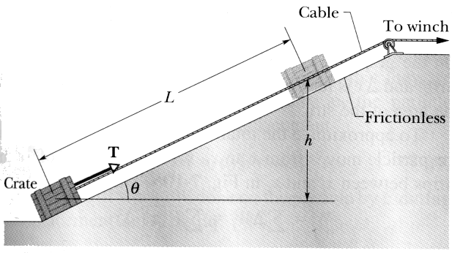
An initially stationary crate of mass m is pulled a distance L up a frictionless ramp to a height h where it stops.

Find an expression for the work W_{g} done on the crate by gravity during the lift in terms of m, h, and g.

A particle of mass m moves in a horizontal circle of radius R on a rough table. It is attached to a string fixed at the center of the circle. The coefficient of friction between the mass and the table is μ_{k}.

a) Draw a free body diagram of the puck.
b) Calculate the work done by each force after one revolution.
c) Calculate the net work done after one revolution.

