A box with mass m, initially at rest, is pushed a distance d along a surface with a force F making and angle θ with the horizontal. The coefficient of friction between the box and the surface is μ_{k}.

a) Find an expression for the final velocity of the box, V_{f}, using Work-Energy techniques.

b) Find an expression for final velocity of the box using Newton's Second Law and kinematics and show that the answer is the same.

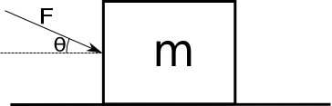

A skier of mass m skis a distance L down a frictionless hill that has a constant angle of inclination θ. The top of the hill is a vertical distance h above the bottom of the hill.

a. Calculate the work done on the skier by each of the forces.

b. Find an expression for the total work, W_{net} , done on the skier. Your expression should be in terms of m, g, and h only.

c. Use the Work Energy Theorem to find the skier's speed, V_{f}, at the bottom of the hill.

d. Use any method you like to find an expression for the final speed of the skier if she were to simply drop from a height h in free fall and compare your answer to the one in part c.

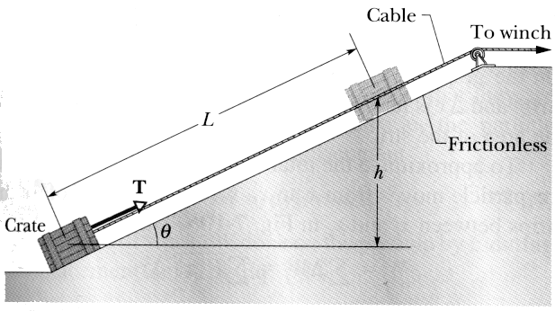
An initially stationary crate of mass m is pulled a distance L up a frictionless ramp to a height h where it stops.

a) Find an expression for the work W_{g} done on the crate by gravity during the lift in terms of m, h, and g.

b) Find an expression for the work W_{T} done on the crate by the tension T in the cable during the lift in terms of m, h and g.

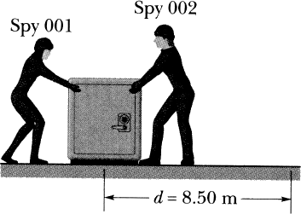
Two spies slide an initially stationary 225 kg safe 8.50 m along a straight line towards their truck. Spy 001 pushes 12.0 N at an angle of 30 degrees to horizontal. Spy 002 pulls 10N at an angle of 40 degrees from horizontal. The floor is frictionless (they're stealing the safe from an ice rink).

a) What is the total work done on the safe during the 8.5 m displacement.

b) During the displacement, what is the work done on the safe by it's own weight and the normal force from the floor?

c) What is the speed of the safe at the end of the displacement.

d) After the 8.50 m displacement, the spies stop pushing and let the safe slide across the ice and onto the carpet at the edge of the rink. If the coefficient of friction between the safe and the carpet is = 0.6, use the Work Energy Theorem to find how far does the safe slides.
A particle of mass m moves in a horizontal circle of radius R on a rough table. It is attached to a string fixed at the center of the circle. The coefficient of friction between the mass and the table is μ_{k}.

a) Calculate the net work done on the puck after one revolution.

b) The initial velocity of the puck is v₀. After completing one revolution, the velocity of the puck is ½v₀. Find an expression for μ_{k} in terms of v₀, π, R and g.

c) How many times will the particle go around? (You should get a number)

Springs exert a force that opposes being stretched or compressed. Hook's law states that the magnitude of the force exerted by the spring is not constant, but is proportional to the amount of compression/extension and in the opposite direction. Mathematically, it is written:

The spring constant, k, represents the strength of the spring and x is the displacement of the spring from it's equilibrium position (the position where it's not exerting any force). The negative sign indicates that the force opposes the displacement x.

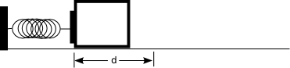
a) A block of mass m is pushed against a spring of spring constant k and the spring is compressed a distance d. Calculate the work done by the spring after it is released.

HINT: solve the following integral

b) What is the block's velocity after leaving the spring?

