A block slides along the track shown below. The track is frictionless until the block reaches the level portion at the top of the hill, where the coefficient of friction is μ_{k}.

How far does the block slide on the level part of the track?

A brick is lifted to a certain height and then dropped to the ground. Next, a second identical brick is lifted twice as high as the first and also dropped to the ground. When the second brick strikes the ground, it has

A. half as much kinetic energy as the first.
B. square root of 2 as much kinetic energy as the first.
C. twice as much kinetic energy as the first.
D. four times as much kinetic energy as the first.

Explain:

A bottle dropped from a balcony strikes the sidewalk with a particular speed. To double the speed of impact, you would have to drop the bottle from a balcony

A. twice as high.
B. three times as high.
C. four times as high.
D. five times as high.
E. six times as high.

Explain:

A car is going 10 mph. The driver hits the brakes. The car travels 3 feet after the brakes are applied. A while later, the same car is going 20 mph. The driver hits the brakes. About how far does the car go after the brakes are applied?

A. 3 ft.
B. 6 ft.
C. 9 ft.
D. 12 ft.
E. 15 ft.

Explain:

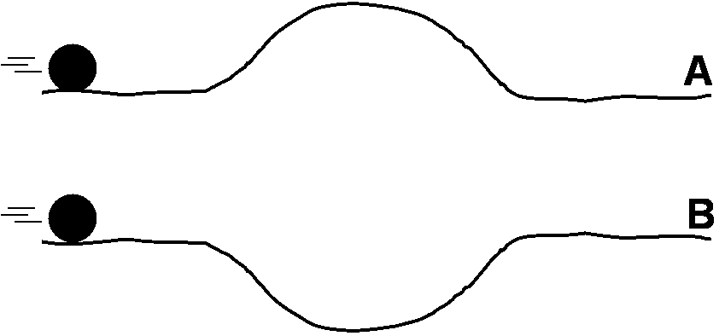
Two identical balls are rolled across tracks A and B. The height of the bump in track A is equal to the depth of the dip in track B. Both balls begin rolling at the same time and with the same speed. Ignore friction. Circle ALL of the following statements that are true.

A. The final speed of ball A is greater than that of ball B.
B. The final speed of ball B is greater than that of ball A.
C. The two balls have the same final speed.
D. The ball on track A finishes the race first.
E. The ball on track B finishes the race first.
F. The two balls take the same amount of time to reach the ends of their tracks.

Explain:

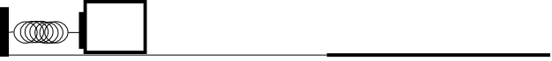
A block of mass m is pushed against a spring of spring constant k and the spring is compressed a distance l. The block is released and slides across a frictionless surface for a short distance before encountering a surface with a coefficient of friction μ_{k}.

a. Use conservation of energy to find an expression for the velocity of the block after it leaves the spring.

b. Use conservation of energy to find an expression for how far it slides on the surface with friction before coming to a stop.

A mass m rests on a frictionless horizontal track while compressing a horizontal spring of spring constant k a distance d. The mass is released and it slides along a frictionless horizontal track before sliding up a frictionless circular surface of radius R.
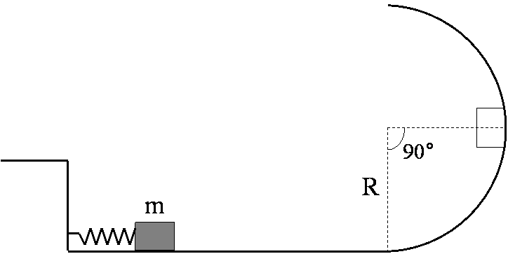

a. Find an expression for the compression d such that the mass just comes to rest at a radius position of θ=90° as shown in the picture?

b. Now include friction in the problem. If the spring is compressed the same distance d and the block stops at θ<90°, how much work was done by the frictional force acting on the block?

Use work-energy techniques to solve the following problem.

Two masses are connected by a light string passing over a light frictionless pulley. The mass m₂ is released from rest at a height of 4.0 m above the ground.

Determine the speed of m₁ just as m₂ hits the ground and the maximum height m₁ rises above the ground.

m₁ = 3.0 kg
m₂ = 5.0 kg

