The figure below shows the plot of a potential-energy function for a particle moving along the x-axis.
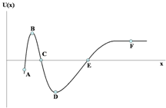
a) At each point indicated, state whether the corresponding force F_{x} acting on the particle is positive, negative, or zero.

A: D:
B: E:
C: F:

b) At which point does the force have the greatest magnitude? Explain.

c) Identify all points corresponding to stable, unstable, and neutral equilibrium.

d) Assuming the particle starts at point A with a large positive velocity, identify the points where the particle’s speed is a maximum, minimum, and constant. Explain. (Remember, in order for there to be a potential energy, the force must be conservative.)

The potential energy functions in a particular physics experiment are U₁ = Ax⁴ and U₂ = Ax³ – Bx, where A and B are constants.

a) Find the force, F₁, associated with U₁.

b) Are there any points along the x-axis where the F₁ equals zero? If so, where?

c) Find the force F₂ associated with U₂.

d) Are there any points along the x-axis where F₂ equals zero? If so, where?

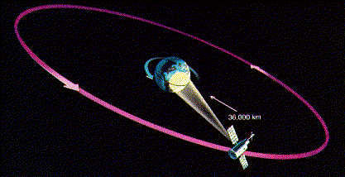
Satellites in geosynchronous orbit always remain above the same geographic spot on the Earth's surface, making them extremely handy for communications.
Using what you know about Newton's Universal Law of Gravity and the rotation of the Earth:

a) calculate the radius of the geosynchronous orbit.
b) What's the orbital velocity of the geosynchronous satellites?
c) calculate how much energy is required to put a 1000kg communications satellite into geosynchronous orbit.

The radius of the Earth is: R_{Earth} = 6.37x10⁶ m.
The mass of the Earth is : MEarth = 5.97x10²⁴ kg
The gravitaional constant: G = 6.67x10⁻¹¹ m³/(kg s²)

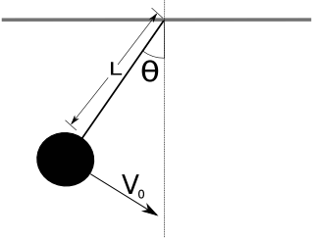
The picture shows a pendulum with a weight of mass m attached to a light (massless) string of length L. The mass has a speed v₀ when the cord makes an angle θ with the vertical.

a) Derive an expression for the speed of the mass when it is in its lowest position.

b) What is the minimum value of v₀ for the chord to make an angle of 90º on the pendulum's upswing?

An 8.75-kg block starts at rest, at height h = 1.0 m, and slides down a frictionless ramp onto a horizontal plane where μ_{k} = 0.05. If the block has enough energy after passing the plane, it will rise onto another frictionless ramp, and so forth.

(a) The block is released, makes its first trip to the right hand side, returns to the left hand side, and then returns once more to the right. On this second excursion to the right side, how high up the ramp does the block go?

Use work-energy techniques to solve the following problem. A 2.0 kg block is dropped from a height of 40 cm onto a spring of spring constant k = 1960 N/m. Find the maximum distance the spring is compressed.

Use work energy to solve the following problem.

A stone of mass m is thrown vertically upward into the air from ground level with an initial speed of v_{o}. If a constant drag force equal to 20% of the stone’s weight acts on the stone throughout its flight, what is the speed of the stone in terms of v_{o} when it returns to the ground?

