Name:

By writing my name above, I affirm that this test represents my work only, without aid from outside sources. In all aspects of this course I perform with honor and integrity.

Show your work on all of the problems – your approach to the problem is as important as (if not MORE) important than) your final answer.

1) Starting with the definition of work, derive the Work Energy Theorem.

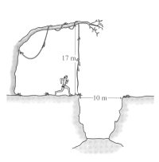
Use work-energy techniques to solve the following problem.

Tarzan is late for a date with Jane and is running as fast as he can to meet her. On the way, he has to get over a 10m wide pit of dangerous croc-a-gators. A 17m vine is hanging vertically from a tree at one side of the pit. Tarzan is going to run up, grab the vine, swing across, and drop vertically to the ground on the other side.

What must his minimum speed be to make it across?

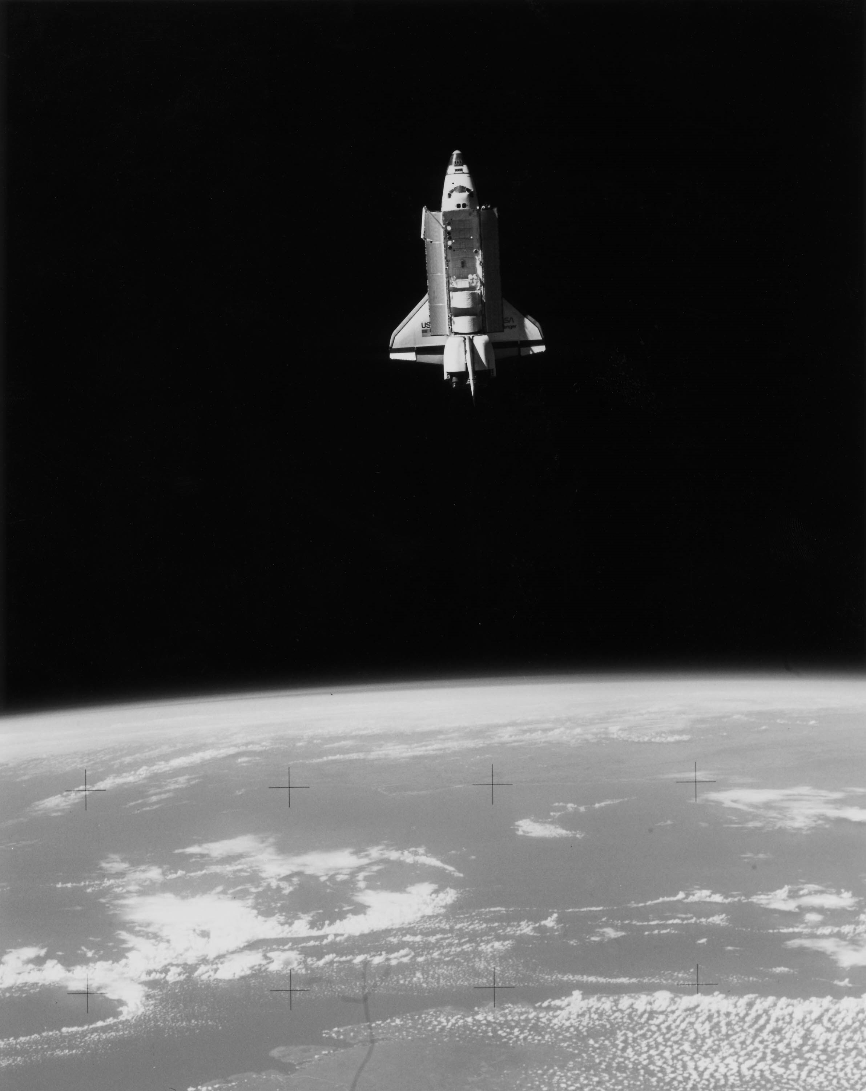
a) Derive a general expression for the amount of energy required, E, to put the space shuttle into an orbit of radius R. Ignore the Earth's rotation. (Let K_{i} = 0)

b) Now let's use the equation from part a to compare two orbital energies.

Let R₁ = (1.05)R_{Earth} (the normal orbit of the space shuttle) and let R₂ = ∞. Show that, in terms of energy, low Earth orbit is halfway across the Universe.

In other words, show that:

Use work-energy techniques to solve the following problem.

You are digging around in the physics stock room and find a box of springs. In attempting to measure the spring constants, you find one that doesn't seem to follow Hook's law. After extensive testing, you conclude that the its force law is quadratic and is of the form:

where x is the displacement of the spring from equilibrium andis a unit vector in the direction of the stretch.

a. Calculate a potential function for this spring.

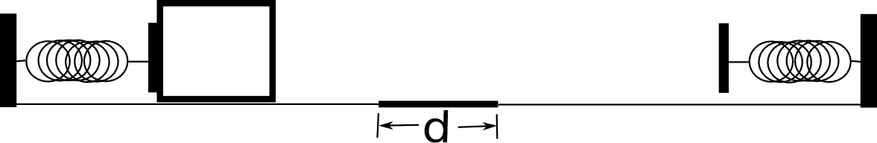
b. A spring that follows Hook's with a spring constant k law is placed opposite the “strange” spring as in the figure below. The “strange” spring is compressed a distance l and a block of mass m is placed against it. All surfaces are frictionless except the dark patch between the two springs. How many times does the block cross the space between the springs?

a = 38.4 N/m²
l = 1.0 m
d = 0.5 m
m = 2 kg
k = 100 N/m
μ_{k} = 0.60

In the system below, the spring is compressed and a 3 kg block resting against it is released from rest. The surface is frictionless except for the dark horizontal surface at the end where the coefficient of friction is μ_{k} = 0.15. The distance between the top of the uncompressed spring and the top of the ramp is 2 m. The spring constant is k = 200 N/m. The ramp makes a 30 degree angle with the horizontal, h₁ = 3 m, and h₂ = 2 m.

a) How much does the spring have to be compressed for the block to just clear the top of the ramp.

b) If the block just clears the top of the ramp (v is zero there but it just makes it over), how far across the frictional surface will it slide.
