Little Laura Ingalls has to haul firewood to the house on her double sled (two sleds attached with a rope). Each loaded sled is 45kg. The rope connecting the two sleds is horizontal. The rope that Laura is pulling makes an angle of 30º with the horizontal. The coefficient of friction between the sled and the ground is μ_{k}=0.30.

a) Find the tension in the rope between the two sleds that will keep the sled moving at a constant velocity.

b) Find the tension in the rope that Laura is pulling that will keep both sleds moving at a constant velocity.

While standing on a rough surface, Stickman
is pulling an ice block to the right with a tension T.

a. Draw a freebody diagram of Stickman. (He does not slide)

b. Draw a freebody diagram of the ice block. (It’s frictionless)

c. Assume that the Box is frictionless and calculate the velocity of the box after it has traveled a distance d starting from rest. Your velocity should be in terms of m,F_{p} (Force of Stickman's pull), θ, and d.

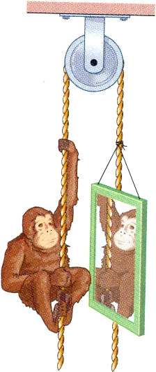
A massless rope is strung over a massless frictionless pulley. A monkey holds onto the rope and a mirror having the same mass as the monkey is attached to the other side of the rope at the monkey's level. Can the monkey get away from its image by climbing up, climbing down, or letting go of the rope?

Four penguins are being playfully pulled along a very slippery (frictionless) ice by a zoo keeper. The masses of the first, second, and third penguins and two cord tensions are shown below. Find the mass of the third penguin.

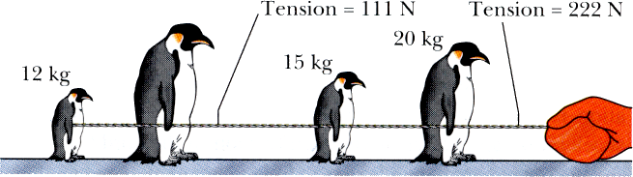

A block rests on an incline plane. The coefficient of friction between the block and the plane is μ_{s}. Find an expression for the maximum angle of the incline before the block slips.

HINT: The equation for the force of static friction (F = μ_{s}N) represents the maximum force that friction can provide.

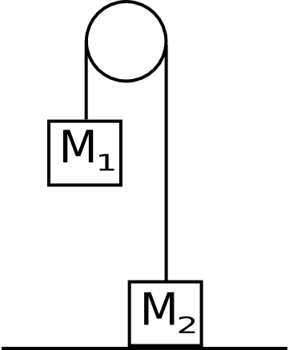
One end of a rope is connected to a mass M₁=10kg. The rope passes over a massless frictionless pulley and the other end is connected to a mass M₂ = 5kg. M₂ is initially resting on the ground and M₁ is suspended 3m above the ground. The system is initially at rest.

If M₁ is released and allowed to hit the ground, what is the maximum height that M₂ will reach?

HINT: When M₁ hits the ground, M₂ will still have an upward velocity. The rope will go slack and M₂ will continue upward until its velocity is zero.

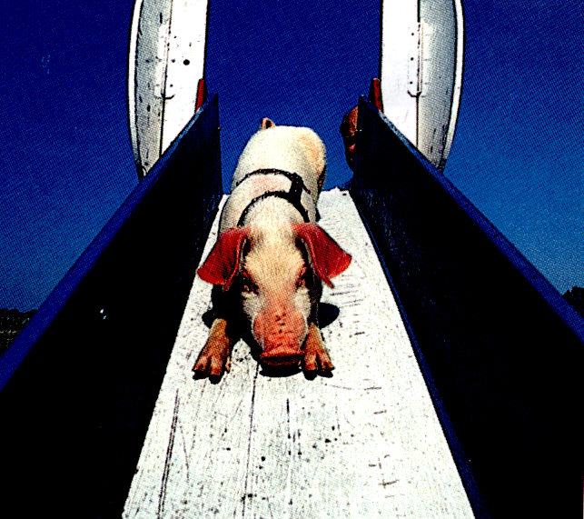
A pig slides down a 35 degree incline in twice the time it would take to slide down a frictionless 35 degree incline. What is the coefficient of kinetic friction between the pig and the incline?

