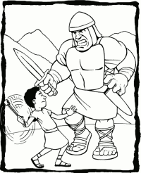
David is fighting Goliath. To defeat him, David's rock must leave his 0.5 m sling at 20 m/s. Unfortunately, his sling was damaged and the maximum tension the rope can withstand is 500 N. What is the mass of largest rock that David can sling? Ignore gravity.

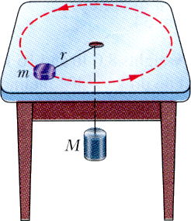
A mass m on a frictionless table is attached to a hanging mass M by a cord through a hole in the table. Find the speed with which m must move in order for M to stay at rest.

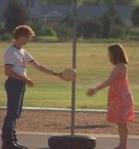
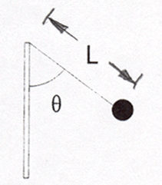
Napoleon lands a flippin' sweet blow to the tether ball, which is attached to a rope of whose length is L = 0.60m sending it whipping around the pole with a period of of 0.75s.

a) Napoleon is jealous of your awesome physics skills and needs your help finding an expression for the angle, θ, that the rope makes with the pole.

b) Calculate a numeric value for θ using your expression from part a and use it to calculate the tension in the rope.

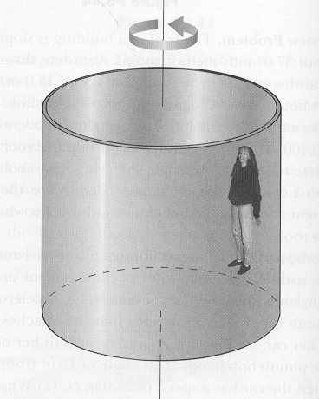
The Cyclone is an exciting state fair ride consisting of a large vertical cylinder that spins about its axis. Riders stand inside the cylinder with their backs against the wall. When the cylinder is spinning fast enough, the floor drops away and the rider “sticks” to the wall.

If the The coefficient of static friction between a wall and person is μ_{s}, and the radius of the cylinder is R, show that the maximum period of revolution is given by:
$P={\left(\frac{4π^{2}Rμ_{s}}{g}\right)}^{\frac{1}{2}}$

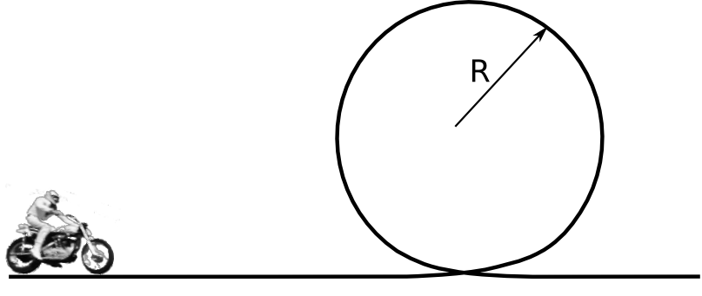
Evel Knievel is going to do the loop the loop as a warm up to jumping 50 busses, a tank of piranha, and a tank of sharks. The loop is a circle with radius R. What is the minimum speed that Evel can be going at the top of the loop without falling?

