Name:

By writing my name above, I affirm that this test represents my work only, without aid from outside sources. In all aspects of this course I perform with honor and integrity.

Show your work on all of the problems – your approach to the problem is as important as (if not MORE) important than) your final answer.

1) Starting with the unit vector expression for the position, r, of a particle constrained to move in a circle, derive an expression for the magnitude of the velocity vector and the magnitude of the acceleration vector assuming that the particle is moving in uniform circular motion.

Include a picture with the position vector, r, the velocity vector, v, the acceleration vector, a, and the position angle, θ, clearly marked.

Clearly state any assumptions required by the proof.

2) A and B are blocks with masses of 44 kg and 22 kg respectively. The coefficient of friction between the table and the block is 0.20.
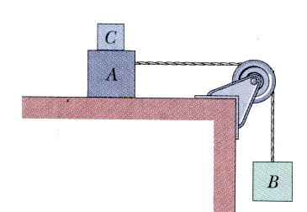
a) Determine the minimum mass of block C so that block A does not slide.

b) If block C is suddenly lifted off of A, what is the acceleration of A?

3) Find an expression for the horizontal force, F, that be must be applied to the cart so that the blocks remain stationary relative to the cart. Assume all surfaces are frictionless and that all wheels and pulleys are massless and frictionless.

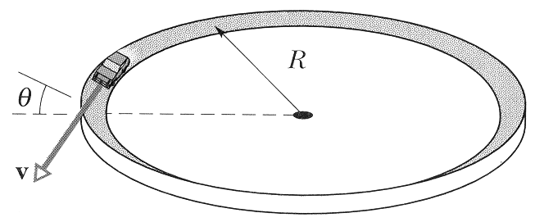
4) Curves on roadways are often banked so that the reaction force from the road provides part of the centripetal acceleration required to keep the car moving around the circle.

Assume the road is a circle of radius R, the car is going some velocity v, and the tires have some coefficient of static friction μ_{s}.

Find an expression for the minimum angle required to keep the car on the road in terms of R, v, and μ_{s} .
5) A block is projected up an incline plane making an angle θ with the horizontal. It returns to its initial position with half of its initial speed. Show that the coefficient of kinetic friction is: μ_{k} = 3/5tan(θ).

