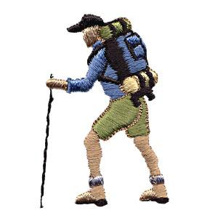
A hiker begins a trip by first walking 25 km southeast from her base camp. On the second day, she walks 40 km in a direction 60° north of east.

- Sketch the hiker's displacement vector for day 1,, and write the components in unit vector notation.
(assume East is and North is )

- Sketch the hiker's displacement vector for day 2,, and write the components in unit vector notation.

- Sketch the the vector sum of the total trip and solve the vector equation . Write in unit vector notation.

- Calculate the magnitude and direction of .

After moving three times, you find yourself 5.39 m away from where you started and 21.8º below the x-axis. Your first move was 5.00 m at an angle of 53.1º. Your second move was 6.00 m along the x-axis and some unknown distance along the y-axis. Your third move was some unknown distance along the x-axis and –3.00 m along the y-axis.

(a) Write each of the four vectors in unit vector notation.

(b) Calculate the unknown components of your second and third move. Make a sketch of the system.

Consider 3 vectors. Vector A is given by 4.00i + A_{y}j, vector B has a magnitude of 6.00 and is pointing at an angle of 35.0º with respect to the x axis, and vector C is given by C_{x}i + 7.00j.

a. Assuming that A + B = C, find the missing components A_{y} and C_{x}.
b. Find the magnitude of C?
c. Find the angle of C makes with respect to the x – axis?

Alice and Ben need to check insect traps at three field sites. Alice will check one, Ben one, and the two will meet at the third.

Alice travels 2.00 km at 20o E of N to the first site and then 2.50 km at 11o N of E to the next.

Ben travels 3.00 km at 15o S of E to his first site.

a) Write analytical expressions (no numbers) for the x and y components of the displacement required for Ben to meet Alice.

b) Plug the numbers into your analytical equation and get a numeric answer.

c) Convert the x and y components into magnitude and direction.

Make a clear sketch of the situation. In the sketch, define your coordinate system and all appropriate variables.

