Bill and Ted are going to race. Bill can run 15 mi/hr and Ted can only run 11 mi/hr. How far from the finish line is Ted when Bill finishes a quarter mile race?

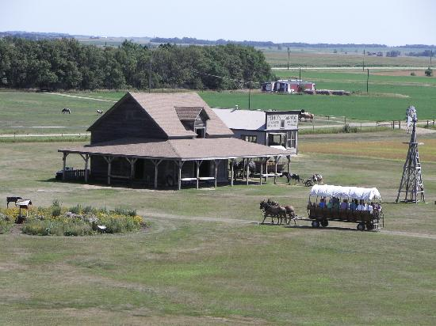
Ma and Pa Ingalls are going to have another baby! Ma says “It's time!” so Pa gets the team hitched up and they take off for Doc Weber's place. Doc's place is 15 miles south and 10 miles east of the homestead. But In his excitement, Pa drives northeast at 18 miles per hour for 1.5 hours. The baby will arrive 4 hours after Ma said “It's time!”

How fast and in what direction does Pa have to drive to make it to Doc's before the baby arrives? Find the magnitude and the direction.

Sketch position vs. time graphs for the following situations. You should label your axes, but you don’t need to include numbers.

(a) A student walks to the bus stop, waits for the bus, then rides to campus. Assume that all the motion is along a straight street.

(b) A student walks slowly from home to the bus stop, realizes he forgot his paper that is due, and quickly walks home to get it.

(c) The quarterback drops back 10 yards from the line of scrimmage, then throws a pass 20 yards to the receiver, who catches it and sprints 20 yards to the goal. Draw your graph for the football. Think carefully about what the slopes of the lines should be.

Below are four velocity vs. time graphs. For each, draw the corresponding position vs. time graph.

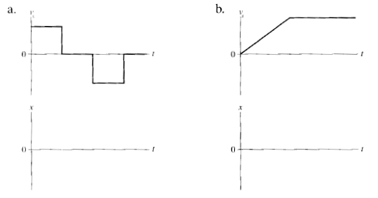
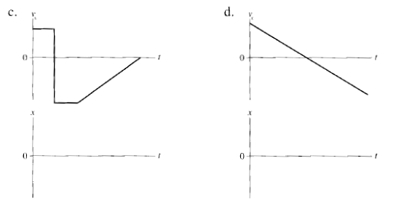

I can run at 90 m/s, 20% faster than my little brother (we're super heroes). We are running a 100m dash. How much of a head start (distance) should I give him so that we cross the finish line at the same time?

Make a sketch of the situation. Define a coordinate system and all of the relevant variables. Derive the analytical solution (no numbers!). Finally, plug in the numbers and calculate the answer.

You are traveling north in your car approaching a rail-road crossing. A 200 ft passenger train traveling east at 50 mi/hr is 40 ft away from the intersection. The front of your 10 ft long car is 30 ft away from the intersection.

a) What minimum speed does your car need so that the back end of your car clears the tracks before the train gets to the intersection?

b) What is the maximum speed that your car can be traveling so that it clears the back end of the train?

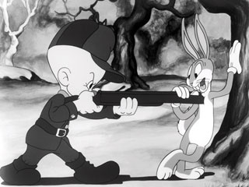
Elmer Fudd is hunting wabbits. He spots Bugs Bunny 25 feet due south of him. Bugs takes off running at 25 mi/hr 15º north of west. Bullets from Elmer's .38 special travel 600 ft/s.

What direction should Elmer fire so that his bullet intercepts Bugs.

