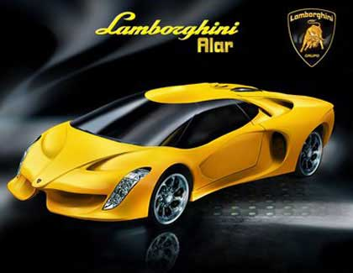
The salesman where I bought my car told me that my new Lamborghini can go from 0 to 60 miles per hour in 5 seconds. I tried bragging to my physicist friends, but they said “No car is worth owning that doesn't have an acceleration of at least 16 ft/s². And if you're going to own a car like that, you have to know how FAR it's gone after 5 seconds.”

a) Is my car cool enough for physics?
b) Am I cool enough for physics?
A daring ranch hand sitting on a tree limb wishes to drop vertically onto a horse galloping under the tree. The constant speed of the horse is 10.0 m/s, and the distance from the limb to the level of the saddle is 3.00 m.

What must be the horizontal distance between the saddle and the limb when the ranch hand makes his move?

Make a sketch of the situation. Define a coordinate system and all of the relevant variables. Derive the analytical solution (no numbers!). Finally, plug in the numbers and calculate the answer.

Circle the correct answers and briefly explain your reasoning.

(1) If you drop an object in the absence of air resistance, it accelerates downward at 9.8m/s². If instead you throw it downward, its downward acceleration after release is
1. less than 9.8 m/s².
2. 9.8 m/s².
3. more than 9.8 m/s².

(2) A person standing at the edge of a cliff throws one ball straight up and another ball straight down at the same initial speed. Neglecting air resistance, the ball to hit the ground below the cliff with the greater speed is the one initially thrown
1. upward.
2. downward.
3. neither—they both hit at the same speed.

(3) A train car moves along a long straight track. The graph shows the position as a function of time for this train. The graph shows that the train:

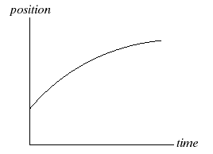

1. speeds up all the time.
2. slows down all the time.
3. speeds up part of the time and slows down part of the time.
4. moves at a constant velocity.

(4) You are throwing a ball straight up in the air. At the highest point, the ball’s
1. velocity and acceleration are zero.
2. velocity is nonzero but its acceleration is zero.
3. acceleration is nonzero, but its velocity is zero.
4. velocity and acceleration are both nonzero.

A subway train starts from rest at a station and accelerates at a rate of 1.60 m/s² for 14.0s. It runs at a constant speed for 70.0 s and slows down at a rate of 3.50 m/s² until it stops at the next station.

Accurately sketch the velocity and acceleration vs. time graphs for this situation.

During the interval of constant speed, how fast is the train going?

How far does the train travel as it decelerates to a stop?

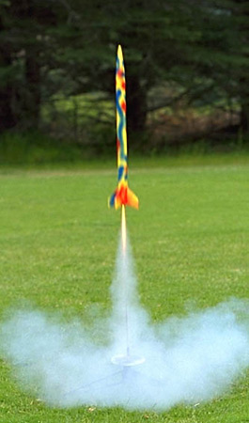
A model rocket, initially at rest, is fired vertically with an acceleration of 4.00 m/s2. After 6.00s, it's fuel is exhausted and it continues with the acceleration due to gravity.

a) Find the rocket's height and velocity at the moment that its the fuel runs out.
b) Find the rocket's maximum height.
c) Find the total time that the rocket is in the air.


Wile E. Coyote is standing on the edge of a cliff throwing dynamite. The cliff is 30.0 m high, and Wile E. throws the dynamite straight up in the air. The dynamite falls past the edge of the cliff and hits the ground 3.50 s after it was thrown.

(a) What was the dynamite’s initial velocity?

(b) Emboldened by his first throw, Wile E. decides to light the next stick and repeat his throw (same trajectory), this time trying to hit Roadrunner. The dynamite explodes 1.60 seconds after The Coyote throws it. Is he toast?

Speedy Sue, driving at 30.0 m/s, enters a one-lane tunnel. She then observes a slow-moving van 155 m ahead traveling at 5.00 m/s. She applies her brakes but can accelerate only at –2.00 m/s² because the road is wet. Will there be a collision? If so, determine how far into the tunnel and at what time the collision occurs. If not, determine the distance of closest approach between Sue’s car and the van.

Make a sketch of the situation. In the sketch define your coordinate system and appropriate variables. In your solution give equations in symbols, next equation with numerical values including units, then give answer.

