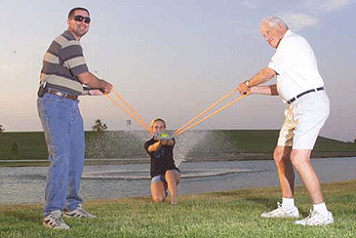
You and your buddies have created a water balloon slingshot. Using a radar gun, you measure the velocity of the water balloon as it leaves the slingshot. Because you're taking physics, your friends want you to work out how far the balloon will go for a given launch angle.

Find an equation for the horizontal distance the balloon will travel in terms of the magnitude of it's initial velocity and the launch angle with respect to the horizontal.

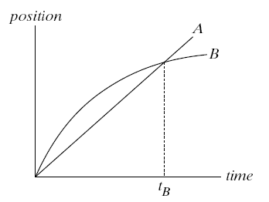
The graph shows position as a function of time for two trains running on parallel tracks. Which statement is true?

1. At time t_{B}, both trains have the same velocity.
2. Both trains speed up all the time.
3. Both trains have the same velocity at some time before t_{B}.
4. Somewhere on the graph, both trains have the same acceleration.

Explain.

Suppose you roll a ball off a table top. Will the time to hit the floor depend on the speed of the ball? Why?

A battleship simultaneously fires two shells at enemy ships. If the shells follow the parabolic trajectories shown, which ship gets hit first?

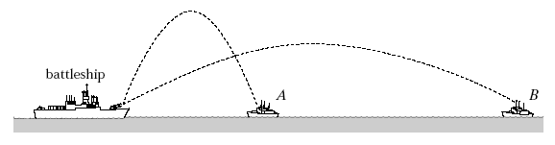
1. A
2. both at the same time
3. B
4. need more information

Explain.

6. At what point in its trajectory does a batted baseball have its minimum speed? Why?

7. A friend claims that bullets fired by some high-powered rifles travel for many meters in a straight-line path before they start to fall. Another friend disputes this claim and states that all bullets from any rifle drop beneath a straight-line path a vertical distance given by and that the curved path is apparent for low velocities and less apparent for high velocities. Now it’s your turn: Will all bullets drop the same vertical distance in equal times? Explain.

You throw a ball toward a wall with a speed of 25.0 m/s and at an angle of 40.0º above the horizontal. The wall is 22.0 m from the release point of the ball.

(a) How far above the release point does the ball hit the wall? (Be sure to draw a picture.)

(b) What are the horizontal and vertical components of its velocity as it hits the wall?

(c) When it hits, has it passed the highest point on its trajectory? How do you know?

You are sitting in the middle of a field listening to a concert when a water balloon hits you from behind at a speed of 14 m/s coming in at an angle of -60º as measured off of the x axis. If the rows are separated by 1.5 m, how many rows behind you are the vandals sitting?

a. Draw a sketch of the situation showing ALL relevant variables and define the coordinate system.
b. Using the kinematics equations, derive an expression for the number of rows in terms of GIVEN variables defined in part a.
c. Using your expression from part b and numbers given in the problem statement, calculate the number of rows.

Gumby has just purchased a new skateboard; but, unfortunately, he does not know how to stop. Traveling at 8.0 m/s, he reaches the top of a hill sloping down at 30.0º.

How far down the hill does Gumby crash? (Find the distance d)

