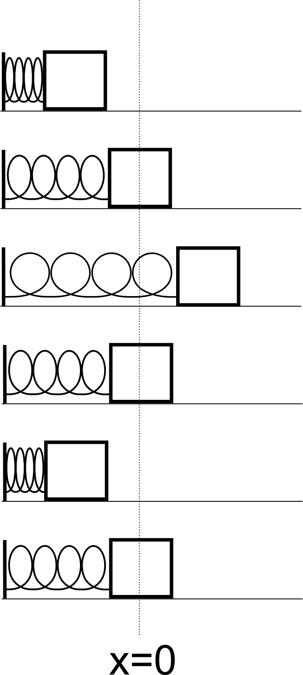
Each row in the table below represents a snapshot of a mass attached to a spring. Assume that the mass starts from rest in the first row. In the second row, it is passing through x=0. In the third row, it has reached its maximum extension. In the fifth row, it has reached its maximum compression. In the cells below, mark an arrow indicating the direction of the associated force, acceleration, velocity, and position vectors for each row. If the magnitude is zero, put a zero in the cell.

F | a | v | x

The general form of the differential equation describing a simple harmonic oscillator is:

$$\frac{d^{2}x}{{\text{dt}}^{2}}=−ω^{2}x$$

a) Show that the differential equation is satisfied if$\text{x=A}\text{cos}\left(\text{ωt+φ}\right)$where A, ω, and φ are constants.

b) Derive an expression for the velocity of a simple harmonic oscillator.
c) Derive an expression for the acceleration of a simple harmonic oscillator.
HINT: What are the definitions of velocity and acceleration?

d) Why can't we apply the kinematics equations to a simple harmonic oscillator?

The figure below is a position versus time graph of a particle in simple harmonic motion. Assume that it's position is given by: $\text{x=A}\text{cos}\left(\text{ωt+φ}\right)$
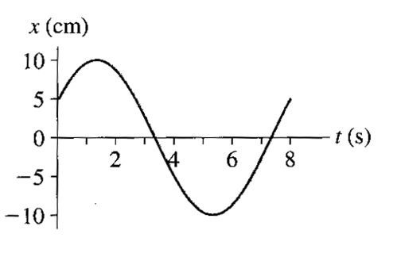

a) What is the maximum displacement (amplitude) of the particle?
What is the maximum value of the cos function?
Which constant in the above equation gives the maximum displacement?

b) What is x when t = 0?
Given your answer to part a, what is the value of φ (known as the phase constant) when t = 0?

c) What is the period (T) of the oscillations?
What are the units of ω? (HINT: What are the units of the phase angle?)
What is the mathematical relationship between ω and T?
Find the numerical value of ω.

d) What is the maximum velocity?

e) What is the maximum acceleration?

A block with a mass of m = 2.00 kg is attached to a spring with a spring constant k = 100 N/m. When t = 1.00 s, the position and velocity of the block are x(1s) = 0.129 m and v(1s) = 3.415 m/s.

a) Find the angular frequency, ω, of the oscillator.

b) Find the phase constant.

c) Find the amplitude

d) What was the position of the block at t = 0.00 s?

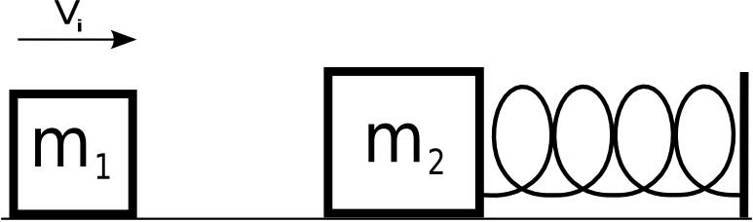
A block with a mass of m₁ = 10 kg is moving to the right with a velocity V_{i}. It collides and sticks to a block with a mass of m₂ = 15 kg. The second mass is attached to a spring with spring constant k=3 N/m. Before the collision, the spring is at rest in it's equilibrium position.

a) What is the frequency, ν, of the resulting oscillator after the collision?
b) Assuming that the moment of collision is t=0, find the phase constant of the oscillator?
c) If the resulting amplitude of the oscillator is A = 3 m, what was the initial velocity of m₁?

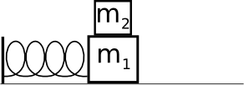
Two blocks, m₁=10 kg and m₂=1 kg, and a spring (k=200 N/m) are arranged on a horizontal, frictionless surface. The coefficient of static friction between the blocks is μ_{s}=0.40. What is the maximum amplitude of the resulting simple harmonic oscillator if m₂ is not to slip?

