The device in the picture below is known as a torsion pendulum. It is a flat disk attached to a length of stiff wire. When the wire is twisted, it responds by providing a torque on the disk, much the same way a spring provides a force when it is stretched. The torque provided by the wire is$\text{T=}−\text{κθ}$, where κ (greek letter kappa) is the torsion constant and theta is the angular displacement from equilibrium.

a) The moment of Inertia of the disk is $\text{I=}\frac{1}{2}{\text{MR}}^{2}$. Using the rotational version of Newton's Second Law, find the oscillator frequency of the torsion pendulum.

b) If a solid bar of length L,$\text{I=}\frac{1}{\text{12}}{\text{ML}}^{2}$, were suspended from the wire, what would the oscillator frequency be?

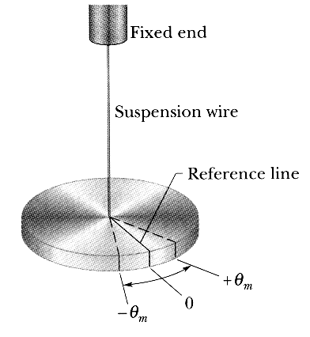
Below is a simple pendulum consisting of a massless rod of length L with a point mass if mass m attached to the end.

a) Find the frequency of small oscillations of the pendulum.
b) At t=0, the pendulum makes an angle θ₀ with the vertical and the point mass has a velocity V₀. What is the phase angle of the oscillator?
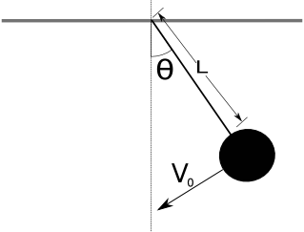

A solid cylinder of mass M is attached to a horizontal spring with force constant k. The cylinder can roll without slipping along the horizontal plane. When the system is displaced from the equilibrium position, it executes simple harmonic motion. Derive an expression for the period of the oscillations in terms of M, k, and I.

A meter stick with a mass M is suspended from one end and allowed to swing like a pendulum.

a) What is its period of small oscillations?
b) What length L does a simple pendulum (a point mass attached to a massless rod) need in order to have the same period?

A block of mass M resting on a frictionless surface is attached to a stiff rod of negligible mass. The other end of the rod is attached to the top of a thin bar of length l mass M that is allowed to rotate about its center. The bottom of a bar is attached to a light spring of spring constant k. The spring is relaxed when the bar is vertical. Find the frequency of small oscillations.
