Name:

By writing my name above, I affirm that this test represents my work only, without aid from outside sources. In all aspects of this course I perform with honor and integrity.

Show your work on all of the problems. Your approach to the problem is as important as, if not more important than, your answer. Draw clear and neat pictures showing coordinate systems and all of the relevant problem variables. also, explicitly show the basic equations you are using. Be neat and thorough. The easier it is for me to understand what you are doing, the better your grade will be.

A few potentially useful equations

Moment of Inertia, discrete definition $\text{I=}\sum{m_{i}}r_{i}^{2}$

Moment of Inertia, integral definition $\text{I=}\int{r^{2}}\text{dm}$

Parallel Axis Theorem ${\text{I=I}}_{\text{cm}}{\text{+Md}}^{2}$

Superposition $I_{\text{Total}}=\sum{I_{i}}$

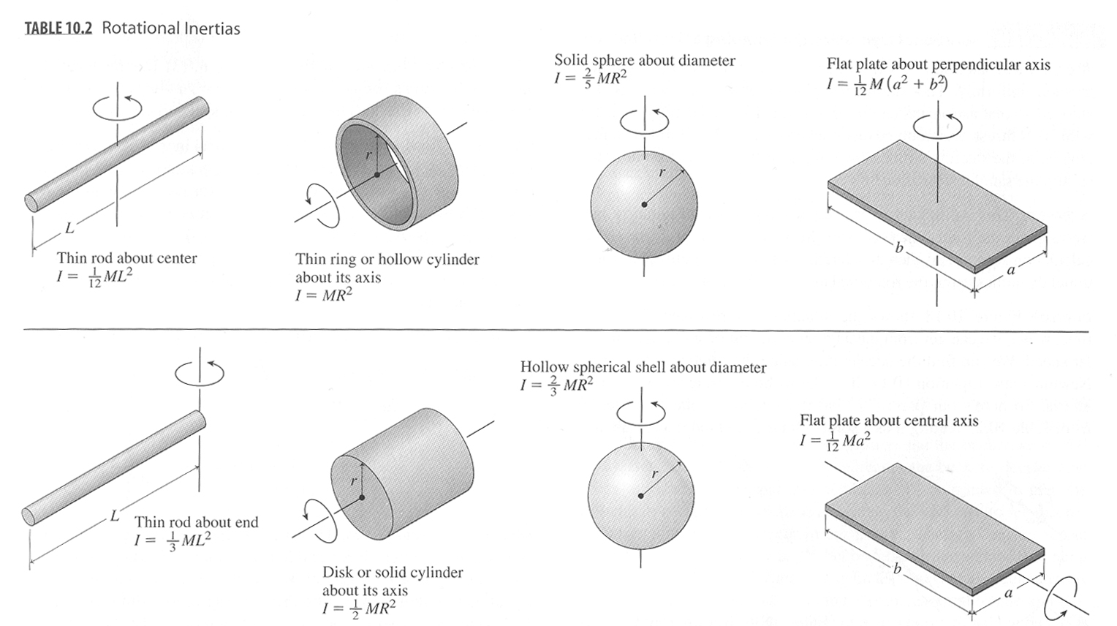

1) Derivations
a) (10pts) Given a differential equation of the form $\frac{d^{2}x\left(t\right)}{{\text{dt}}^{2}}=−ω^{2}x\left(t\right)$, write the general solution for $x\left(t\right)$, $v\left(t\right)$, and $a\left(t\right)$in terms of the angular frequency ω, the amplitude A, and the phase angle φ.

b) (10pts) Given the boundary conditions $x\left(t_{0}\right){\text{=x}}_{0}$and $v\left(t_{0}\right){\text{=v}}_{0}$, derive an expression for the phase angle φ and the amplitude A in terms of x₀, v₀, and ω.

A block of mass m_{b} = 5.0 kg is attached to a spring of spring constant k = 4 N/m where it is allowed to oscillate horizontally on a frictionless surface. The spring is compressed a distance d = 0.5 m from equilibrium and released. As the block passes equilibrium, a wad of clay, m_{c} = 10.0 kg, falls from directly above and sticks to the block.

a) What is the angular frequency of the block/clay system?
b) What is the velocity of the block/clay system just after the collision?
c) What is the amplitude of the block/clay system?

A wheel is free to rotate about a fixed axle. A spring with a spring constant k is attached to one of its spokes at a distacne r from the axle, as shown in the picture. Assume that the wheel is a hoop of mass m and radius R (the spokes have negligible mass).

a) Using Newton's Second Law, find the angular frequency of small oscillations in terms of m, R, r and the spring constant k.
b) Using Energy techniques, find the angular frequency of small oscillations in terms of m, R, r and the spring constant k.
b) What is the angular frequency if r = R.
c) What is the angular frequency if r = 0.
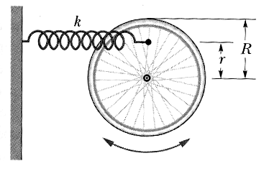
A 1 kg meter stick is hung from its and allowed to pivot. A small wad of clay with a mass of 0.25 kg with a velocity V_{c} = 2 m/s impacts the bottom of the meter stick. Assuming that the resulting oscillations are small:

a) Find the angular frequency of the resulting pendulum.

