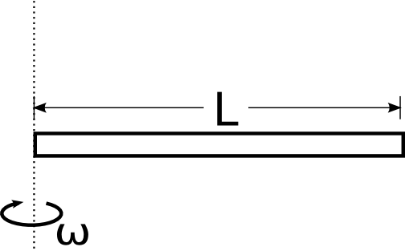
Calculate the moment of inertia of a uniform bar of length L and mass M about the axis of rotation shown.

Calculate the moment of inertia of a uniform bar of length L and mass M about the axis of rotation shown.
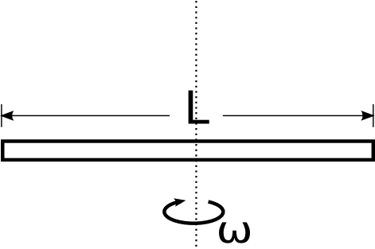
Four point masses, each of mass m, are attached to a rigid massless rod that makes an angle θ with the axis of rotation. Let L₂ = 2L₁.

a) What is the moment of inertia of this system?
b) What is the kinetic energy of this system if it's rotating with angular velocity ω.
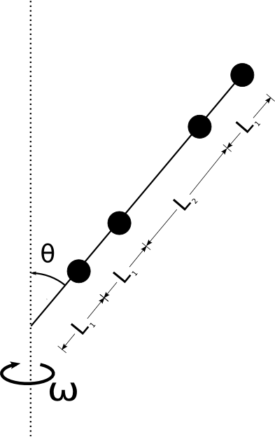
Calculate the moment of inertia of the bent rod of mass M shown in the figure below. The rotation axis is in the plane of the "V" bisecting it at the vertex. The rod is bent at an angle θ and each leg has a length L.

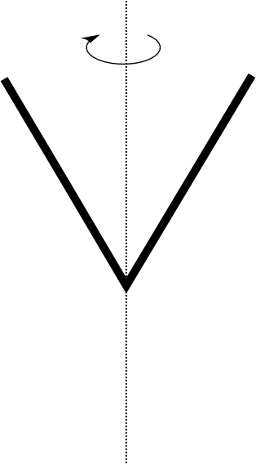

A thin rod of length L has a non-uniform density profile of ${\text{λ=λ}}_{0}\left[2\frac{l^{2}}{L^{2}}+\frac{1}{3}\right]$.

What is the moment of inertia of this rod if it's about an axis perpendicular to the light end of the rod?
Write it in terms of the total mass M.

HINT: Integrate to get the total mass and then integrate to get the moment of inertia and combine the two results.

