A clock pendulum is constructed from a solid bar of length L and mass M with a disk of radius R and mass m. The bar is then hung from a pivot at one end and the disk is attached to the opposite end, as in the picture below.

a) The moment of inertia of a uniform rod about an axis perpendicular to the rod through its center of mass is $I_{\text{cm}}=\frac{1}{\text{12}}{\text{ML}}^{2}$. Using the Parallel Axis Theorem, calculate the moment of inertia of the rod about one end.

b) The moment of inertia of a disk about an axis perpendicular to its surface through its center of mass is $I_{\text{cm}}=\frac{1}{2}{\text{mR}}^{2}$. Using the Parallel Axis Theorem, calculate the moment of inertia of the disk when it's attached to the pendulum as shown in the picture below.

c) Using the Principal of Superposition, calculate the moment of inertia of the combined rod-disk system.
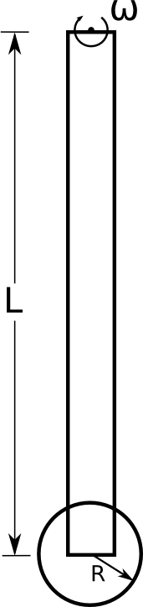
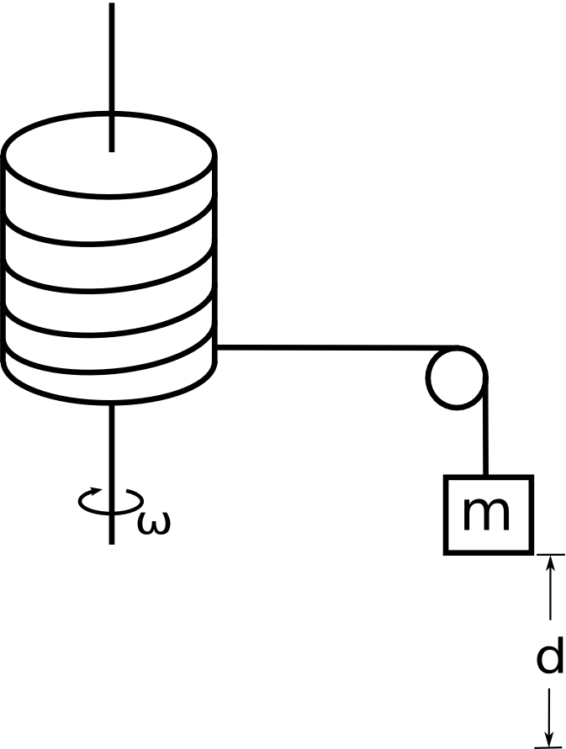
A solid cylinder of mass M, radius R, and moment of inertia I = ½MR² is allowed to rotate without friction about an axis through its center as shown. A massless string is wrapped around the cylinder, passes over a small massless frictionless pulley and is attached to a small mass m.

If the mass and the cylinder start from rest, what will the angular velocity of the cylinder be after the mass falls through a distance d?

Using conservation of energy, find an expression for ω_{f} in terms of d, M, m, and R.

Use work energy to solve the following problem.
Two masses are connected by a light string passing over a frictionless pulley. the Mass m₂ is released from rest at a height of 4.0 m above the ground. You can treat the pulley as a solid disk.

Determine the speed of m₁ as m₂ hits the ground.

m₁ = 3.0 kg
m₂ = 5.0 kg
m_{pulley} = 0.5 kg
r_{pulley} = 0.1 m

A rolling object with a radius R, mass m, and moment of inertia $I_{\text{cm}}=\frac{1}{2}{\text{mR}}^{2}$, starts from rest at the top of an incline plane of height h that makes an angle θ with the horizontal.

a) What is the linear velocity of disk at the bottom?
b) What is the angular velocity of the disk at the bottom?

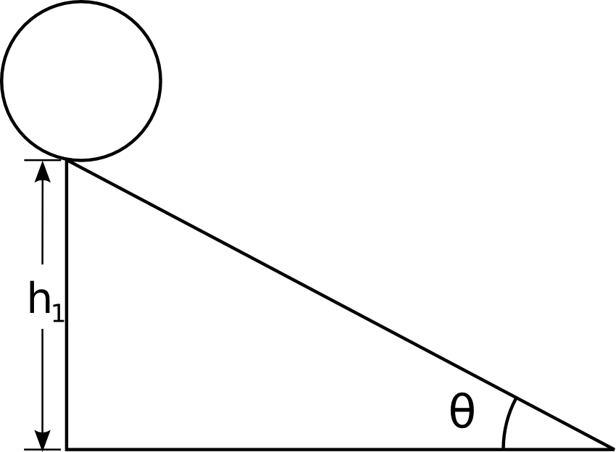

A solid cylinder (radius = 2R, mass = M) rolls without slipping as it is pulled by a massless yoke attached to a string. The string goes over a frictionless pulley shaped as a solid disk (radius = R, mass = M) and is attached to a hanging weight (mass = M).

What is the velocity of the hanging weight after it has fallen a distance d?

Consider, once again, the clock pendulum pictured below. The disk has a mass m and radius r and the bar has mass M and length L.

a) Calculate the center of mass of the combined bar-disk system as measured from the axis of rotation.
b) If the pendulum is pivoted so that it makes an angle θ with the vertical, what will the angular velocity be when θ=0?

A block of mass M rests on a rough table with μ_{k} = 0.3. A massless string is attached to the block, wrapped around a solid cylinder having a mass M and a radius R, runs over a massless frictionless pulley, and is attached to a second block of mass M that is hanging freely.

Using work/energy techniques, calculate the velocity of the blocks after they have moved a distance d.

$$I_{\text{cylinder}}=\frac{1}{2}{\text{MR}}^{2}$$

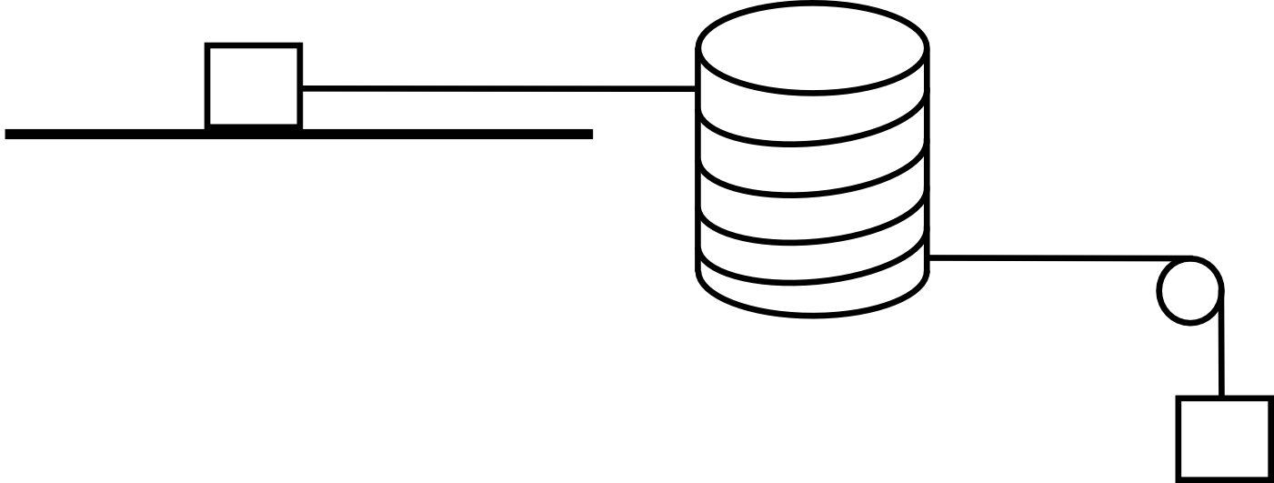
[ NOTE: Do NOT use torque/kinematics ]

