Below are several objects. Each circle is a point mass, and each point has the same mass. The connecting rods are massless. Rank them in order of moment of inertia, least to most. If any have the SAME moment, give them the same ranking number. Explain your reasoning.

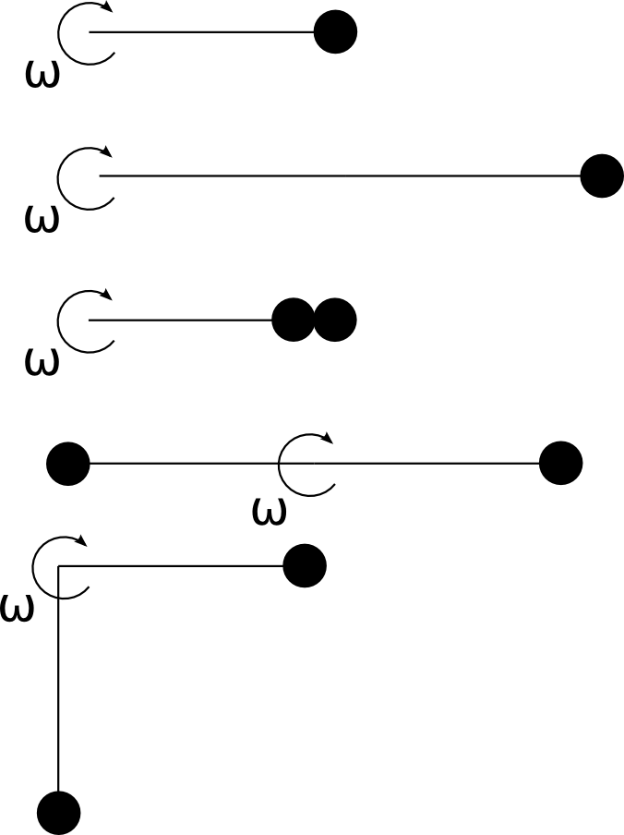

Circular disks A and B have the same mass and thickness, but the density of disk A is greater than the density of disk B. Which has the greater moment of inertia? Explain your reasoning.

Two bars have the same mass, but one is shorter than the other. Which has a larger moment of inertia? Explain your reasoning.

Below are the cross sections of five solids with identical masses. They are allowed to rotate about an axis through their centers perpendicular to the plane of the page. They all have equal widths at their widest points. Without looking them up or doing any calculations, rank the objects in order of moment of inertia, least to most. Explain your reasoning.


In the pictures below, two masses are connected by a massless rod and the system is allowed to rotate about the pivot shown. The large circle is more massive than the small circle. A force is applied to each system as shown in the diagram. Rank the three systems in order of their angular accelerations, least to most. Explain your reasoning.

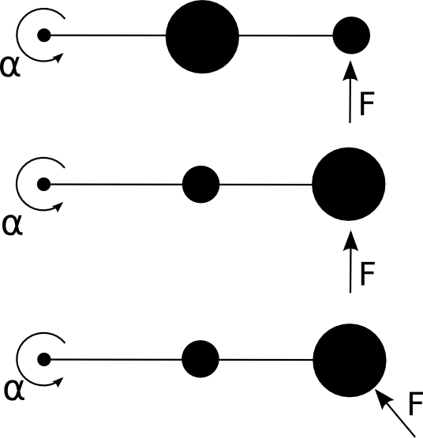

In the pictures below, two masses are connected by a massless rod and the system is allowed to rotate about the pivot shown. A force is applied to each system as shown in the diagram. Rank the three systems in order of their angular accelerations, least to most. Explain your reasoning.
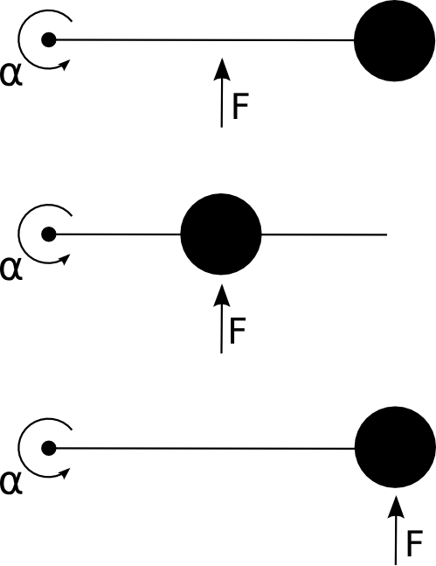

Two meter sticks are stood in the corner where the floor meets the wall. One has a large mass attached to the end furthest from the corner. Which one hits the ground first? Discuss.
A small 0.75 kg ball is attached to one end of a 1.25 m long massless rod. The other end of the rod is hung from a pivot under the influence of gravity. When the resulting pendulum is 30⁰ from vertical:

a) What is the magnitude of the torque about the pivot? (Draw a free body diagram)
b) What is the instantaneous angular acceleration (the acceleration at the moment when the pendulum is released)?
c) Can we use kinematics to find the angular velocity of the pendulum at the bottom of its swing? Why or why not?

A cylinder with a mass of 2.0 kg can rotate about its central axis through the point 0. Forces are applied as in the figure below. F₁ = 6.0 N, F₂ = 4.0 N, F₃ = 2.0 N, F₄ = 5.0 N, R₁ = 5 cm, R₂ = 12cm. Find the direction and the magnitude of the angular acceleration of the cylinder. (During rotation, the forces maintain the same angles relative to the cylinder.)
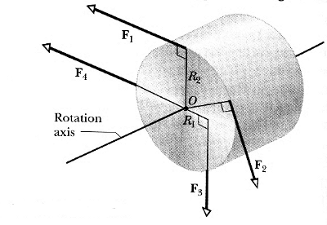
A door has a mass of 50 kg and is 0.8 m wide. The moment of inertia is I = 1/3 MW² where W is the width of the door. I push on the door with a constant force of F = 10 N in two places; in the middle of the door a distance W/2 from the hinge and at the knob, a distance W from the hinge.

a) Draw free body diagrams of the two cases.
b) What is the magnitude of the Torque for each case?
c) What is the magnitude of the angular accelerations for each case?
d) How much time does it take the door to rotate through 90⁰ in each case?
e) How much force would I have to apply at W/2 so that the door rotated through 90⁰ in the same amount of time as applying 10 N to the knob?

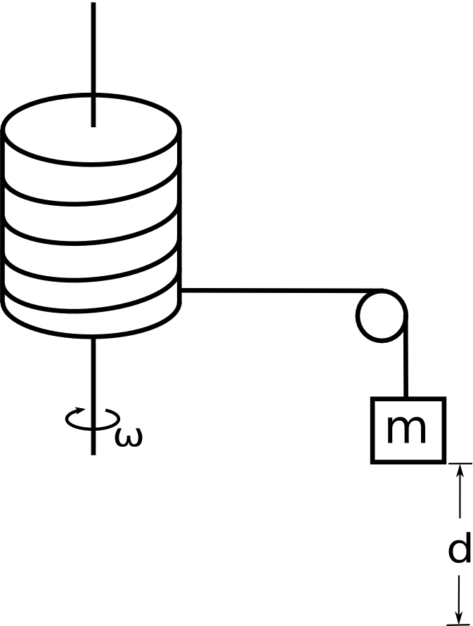
A solid cylinder of mass M, radius R, and moment of inertia I = ½MR² is allowed to rotate without friction about an axis through its center as shown. A massless string is wrapped around the cylinder, passes over a small massless frictionless pulley and is attached to a small mass m.

If the mass and the cylinder start from rest, what will the angular velocity of the cylinder be after the mass falls through a distance d?

Using Torque and Kinematics, find an expression for ω_{f} in terms of d, M, m, and R.

