Use Torque and Kinematics to solve this problem.

A rolling object with a radius R, mass m, and moment of inertia I, starts from rest at the top of an incline plane of height h that makes an angle θ with the horizontal.

a) Find an expression for the linear and angular acceleration of the object in terms of I.
b) Using kinematics, find an expression for the linear and angular acceleration of the object in terms of I?
c) Assume that the object is a disk with $\text{I=}\frac{1}{2}{\text{mR}}^{2}$ and plug I into your velocity expressions. Verify that your answers are the as when you solved this problem using energy.

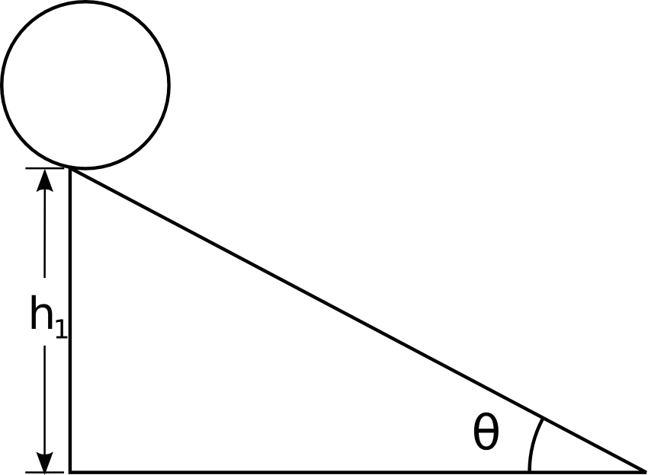

Use Torque and Kinematics to solve the following problem.

Two masses are connected by a light string passing over a frictionless pulley. the Mass m₂ is released from rest at a height of 4.0 m above the ground. You can treat the pulley as a solid disk.

$$I_{\text{pulley}}=\frac{1}{2}{\text{MR}}^{2}$$

Determine the speed of m₁ as m₂ hits the ground.

m₁ = 3.0 kg
m₂ = 5.0 kg
m_{pulley} = 0.5 kg
r_{pulley} = 0.1 m

Use Torque and Newton's Second Law solve this problem.

A solid cylinder (radius = 2R, mass = M) rolls without slipping as it is pulled by a massless yoke attached to a string. The string goes over a frictionless pulley shaped as a solid disk (radius = R, mass = M) and is attached to a hanging weight (mass = M).

$$I_{\text{cylinder}}=\frac{1}{2}{\text{MR}}^{2}$$

What is the acceleration of the system?

Use Torque and Newton's Second Law solve this problem.

A block of mass M rests on a rough table with μ_{k} = 0.3. A massless string is attached to the block, wrapped around a solid cylinder having a mass M and a radius R, runs over a massless frictionless pulley, and is attached to a second block of mass M that is hanging freely.

Find the acceleration of this system.

$$I_{\text{cylinder}}=\frac{1}{2}{\text{MR}}^{2}$$

