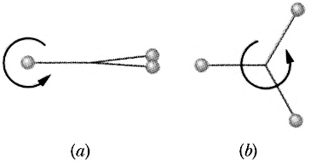
1. A Bola consists of three heavy balls connected to a common point by identical lengths of sturdy string. It is launched by holding one of the balls overhead and rotating the wrist, causing the other two balls to rotate in a horizontal circle. When it is released, its configuration changes from that shown in figure a to that shown in figure b.

Does its angular momentum about it's axis of rotation increase, decrease, or stay the same?
Does it's angular velocity about it's axis of rotation increase, decrease, or stay the same?
Discuss.

2. Below is the overhead view of a rectangular slab that is allowed to rotate freely about a point at its center. The numbered arrows represent seven paths along which wads of bubble gum are thrown, all with the same mass and speed, that stick to the edge of the slab.

Rank the paths according to angular speed of the slab gum combination after impact.

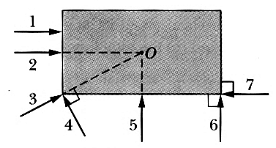

The diameter of the Sun is approximately 100 Earth diameters and has a rotational period of about 25 days. If it ran out of nuclear fuel and suddenly collapsed to the diameter of the Earth, what would it's new rotational period be?

$$I_{\text{sphere}}=\frac{2}{5}{\text{MR}}^{2}$$

A disk with moment of inertia of I₁ rotates about a vertical, frictionless axle with an angular speed ω_{o}. A second disk, initially at rest, has a moment of inertia I₂ and is dropped onto the first disk. Because of friction between the two surfaces, the two disks eventually reach the same speed ω_{f}.

(a) Calculate ω_{f}.

(b) Show that the kinetic energy of the system decreases in this interaction and calculate the ratio of the final rotational energy to the initial rotational energy.

A child of mass M is on the outer edge of a merry-go-round that has a radius R and a moment of inertia I. Her friend throws a baseball with a mass m and velocity v in a direction tangent to the edge of the merry-go-round that is caught by the girl.

Find an expression for the angular velocity of the child, merry-go-round, baseball combination after the impact.

A bullet of mass m is fired with a velocity v_{b} perpendicular to a door of width W and mass M. The moment of inertia of the door about its center is I_{cm} = 1/12MW². The bullet impacts the door on the edge opposite the hinge as shown in the picture below. Find an expression for the angular velocity of the bullet door combination after the impact.
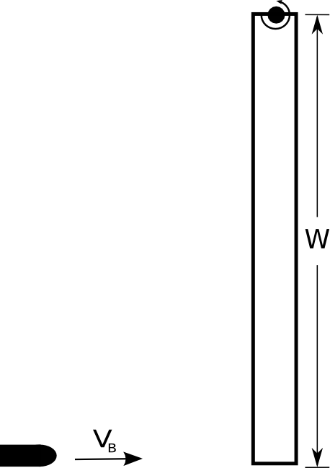
A chunk of clay of mass m_{clay} = 0.500 kg is moving at a velocity of 3.00 m/s when it hits and sticks to a long thin rod that is hung from a point ¼ of the way down from the top. The rod has a mass of m_{rod} = 2m_{clay} = 1.00 kg and a length of 1.00 m.
The moment of inertia a long thin rod about its center of mass is $I_{\text{cm}}=\frac{1}{\text{12}}{\text{mL}}^{2}$.

(a) What is the moment of inertia of the rod–clay combination? Calculate a number that you can use in the remainder of this problem.

(b) Where is the center of mass of the rod-clay combination as measured from the pivot point? Calculate a number that you can use in the remainder of this problem.

(b) What is ω of the resulting pendulum right after the collision?

(d) What is the maximum angle θ that the pendulum makes with the vertical?

