Name:

By writing my name above, I affirm that this test represents my work only, without aid from outside sources. In all aspects of this course I perform with honor and integrity.

Show your work on all of the problems. Your approach to the problem is as important as, if not more important than, your answer. Draw clear and neat pictures showing coordinate systems and all of the relevant problem variables. also, explicitly show the basic equations you are using. Be neat and thorough. The easier it is for me to understand what you are doing, the better your grade will be.

1) Derivations
a) (10pts) Starting with the definition of linear Kinetic energy ($\text{K=}\frac{1}{2}{\text{mV}}^{2}$), show that rotational kinetic energy of a rigid body is$\text{K=}\frac{1}{2}{\text{Iω}}^{2}$ where $\text{I=}\int{r^{2}}\text{dm}$.

b) (10pts) Starting with the definition of angular momentum ($\text{L=m}\left(\vec{r}×\vec{V}\right)$), show that the angular momentum of a rigid body is $\text{L=Iω}$ where $\text{I=}\int{r^{2}}\text{dm}$.

2. The picture below shows a modified atwood machine composed of two pulleys of different radii that have been glued together so that their angular velocities will be the same. Two blocks of equal mass are attached to the system by ropes. One rope is wound around the small pulley and the other rope is wound around the large pulley. The mass of the pulley is the same as the mass of the two blocks and R₂ = ½ R₁.

Assume that the moment of inertia of the pulley is $I=\frac{1}{2}{MR}_{1}^{2}$
Also, let

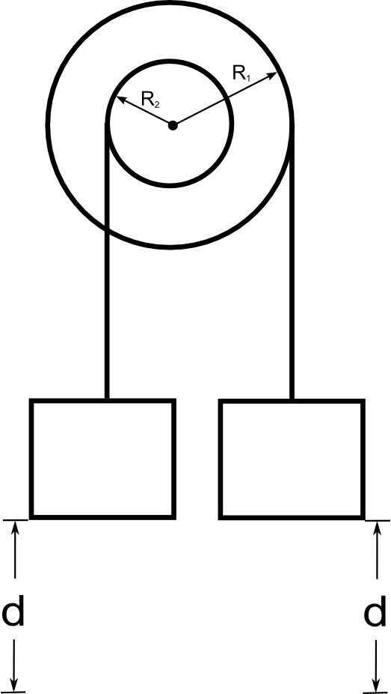
a) If the masses are initially at rest, which way will the pulley rotate, clockwise or counter clockwise?
b) Using Work/Energy techniques, find an expression for the angular velocity of the pulleys after the mass attached to the large pulley has moved a distance d.

3.The picture below shows a modified atwood machine composed of two pulleys of different radii that have been glued together so that their angular velocities will be the same. Two blocks of equal mass are attached to the system by ropes. One rope is wound around the small pulley and the other rope is wound around the large pulley. The mass of the pulley is the same as the mass of the two blocks The mass of the pulley is the same as the mass of the two blocks and R₂ = ½ R₁.

Assume that the moment of inertia of the pulley is $I=\frac{1}{2}{MR}_{1}^{2}$

a) Using Newton's Second Law (the rotational version and/or the translational as appropriate), find an expression for the angular acceleration of the pulleys.
b) Using your expression for acceleration from part a and kinematics, find an expression for the angular velocity of the pulleys after the mass attached to the large pulley has moved a distance d.

4) Two skaters, each with a mass of 50 kg, approach each other along parallel paths separated by 3.0 m. They have equal and opposite velocities of 1.4 m/s. The first skater is holding one end of a long pole with negligible mass. As the skaters pass, the second skater grabs the other end of the pole. Assume that the ice is completely frictionless.

a) What is the moment of inertia about the center of mass of the resulting skater-pole system?
b) What is the resulting angular velocity of the skater-pole system?

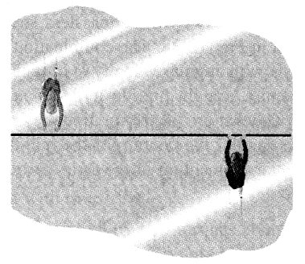

5) A long, uniform rod of length L and mass M is pivoted about a horizontal, frictionless pin passing through one end of the rod. The rod is given a very slight push when it is in a vertical position.
The moment of inertia of a rod about its center of mass is $I_{cm}=\frac{1}{12}{ML}^{2}$

Find the angular velocity of the rod as it passes the horizontal

