Name:

By writing my name above, I affirm that this test represents my work only, without aid from outside sources. In all aspects of this course I perform with honor and integrity.

Show your work on all of the problems – your approach to the problem is as important as (if not MORE) important than) your final answer.

1) Derive the equations for the final velocities of particles undergoing an elastic collision in 1 dimension.

2. Three particles (point masses) are positioned at the vertices of an equilateral triangle. The two of the particles on the x-axis have the same mass. The y position of the center of mass is exactly halfway between the x-axis and the third particle. What is the mass of the third particle?
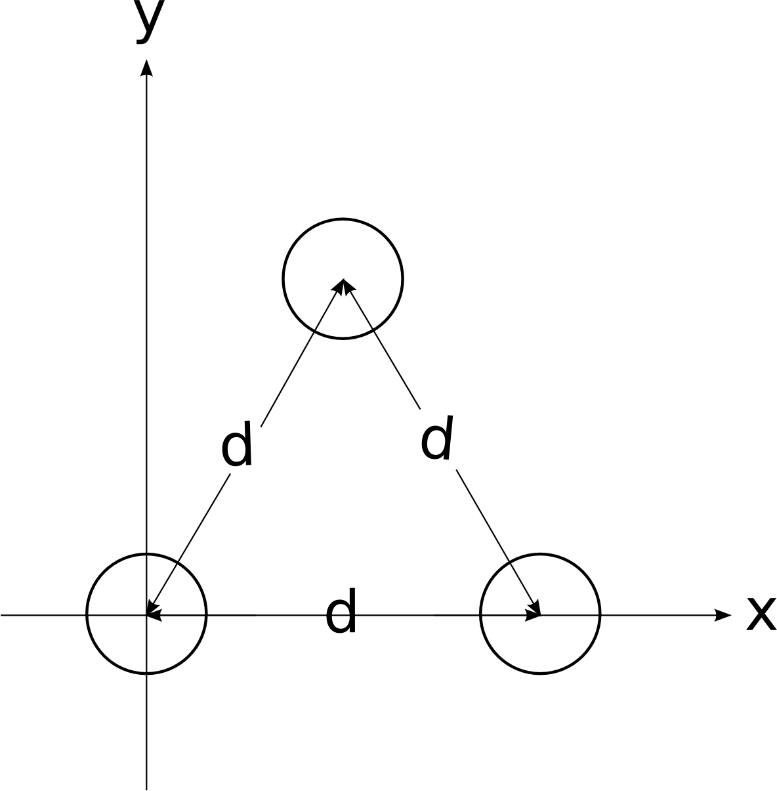

3. Find the location of the center of mass of a quarter of a circle of radius R.
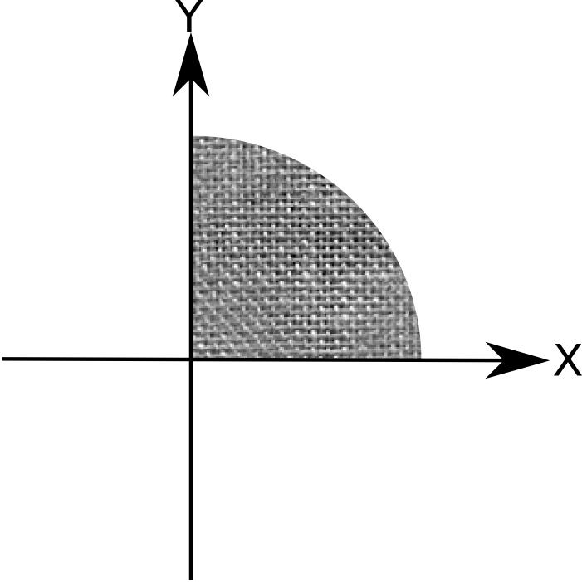

4. A mass m₁ = 3 kg is attached to a string of length l = 4.0 m to create a pendulum. The pendulum, initially making an angle θ with the vertical, is released from rest. At the bottom of its swing, it collides elastically with mass m₂ = 5 kg. Mass 2 rolls (no friction) and sticks to m₃ = 5 kg. The m₂, m₃ combination slides with μ_{k} = 0.3 a distance d = 0.2 m before coming to rest.

What was the original value of θ?
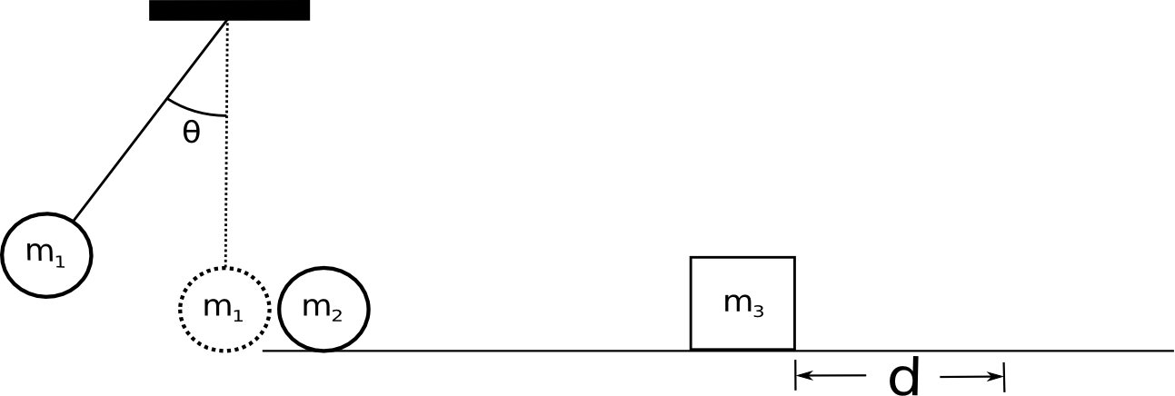

5. A cannon and 20 cannon balls are inside of a sealed railroad car of length L. The cannon fires balls to the right where they collide inelastically with the far wall and stop. The train car weighs 6000 kg, the cannon weighs 500 kg and each cannon ball weighs 20 kg. Assume that the track is frictionless, cannon is small compared to the car, and that the cannon balls travel the entire distance L.

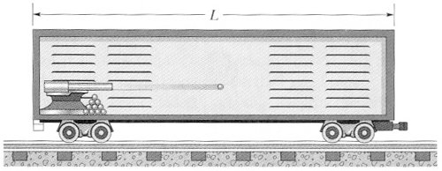

a) How far has the train car moved after ALL of the cannon balls have been fired?
b) What is the final velocity of the car after all of the cannonballs have hit the opposite wall?

