Three balls of equal mass form an equilateral triangle. Assume that the balls are point masses and find the center of mass of the system.

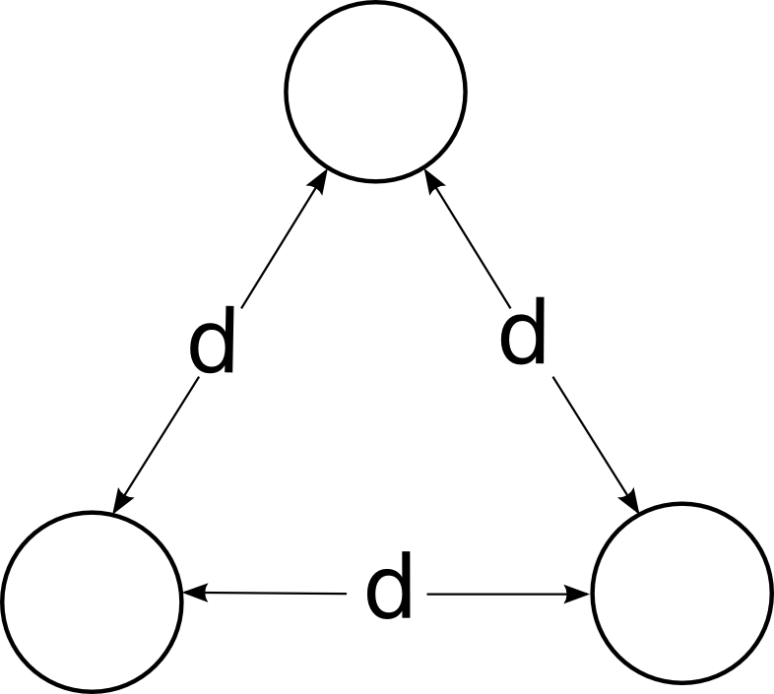

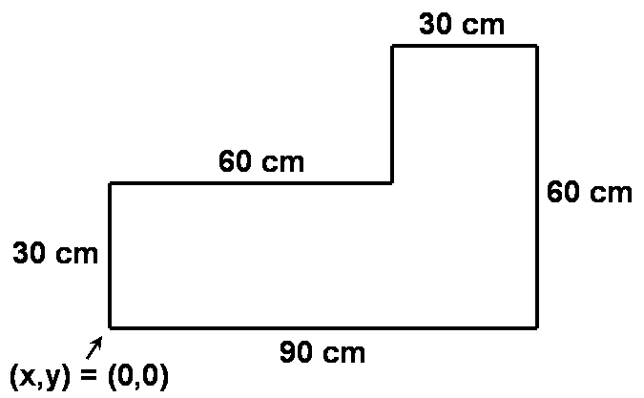
The uniform sheet of plywood in the figure has a mass of 20 kg. Find the x and y coordinates of the center of mass.

HINT: For a perfectly rectangular piece of plywood, the center of mass is exactly in the center of the piece. Imagine that the plywood is composed of two rectangular pieces and then treat those two pieces as point masses located at the center of mass of each piece.

A thin rod of length L has a non-uniform density profile of ${\text{λ=λ}}_{0}\left[2\frac{l^{2}}{L^{2}}+\frac{1}{3}\right]$.

where l is the distance from one end of the rod and λ₀ is a constant and has units of mass per unit length.

a) Calculate the total mass of the rod.
b) Calculate the center of mass of the rod.

Calculate the center of mass of a triangular chunk of aluminum of mass M, length l, and height h.
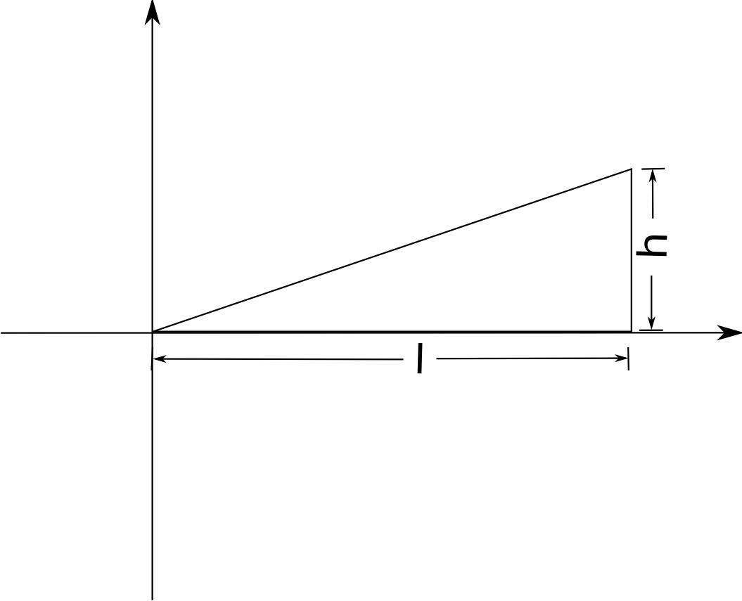

A flat piece of aluminum is cut into a semi-circle of radius R. Calculate the coordinates of the center of mass.

