1. Which would be more damaging – driving into a massive concrete wall, or driving at the same speed into a head-on collision with an identical car traveling toward you at the same speed? Explain.

2. A lunar vehicle is tested on Earth at a speed of 10 km/hr. When it travels as fast on the moon, is its momentum more, less, or the same?

3. It is generally much more difficult to stop a heavy truck than a skateboard when they are moving at the same speed. State a case where the moving skateboard (still moving at the same speed) could require more stopping force.

4. A drain plug is opened in the bottom of a rolling car that is full of water. Consider the effects of speed, momentum, and kinetic energy of the rolling car.

The speed of the car will
(a) increase (b) decrease (c) not change.

The momentum of the car will
(a) increase (b) decrease (c) not change.

The kinetic energy of the car will
(a) increase (b) decrease (c) not change.

A golf ball G and a bowling ball B, move towards each other, collide and bounce apart. Let F_{G} be the force experienced by the golf ball and let F_{B} be the force experienced by the bowling ball.

1. F_{G} is ____ F_{B}.
a) Greater than
b) The same as
c) Less than

2. The amount of time that F_{G} is applied is ____ the time that F_{B} is applied.
a) Greater than
b) The same as
c) Less than

3. Sketch a graph showing a plausible F_{G} as a function of time and another graph showing F_{B} function of time. Be sure to consider the sign of each force.

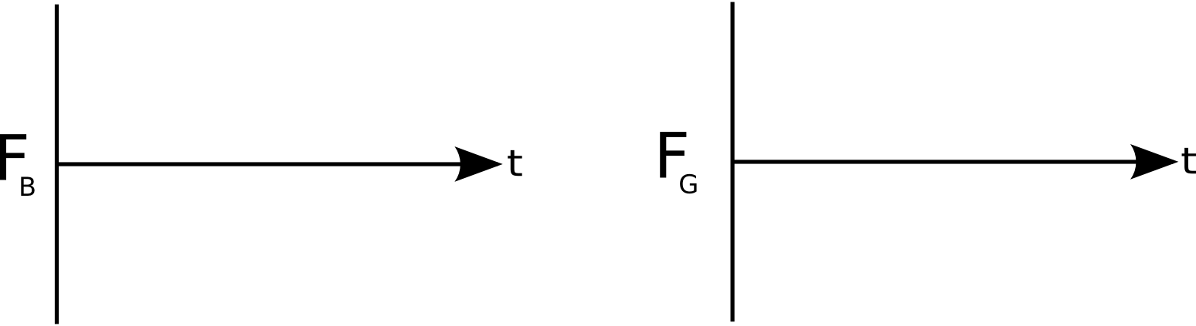

4. Compare the impulse delivered to the golf ball to the impulse delivered to bowling ball. What's the same? What's different?

5. The magnitude of the change in momentum of the golf ball is ___ the magnitude of the change in momentum of the bowling ball
a) Greater than
b) The same as
c) Less than

6. After the collision, the kinetic energy of the golf ball is ____ the kinetic energy of the bowling ball.
a) Greater than
b) The same as
c) Less than

Train Car A has a mass of 2600 kg and a velocity of 16 m/s to the right. It collides with a stationary Train Car B whose mass is 5900 kg. The cars undergo a partially elastic collision bounce off of each other, and Car B moves to the right at 8 m/s. The two cars are in contact with each other for 1.8 seconds during impact.

a) What is the velocity of Train Car A just after the collision?
b) What average force (magnitude and direction) does Car A exert on Car B during the collision?
c) What impulse (magnitude and direction) does Car B exert on Car A during the collision?
e) Calculate the change in momentum of both cars.
d) How much energy was lost in the collision?

A truck moving at 30.0 m/s undergoes a perfectly inelastic head-on collision with a car moving at 22.0 m/s. The total mass of the truck, including the driver is 9000 kg and the total mass of the car, including the driver and passenger, is 1500 kg. Each driver has a mass of 60.0 kg and the collision time for the drivers is 0.200 s. The car passenger has a mass of 60.0 kg and is not wearing a seatbelt. The passenger’s collision time is 0.010 s. What is the average force on the truck driver, the car driver, and the passenger?

Rain is falling straight down with a speed of 15 m/s, and it hits the roof of a car perpendicularly. The mass of rain per second hitting the roof is 0.060 kg/s. If we assume the rain comes to rest after hitting the roof, what is the average force exerted by the roof on the rain? How much force is exerted by the rain on the roof?

Compare raindrops to hailstones. If the mass of hail per second hitting the roof is also 0.060 kg/s, and the hail also falls at a speed of 15 m/s, how much average force does the hail exert on the roof if the hail bounces as soon as it hits? (Assume an elastic collision.)

