Name:

By writing my name above, I affirm that this test represents my work only, without aid from outside sources. In all aspects of this course I perform with honor and integrity.

Show your work on all of the problems. Your approach to the problem is as important as, if not more important than, your answer. Draw clear and neat pictures showing coordinate systems and all of the relevant problem variables. also, explicitly show the basic equations you are using. Be neat and thorough. The easier it is for me to understand what you are doing, the better your grade will be.

1) (15pts) Derive the equations for the final velocities of two particles undergoing an elastic collision in 1 dimension.

Extra Space for #1

2.1 When you fire a rifle, the bullet flies out and the rifle recoils. The magnitude of the momentum of the bullet is _____ the momentum of the rifle.

a. greater than
b. the same as
c. less than

2.2 When you fire a rifle, the bullet flies out and the rifle recoils. Assuming that the bullet weighs less than the rifle, the Kinetic Energy of the bullet is _____ the Kinetic Energy of the rifle.

a. greater than
b. the same as
c. less than

Two cars with masses m₁ and m₂ undergo a perfectly elastic collision. Assume that the initial velocity of car 2, V_{2I}, is zero and that m₁ > m₂.

2.3) The post collision velocity of car 1, V_{1F}, will be:

a. Positive
b. Negative
c. Zero
d. No way to know.

2.4) The post collision velocity of car 1, V_{1F}, will be _____ the post collision velocity of car 2, V_{2F}.

a. greater than
b. equal to
c. less than
d. No way to know.

2.5) According to Newton's Second Law for systems of particles, if the sum of the external forces is zero:

a. The position of the center of mass must be constant
b. The velocity of the center of mass must be zero
c. The momentum of the system must be constant.
d. None of the above statements is true.

A small block of mass m₁ is released from rest from the top of a curve-shaped frictionless wedge of mass m₂ that sits on a frictionless horizontal surface. After leaving the wedge, m₁ has a velocity v₁.

Find an expression for the height of the ramp, h, in terms of m₁, m₂, and v₁.
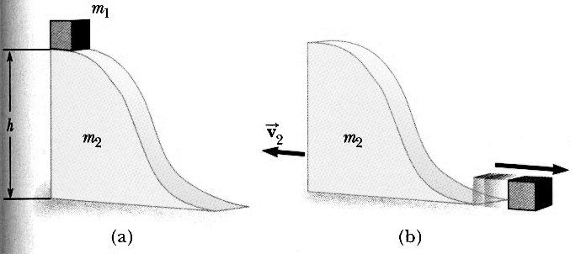

Two metal spheres of mass m₁ and m₂, are suspended by cords so that they just touch when the cords are vertical. m₁ is pulled back so that its cord makes an angle θ₁ with the vertical, is released from rest, and allowed to collide elastically with m_{2.}

Find the maximum angle, θ₂, that the cord attached to m₂ makes with the vertical.

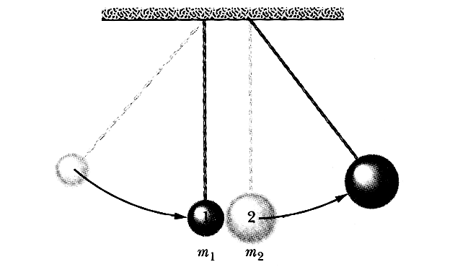

In the Olympiad of 708 B.C., some athletes competing in the standing long jump used hand held weights called halteres to lengthen their jumps. The weights were swung in front of them just before liftoff (as pictured) and then thrown behind them during the flight.

Let the mass of the athlete be M_{A}, the mass of the halteres be M_{H}. The athlete leaves the ground (with or without the halteres) with an initial velocity V₀ at an angle θ with the horizontal. At the peak of his trajectory, he throws the weights backward so that their velocity with respect to the ground is zero. How much distance is added to the athlete's jump by throwing the weights?

