Weighing Jupiter – Period 1

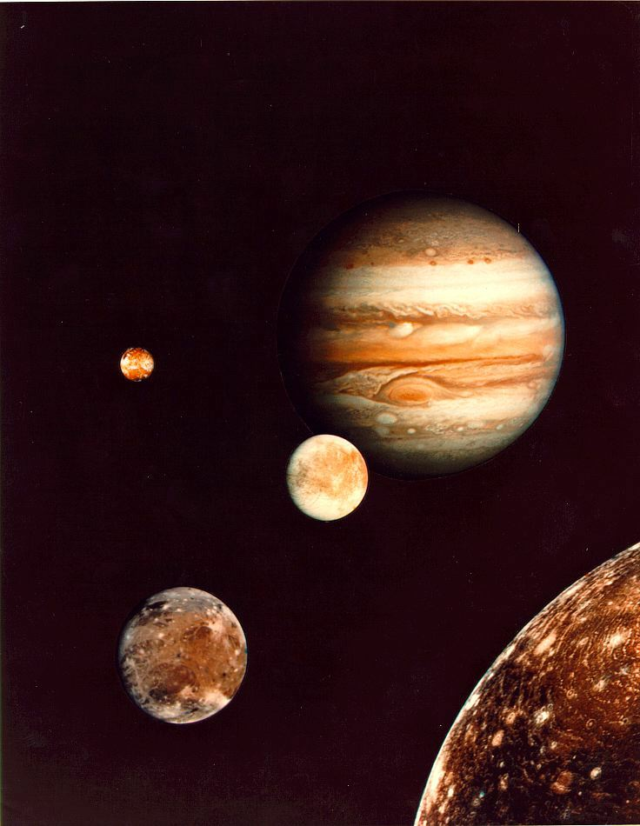
Introduction
Scientific investigation often involves inference, the use of observational evidence to infer the true nature of a system under study. For example, imagine that you have observed a hole chewed in a bag of flour along with tiny tooth marks on the paper. From this evidence, you would infer the presence of a rodent. In this lab, we will use scientific inference, observational data coupled with physical principles, to infer the mass of the planet Jupiter.

In 1543 Copernicus hypothesized that the planets revolve about the Sun in circular orbits. Not much later, Tycho Brahe carefully observed the location of the planets over a period of 20 years using a sextant and a compass. Tycho’s observations were used by his student, Johannes Kepler, to deduce three empirical mathematical laws governing the motions of the planets in the solar system.

Kepler's Third Law mathematically relates the semi-major axis of a planet's orbit (its average distance from the Sun) to its orbital period (how long it takes to get all the way around the Sun). Isaac Newton later demonstrated that all of Kepler's laws are natural consequences of a few basic laws of nature. While Kepler was only talking about the solar system, Newton's generalization applies to any two orbiting bodies. This is Newton’s version of Kepler’s Third Law:

$$a^{3}=\frac{G\left(\text{M+m}\right)}{4π^{2}}P^{2}$$

In the equation above, a is the semi-major axis of the orbit, P is the orbital period, and M and m are the masses of the orbiting bodies. With Newton's modification, we have a way to infer mass by observing the orbital dynamics of a system. In Part 1 of this lab series, we will explore the way in which the above relationship applies to Jupiter and its moons.

Part 1: The Jovian System

Our investigation begins by developing an understanding of the motions of Jupiter's moons as observed from the Earth.

- Below is a typical snapshot of Jupiter and its moons. Use the picture to answer Questions 1 and 2 in your answer packet.

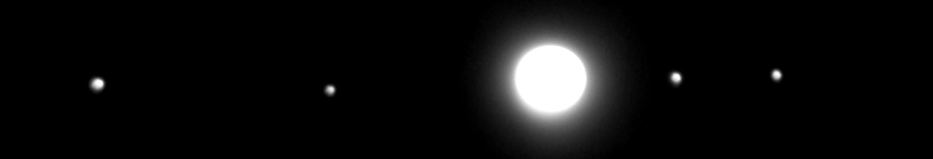
- Below are three snapshots of the of the Jovian system as viewed from above Jupiter's north pole. In the space provided in your answer packet, sketch the system as it would be seen from Earth.
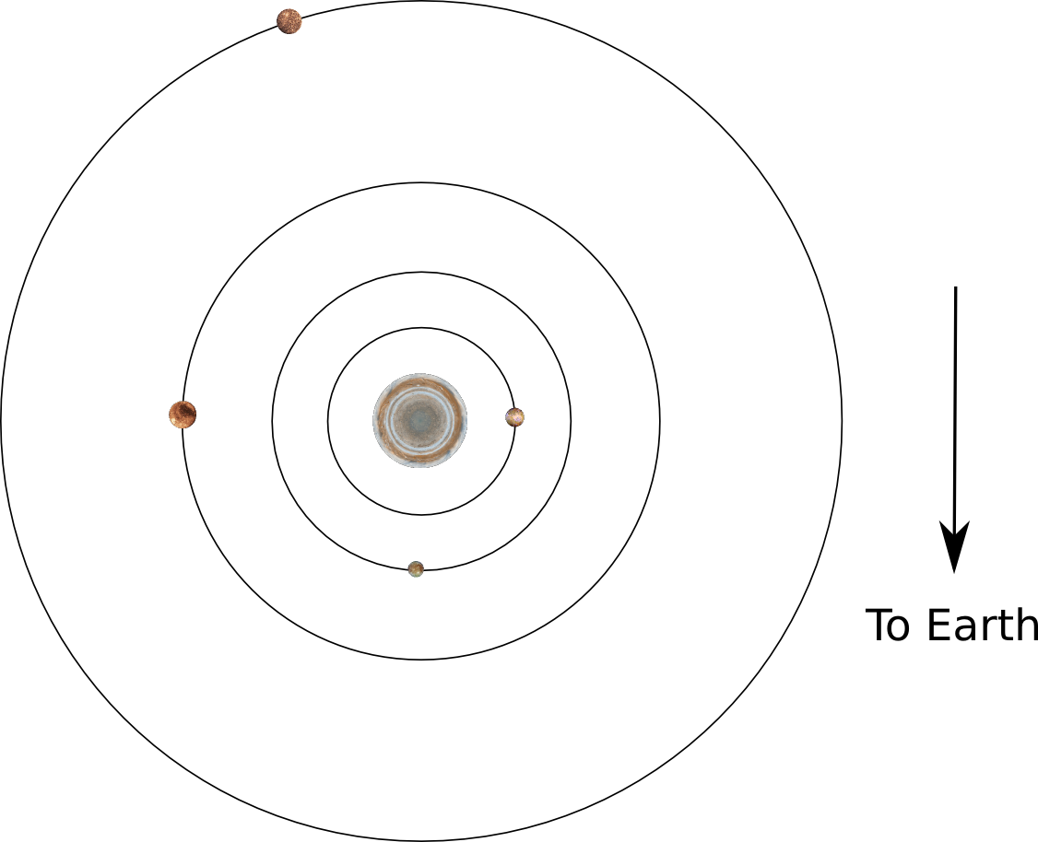

Snapshot 1

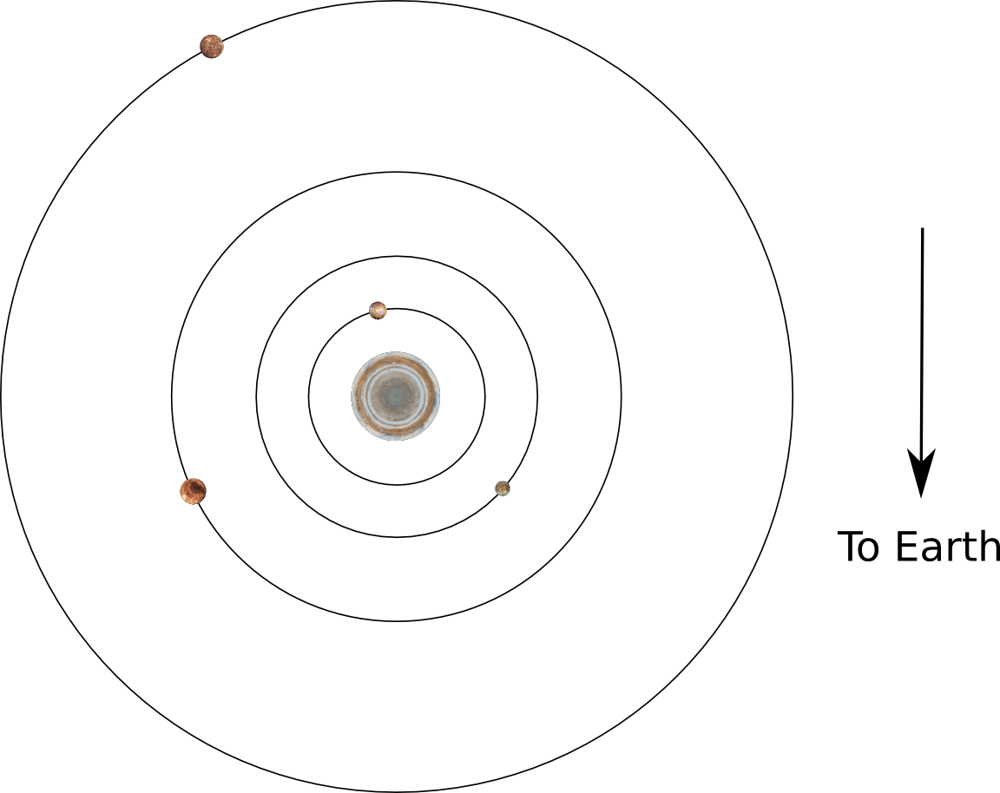
Snapshot 2

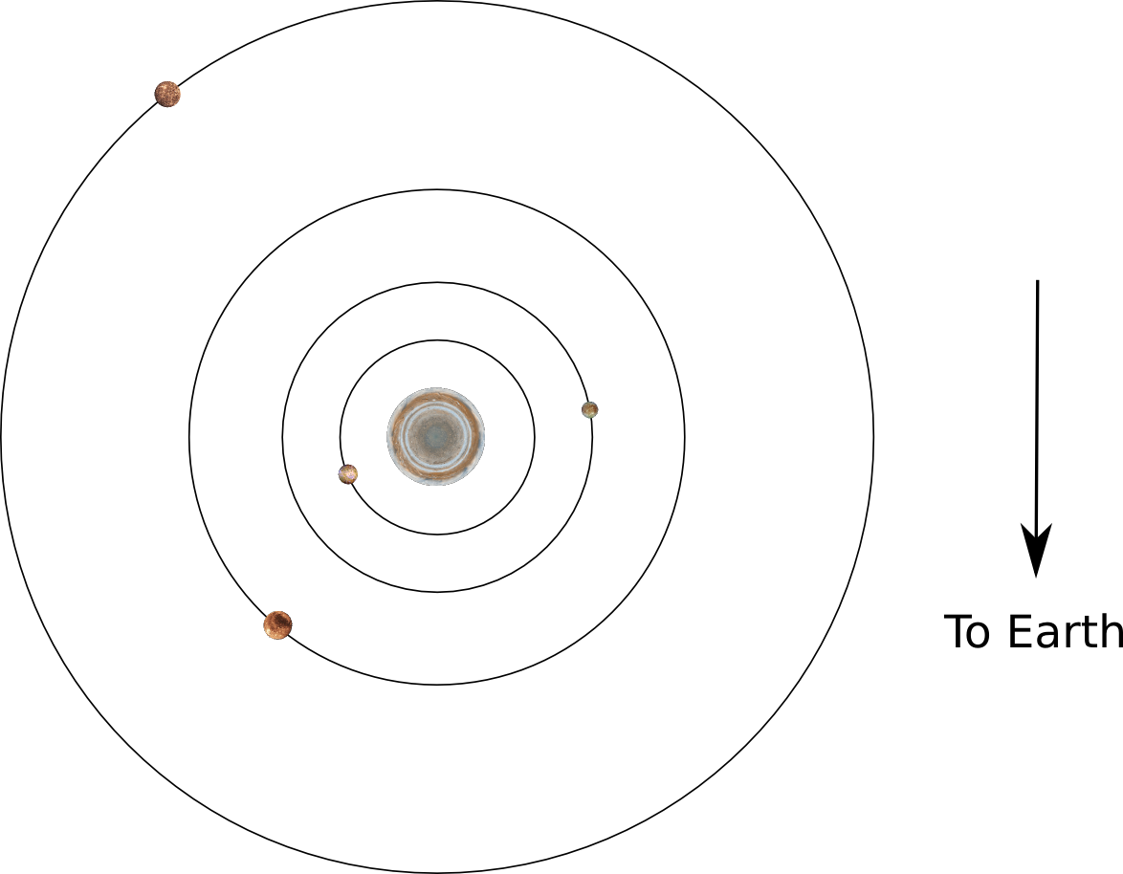

Snapshot 3
- The snapshots above were taken 12 hours apart from each other. Use this information to answer Question 4.

- On the lab web page (http://ida.phys.stthomas.edu/MoonsOfJupiter), click the Jupiter Simulations Link and watch the video there. Then, answer Questions 5 and 6.

Part 2: Develop an Observing Plan

In the next step in our investigation, we will explore the connection between images of the Jovian system and Newton's version of Kepler's Third Law.

- In your answer packet, answer Part 2 Questions 1 and 2.

- On the lab web page, choose the Circular Motion link. Watch the simulation after choosing each of the options under the 'Image' menu. Answer Questions 3 and 4.

- Observing Restrictions!
- Jupiter is currently only observable for 3 hours per night.
- Your project has been awarded a total 15 images.

- The Circular Motion plot on the web page displays a continuous line. You will not have continuous observations but snapshots at several discrete points in time. You must use what you know about the orbital period of each of Jupiter's moons (from Part 1) and your observing restrictions (above) to decide how to best distribute your observations in time. Answer Questions 5 through 9.

- Discuss your parameters from Question 9 with the class and come to a class consensus on your observing plan.

