Weighing Jupiter

Turn in one copy of this lab with each group member's printed name and signature. By signing, you certify that you have actively participated in the exercise and have put forth effort in equal share to your fellow group members.

Printed Name Signature

______________________ _____________________

______________________ _____________________

______________________ _____________________

______________________ _____________________

Part 1

1. The orbits of Jupiter’s moons are circular, yet in all images taken from Earth, they appear in a straight line. Why?

We are viewing the system edge on and a circle viewed edge on looks like a line.

If our view was from the top (pole on) the moons would appear in various orientations with respect to each other but a particular moon’s distance from Jupiter would be constant.

2. List everything that you could possibly directly measure in a single image of Jupiter and its moons.

The brightness of Jupiter and its moons
Their diameters (in pixels)
The distances between everything (moon-moon distances and Jupiter-moon distances)

3. Sketch the view from Earth of each of the three Jovian system snapshots in Part 2.

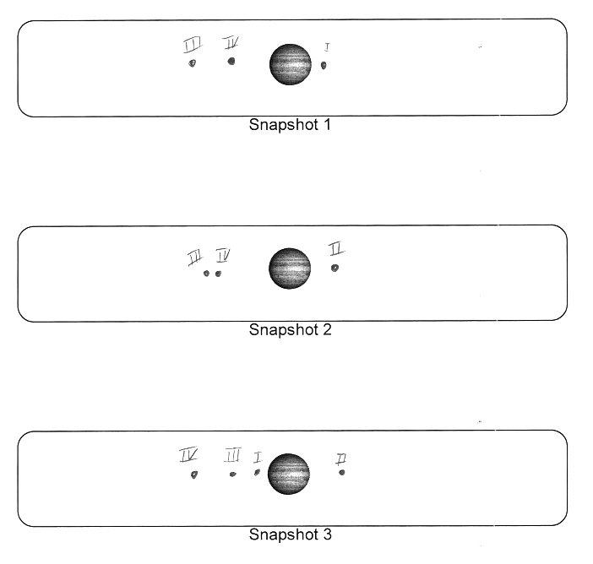

4. Estimate the orbital period of each of the four Galilean moons.
Explain your calculation.

Moon | Orbital Period  (Hours) | Orbital Period  (Days)
I | 40 | 1.7
II | 85 | 3.5
III | 180 | 7.5
IV | 393 | 16.3

Students can use a protractor to measure the angular position of the moons in each image to calculate an angular velocity in degrees per hour from which they can estimate the orbital period as follows:
$ω=\frac{Δθ}{Δt}$ and $P=\frac{\text{360}}{ω}$

5. The orbits of Jupiter's moons are almost completely circular. Appealing to Kepler's Second Law, what does this imply about their orbital velocity? How does it change with respect to time and/or position in the orbit?

Kepler’s Second Law implies that, in an elliptical orbit, a planet’s orbital velocity changes in proportion to its distance from the Sun. In a circular orbit, its distance from the Sun never changes and its orbital velocity is therefore constant.
The Jovian moons, being in a circular orbit, have constant orbital velocities.

6. In the video, we are viewing the system edge on. At what point in the orbit does the moon appear to move the fastest? The slowest? Why?

The moons appear to move fast when they are close to Jupiter and slow when they are far away. This apparent change in velocity is not due to Kepler’s Second Law, but rather because we see the system edge on.
When the moon is farthest away from Jupiter in the edge on view, its motion is either directly towards us or directly away from us (purely radial along our line of sight) and its apparent motion (its transverse motion across our line of sight) is zero.
When the moon is in either front of or behind Jupiter, its motion along our line of sight is zero and its apparent or transverse motion is maximum

Part 2
$a^{3}=\frac{G\left(M_{J}\text{+m}\right)}{4π^{2}}P^{2}$1. In the equation at the right:
a = Orbital Semi-major axis
P = Orbital Period
M_{J} = Mass of Jupiter
m = Mass of a moon
G = Universal Gravitational Constant.

Assume that the mass of a moon, m, is very small compared to the mass of Jupiter, M_{J}, and that we know the gravitational constant G (we also know the values of 4 and π).
What else do we need to know to solve this equation for the mass of Jupiter?

If the mass of the moon is very small, we can consider it negligible and it vanishes from the equation. The only unknowns are then the semi-major axis, a, and the orbital period, P.

2. Can we measure these values from a single image of Jupiter?
If yes, how?
If no, why not and what is the solution?

No, we can measure neither the semi-major axis nor the orbital period from a single image.
The semi-major axis could only be measured in an image when the moon’s apparent distance from Jupiter is at its maximum. The period cannot be measured at all because there is no time information in a single image.
The solution is to take a time series of images.

3. Consider a single moon in orbit around Jupiter as seen from Earth. Imagine measuring the position of that moon with respect to Jupiter at many points in time.
Sketch a plot of that data with time on the x-axis and the moon's position on the y-axis.

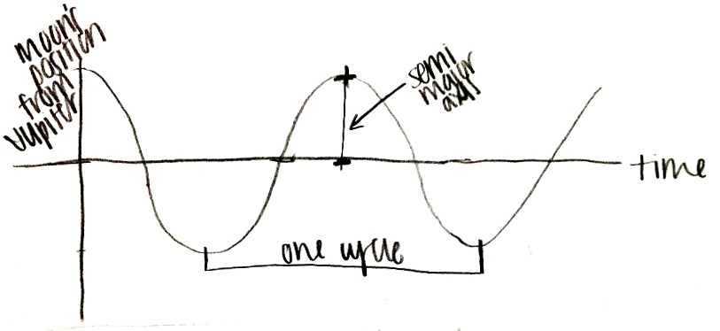

4. How can you use this plot to measure the unknown parameters from Question 1? Mark your plot to show the parameters in question.

In the plot above (which is sinusoidal), the amplitude represents the semi-major axis and the wavelength (the peak to peak distance along the time axis) represents the orbital period.

5. Is it necessary to capture an entire orbital cycle to capture the measurements from Question 4? How much of a cycle to you really need?
Because the curves are symmetric, we really only need a well placed quarter period of a moon. The amplitude can be measured from a single peak and the distance between the peak and the first zero crossing represents one quarter of a period. To ensure that you get a peak and a zero crossing, your observing plan should cover at least a half period.

6. How many observations per orbital period are needed to accurately characterize the curve in Question 3?
In general more is better. The more observations per cycle that you have, the better you will be able to see the curve. Since you have a limited number of observations, the best scenario is to pack them all into a single orbital cycle of one of the moons.

7. Given your observing restrictions and your answers to the previous two questions, which moons should you NOT use? Why?
Because we can only observe Jupiter for 3 out of 24 hours, the short period moons, IO in particular, will be very difficult to measure. The three hour window will only reveal a small section of the orbital curve and the 24 hour gap between samples is large compared to the orbital period.

8. Which moons would work the best? Why?
The long period moons are a better bet. The 24 hour gap between observing windows is small compared to the orbital period of the two long period moons. Also, a few samples placed in the three hour window will provide a sense of the curve’s slope at that point, easing the curve sketching in Period 2.

9. How do you propose to distribute your images?

Number of Images per Night | 3
Time Between Images (minutes) | 60
Number of Nights to observe | 5

The above observing parameters represent the plan used to acquire the attached data.

