Weighing Jupiter

Turn in one copy of this lab with each group member's printed name and signature. By signing, you certify that you have actively participated in the exercise and have put forth effort in equal share to your fellow group members.

Printed Name Signature

______________________ _____________________

______________________ _____________________

______________________ _____________________

______________________ _____________________

Part 1

1. The orbits of Jupiter’s moons are circular, yet in all images taken from Earth, they appear in a straight line. Why?

2. List everything that you could possibly directly measure in a single image of Jupiter and its moons.

3. Sketch the view from Earth of each of the three Jovian system snapshots in Part 2.

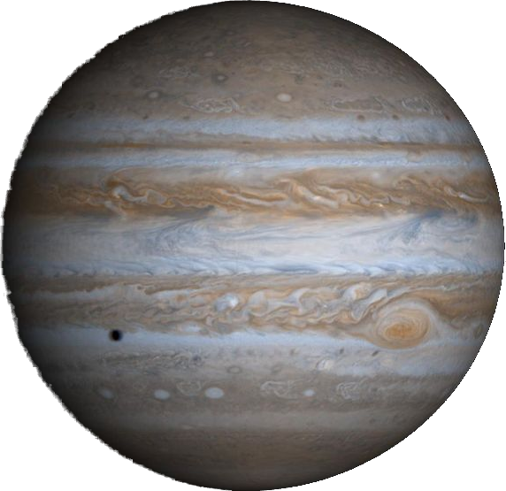

Snapshot 1

Snapshot 2

Snapshot 3

4. Estimate the orbital period of each of the four Galilean moons.
Explain your calculation.

Moon | Orbital Period  (Hours) | Orbital Period  (Days)
I
II
III
IV

5. The orbits of Jupiter's moons are almost completely circular. Appealing to Kepler's Second Law, what does this imply about their orbital velocity? How does it change with respect to time and/or position in the orbit?

6. We are viewing the system edge on. At what point in the orbit does the moon appear to move the fastest? The slowest? Why?

Part 2
$a^{3}=\frac{G\left(M_{J}\text{+m}\right)}{4π^{2}}P^{2}$1. In the equation at the right:
a = Orbital Semi-major axis
P = Orbital Period
M_{J} = Mass of Jupiter
m = Mass of a moon
G = Universal Gravitational Constant.

Assume that the mass of a moon, m, is very small compared to the mass of Jupiter, M_{J}, and that we know the gravitational constant G (we also know the values of 4 and π).
What else do we need to know to solve this equation for the mass of Jupiter?

2. Can we measure these values from a single image of Jupiter?
If yes, how?
If no, why not and what is the solution?

3. Consider a single moon in orbit around Jupiter as seen from Earth. Imagine measuring the position of that moon with respect to Jupiter at many points in time.
Sketch a plot of that data with time on the x-axis and the moon's position on the y-axis.

4. How can you use this plot to measure the unknown parameters from Question 1? Mark your plot to show the parameters in question.

5. Is it necessary to capture an entire orbital cycle to capture the measurements from Question 4? How much of a cycle to you really need?

6. How many observations per orbital period are needed to accurately characterize the curve in Question 3?

7. Given your observing restrictions and your answers to the previous two questions, which moons should you NOT use? Why?

8. Which moons would work the best? Why?

9. How do you propose to distribute your images?

Number of Images per Night
Time Between Images
Number of Nights to observe

