Weighing Jupiter – Period 2
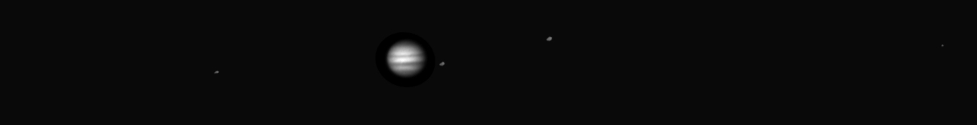
Jupiter and its moons as seen from the UST Observatory.

Introduction

In Lab 1 of this two lab series, we discovered that Kepler's Laws of planetary motion could be used to calculate the mass of a planet. We then learned how we could weigh Jupiter by measuring the period and orbital radius of its moons in a time series of images. In this lab, we are going to use the images from the telescope to first measure the period and semi-major axis of the Jupiter's moons and then use those values to calculate the mass of Jupiter.

Part 1: Measure the moon positions

Depending on your original observing plan, you will have as many as 15 images of Jupiter. In each image, you will measure the distance between Jupiter and each of its four moons and record that distance in a spreadsheet. That's as many as 60 individual measurements! Your instructor may divide you into teams to make the data extraction go faster.

- Open the zip file provided by your instructor, then click “extract all” at the top of the folder. Save it into a new folder on your desktop.

- Navigate into the JupiterData folder and open ‘jupiter_data.xls.’ This is where you will record your raw data.

- Navigate into the ‘ds9’ folder and double click 'ds9.exe'. This is the program you will use to display the images and make measurements.

- Open the first file assigned to you using File->Open. You should see an image of Jupiter, although the moons may not be visible, as in Figure 1 below. (Important: Do not change anything to try to see the moons!!)

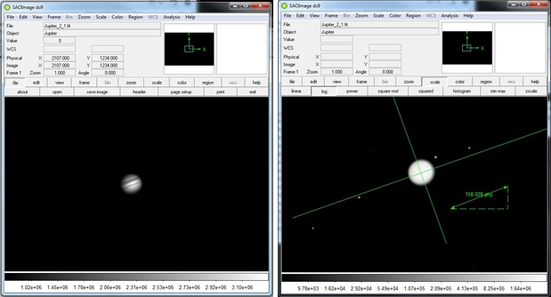
Figure 1: Two images of Jupiter. The image on the left is unscaled. Details on Jupiter are clear, but the moons aren't visible. The image on the right is scaled so that details on Jupiter are washed out but the moons are visible. The image on the right also shows the measurement tools

- Choose Region->Load Regions on the menu bar and load the file called 'Measure.reg'. The measurement tools will appear, as in the figure above.

- Use the ruler tool to measure the diameter of Jupiter. Write your number on the board. Record the class average in the appropriate place in the spreadsheet.

- Press the Scale button and choose a log scale and the moons should appear, although Jupiter will be washed out.
IMPORTANT: Don't change the scaling before you've measured the diameter of Jupiter!

- Put one end of the ruler arrow on the leftmost moon in the image. Place
the other end of the arrow against the line that is perpendicular to the orbital plane of the moons. Try to make your ruler line parallel to the line representing the orbital plane as in Figure 2 below.
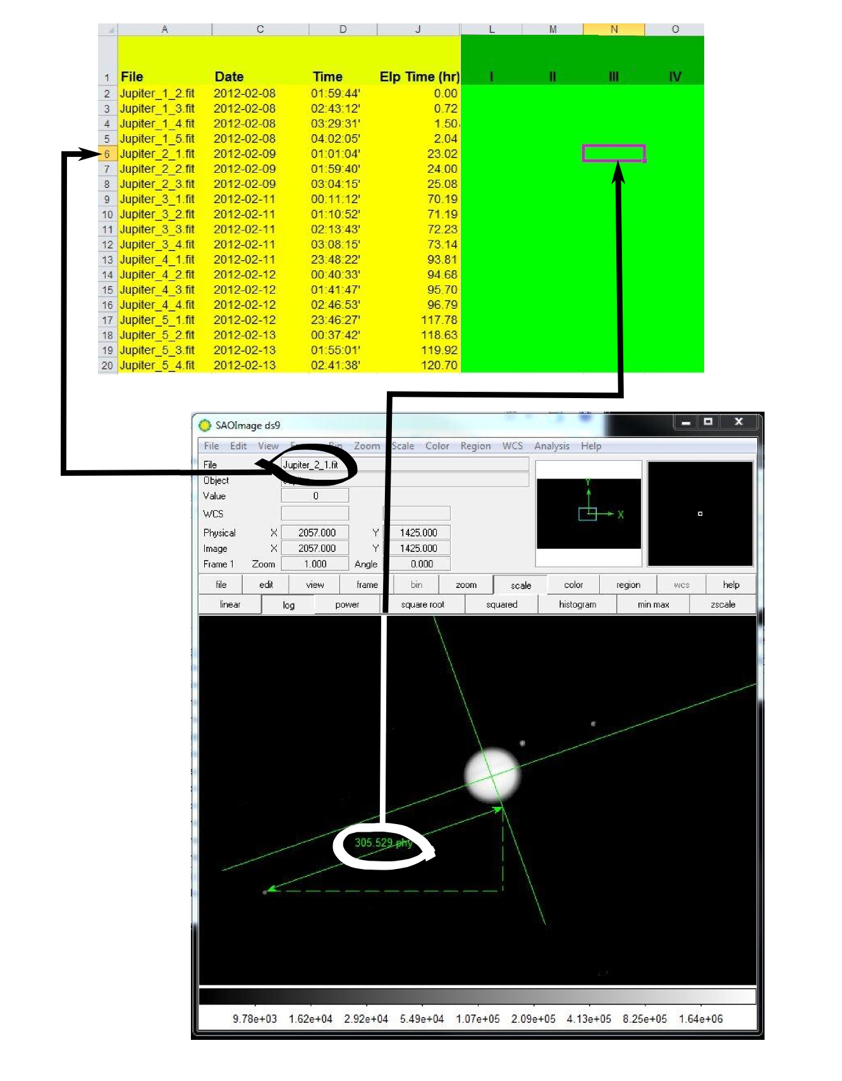
Figure 2: To measure the Jupiter to moon distance, place the ruler tool as shown ensuring that the ruler tool is parallel to the orbital plane. Find the row in the spreadsheet corresponding to the image title and record the moon positions in the green region of the spreadsheet.
- Record your moon position data in the row for the specific file you are measuring in the spreadsheet as shown in Figure 2. The moon order does not matter so long as you are certain to measure all of the moons. If the moon is to the left of Jupiter, record the distance as negative. If it is to the right, record the distance as positive.

- Repeat the preceding procedure for each of your images. Once your data has been recorded, enter all your data into the class spreadsheet before continuing.

Part 2: Determine the orbital parameters

Now that we have the raw data, we will use it to reproduce the curve that you sketched in Period 1 of this lab

- Select the 'Big Plot' sheet in the tabs at the bottom. You will see the observed positions of all the moons plotted. The x-axis is time and the y-axis is distance from Jupiter in pixels. Print the plot so you have a copy to work on.

- Answer questions 1 and 2 in your answer packet by comparing Figure 3 to the plot of your data.

- Now, we need to reproduce the orbital curve that we sketched in the previous lab period. However, our plot contains all of the data from all four moons at the same time and we need to determine which moon is which. Using Figure 3 as a reference, try to “connect the dots” and sketch the orbital curve for as many of the moons as you can.

- Answer Questions 3 in the answer packet.

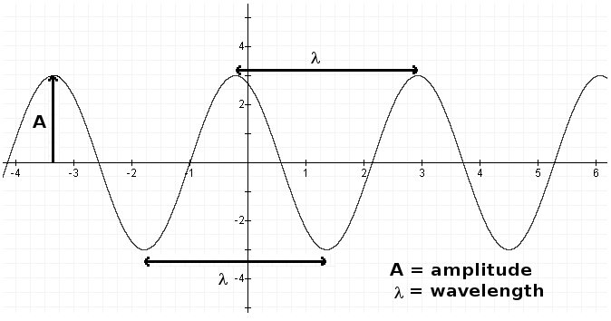
Figure 3: Sample orbital curve sketch.

Part 3: Weigh Jupiter

Now, you will measure the periods and semi-major axis of the moons whose orbital curves you sketched and use those values to calculate Jupiter’s mass.

- For each moon whose orbital curve you sketched, estimate the semi-major axis, a, in pixels and the orbital period, P, in hours from your graph.
Note: In order of distance from Jupiter, the moons are: Io (closest), Europa, Ganymede, and Callisto. Record your data in Table 1.

- Using the fact that Jupiter’s diameter is 1.42x10⁵ km, convert your values for the semi-major axis, a, from pixels to kilometers and record the result in Table 2.

- Using the fact that 1 AU = 1.5x10⁸ km, convert a from kilometers to A.U. and record the result in the second column of Table 2.

- Convert the orbital periods, P, from hours to years and write these in Table 2.

- Use the equation below (Newton’s version of Kepler’s Third Law) to calculate the mass of Jupiter once for each moon and write in Table 3.

$$M=\frac{a^{3}}{P^{2}}$$

M is the mass of the central object in solar masses
a is the semi-major axis in A.U.
P is the orbital period in years

- Calculate the average and record it in Table 3.

- Answer the remaining questions in the answer packet.

