Weighing Jupiter – Period 2

Turn in one copy of this lab with each group member's printed name and signature. By signing, you certify that you have actively participated in the exercise and have put forth effort in equal share to your fellow group members.

Printed Name Signature

______________________ _____________________

______________________ _____________________

______________________ _____________________

______________________ _____________________

Part 2

- What physical property does the amplitude of the sine curve represent? (The amplitude is how high it is from zero, or half the total height.)
The amplitude of the curve is the semi-major axis of the moon’s orbit.

- What physical property does the wavelength of the sine curve represent? (The wavelength is the amount of time it takes to get back to the same position on the graph.)

The wavelength of the curve (since the x-axis is time) represents the orbital period of the moon.

- Describe your fitting process. What was difficult? For which moons was the curve easiest to sketch? Why?
In this data set, there are three observations taken an hour apart per night over five nights. Individual nights are visible as vertical bands and multiple observations on a single night appear as closely spaced data bursts. On a given night, The bursts make it easy to distinguish one moon from another. A burst also provides a pointer to the correct burst on the following night for moons whose periods aren’t too short. Following the pointers, one can “connect the dots” from night to night and trace out the moon’s orbital curve.
This technique works well for Callisto and Ganymede because the periods are longer than the 24 hour gap between nights. Europa and IO are difficult because they are not well sampled.

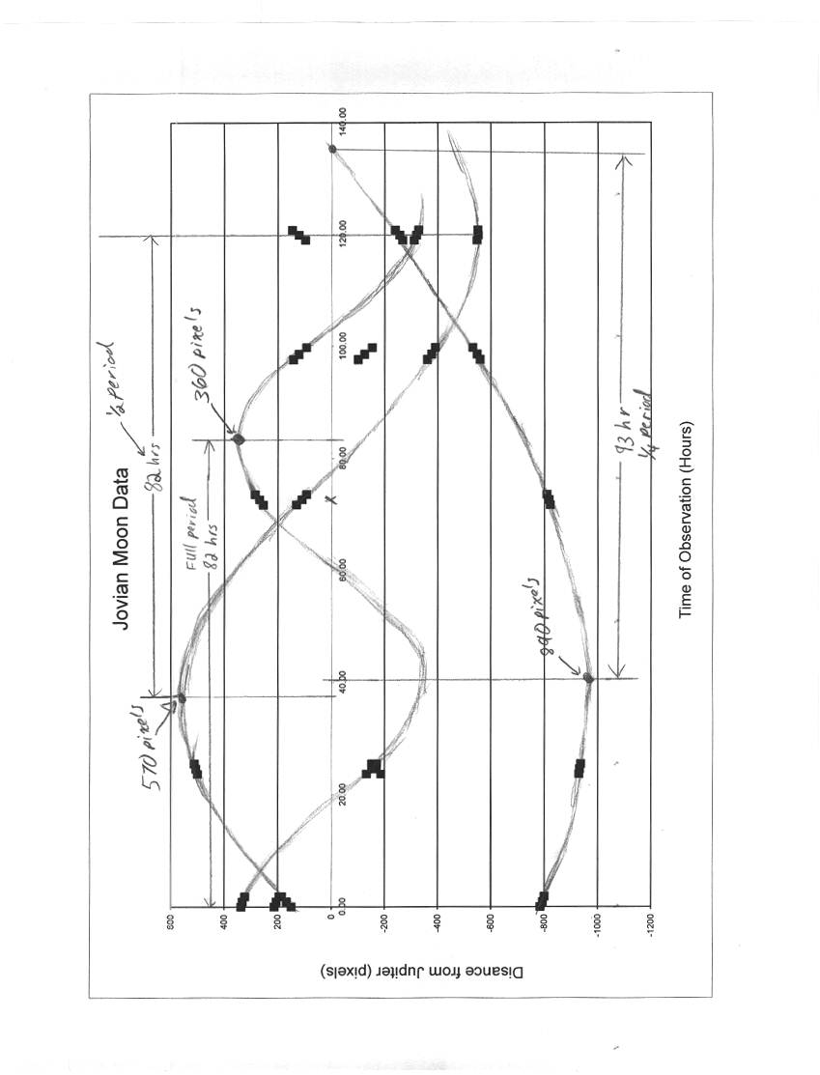
Part 3

Note: In increasing order of semi-major axis, the moons are: Io (closest), Europa, Ganymede and Callisto (farthest)

Table 1: Data
Moon | a  (pixels) | P  (hours)
Io | … | …
Europa | 360 | 82
Ganymede | 570 | 164
Callisto | 890 | 372

Table 2: Conversions
Moon | a  (Kilometers) | a  (A.U.) | P  (years)
Io | … | … | …
Europa | 6.90x10⁵ | 4.60x10⁻³ | 9.36x10⁻³
Ganymede | 1.09x10⁶ | 7.29x10⁻³ | 1.87x10⁻²
Callisto | 1.71x10⁶ | 1.14x10⁻² | 4.25x10⁻²

Table 3: Calculating Jupiter’s Mass
Moon | Mass of Jupiter  (solar masses)
Io | …
Europa | 1.1x10⁻³
Ganymede | 1.1x10⁻³
Callisto | 0.82x10⁻²
Average | 1.0x10⁻³

- Compare the answers you got for the mass of Jupiter from the different moons. How accurate are your measurements?
There are several ways to look at the error depending on the students’ comfort with math.
The standard deviation of data set is 1.7x10⁻⁴. Interpreting the standard deviation as the one sigma error, the true mass of Jupiter lies within the error on the mean.
Comparing to the actual mass of Jupiter (9.546x10⁻⁴), individual moons have an error of approximately 15% and the average value has an error of about 6%, where the percent error is calculated as
$e=\left|\frac{M_{J}−M_{c}}{M_{J}}\right|$,
where M_{J} is the actual mass of Jupiter and M_{C} is the calculated mass.

